**PRESS RELEASE**

**The Gwangju Institute of Science and Technology Scientists Confirm Horse Riding as a Viable Mobility Treatment for Cerebral Palsy**

*The study shows that functional mobility in children with cerebral palsy can be improved through physical interaction with horses.*

**Cerebral palsy (CP) affects around two out of every 1000 children born worldwide. Physical therapy is the foremost way of improving movement, balance, and posture in children with CP. Research has shown that hippotherapy, a form of physical therapy involving horse riding, is effective for treating CP. But how exactly does it help? In a recent study, researchers from GIST explore this question and provide insightful answers as well as a baseline for future research.**

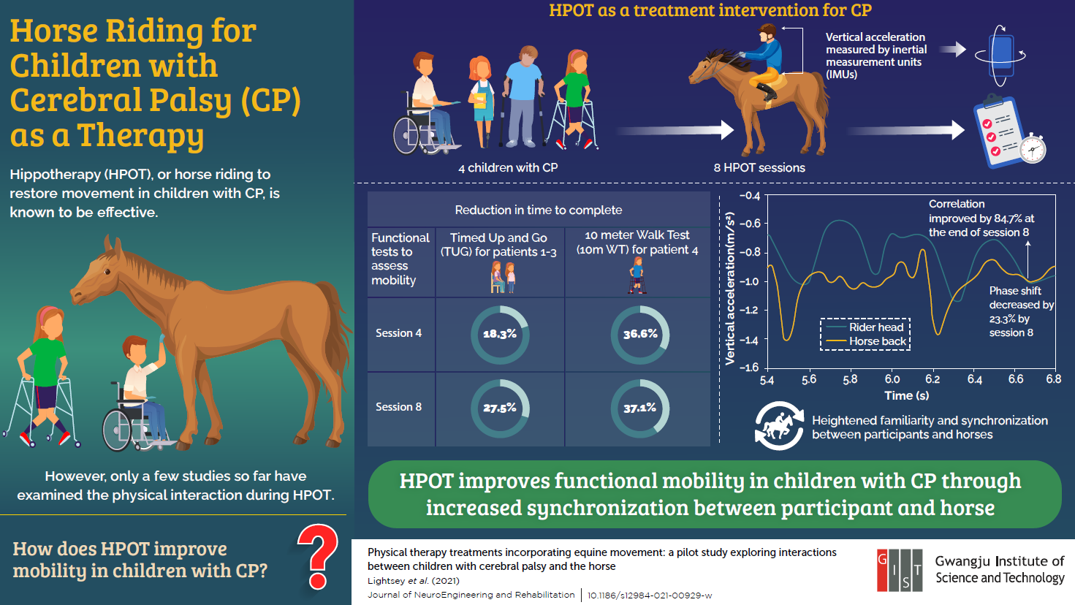

Cerebral Palsy (CP) is a common disability among children, characterized by abnormal gait patterns and the inability to maintain posture and balance. While the condition is incurable, physical therapy treatments can go a long way in improving movement and balance. One such treatment approach is hippotherapy (HPOT), which uses horse riding to improve functional mobility in children with CP. Although supported by scientific studies as an effective treatment approach for (CP), there is, unfortunately, little data concerning how HPOT results in improvement.

Recently, a team of researchers from Korea and the United States addressed this question, investigating physical interaction metrics between horses and children with CP during HPOT. *“My original research interests lie in the rehabilitation of people with neurological impairment, specifically gait and balance. However, I did not know about hippotherapy until rather recently in 2016. After realizing how effective it is in treating children with CP, I was motivated to explore it further,”* explains Dr. Pilwon Hur who headed the study from the Gwangju Institute of Science and Technology (GIST) in Korea. This paper was made available online on September 6, 2021, and was [published in Volume 18 Issue 132 of the *Journal of NeuroEngineering and Rehabilitation.*](https://doi.org/10.1186/s12984-021-00929-w)

The research team studied four children with CP over the course of eight physical therapy sessions. They placed sensors on the horses and children to record their movements and track their acceleration and angular velocity. They found that the data from the horses and children began to resemble each other as time progressed, indicating a synchronization between the horse and the rider. They also gave the children mobility tests after each session and observed improvement in their motor skills at the end of the experiment.

*“We found that physical interaction between the children with CP and the horses, characterized by the children adapting to the horse’s movement and vice versa, is extremely important for the rehabilitation to be effective,”* says Dr. Hur.

Excited by these findings, the team hopes their work will provide a baseline for further research on HPOT. “*To the best of my knowledge, ours is the first study to quantify these interactions and relate them to effectiveness*,” says Dr. Hur. “*Such an understanding would help us optimize physical therapy programs, improving the quality of life for children with CP*.”

We certainly hope his vision is realized soon!

**Reference**

|  |  |
| --- | --- |
| Authors: | Priscilla Lightsey1, Yonghee Lee2, Nancy Krenek1 & Pilwon Hur1,3,* |
| Title of original paper: | Physical therapy treatments incorporating equine movement: a pilot study exploring interactions between children with cerebral palsy and the horse |
| Journal: | *Journal of NeuroEngineering and Rehabilitation* |
| DOI: | 10.1186/s12984-021-00929-w |
| Affiliations: | 1Ride On Center for Kids (ROCK)  2Department of Mechanical Engineering, Texas A&M University  3School of Mechanical Engineering, Gwangju Institute of Science and Technology |

**About the Gwangju Institute of Science and Technology (GIST)**

The Gwangju Institute of Science and Technology (GIST) is a research-oriented university situated in Gwangju, South Korea. As one of the most prestigious schools in South Korea, it was founded in 1993. The university aims to create a strong research environment to spur advancements in science and technology and to promote collaboration between foreign and domestic research programs. With its motto, “A Proud Creator of Future Science and Technology,” GIST has consistently received one of the highest university rankings in Korea.

Website: <http://www.gist.ac.kr/>

**About the author**

Pilwon Hur is an Associate Professor of Mechanical Engineering and the Director of the Human Rehabilitation Group at Gwangju Institute of Science and Technology (GIST) in South Korea. His group is developing control framework for rehabilitation robots to help people with neurological and physical impairments. His group uses neuroscience principles (e.g., free energy principle), and theories from control, dynamics, and robotics. Before coming to GIST, he was an Assistant Professor of Mechanical Engineering at Texas A&M University in College Station, USA. In 2010, Pilwon Hur received a PhD in Mechanical Engineering from the University of Illinois at Urbana-Champaign.