**PRESS RELEASE**

**Gwangju Institute of Science and Technology Scientists Shine Light to Measure Blood Flow in the Brain in Real Time**

*Scientists develop an optical technique that can image dynamic changes in the cerebral blood flow to diagnose brain health*

**Cerebral blood flow (CBF), which supplies oxygen and nutrients to our brain, is a crucial indicator of brain health. Information from CBF can, therefore, help us diagnose brain disorders. While this information is usually obtained from speckle imaging, the technique cannot provide information on both flow speed and direction. Now, scientists from GIST take things to the next level with a new technique that quantitatively estimates CBF in real time at high speeds.**

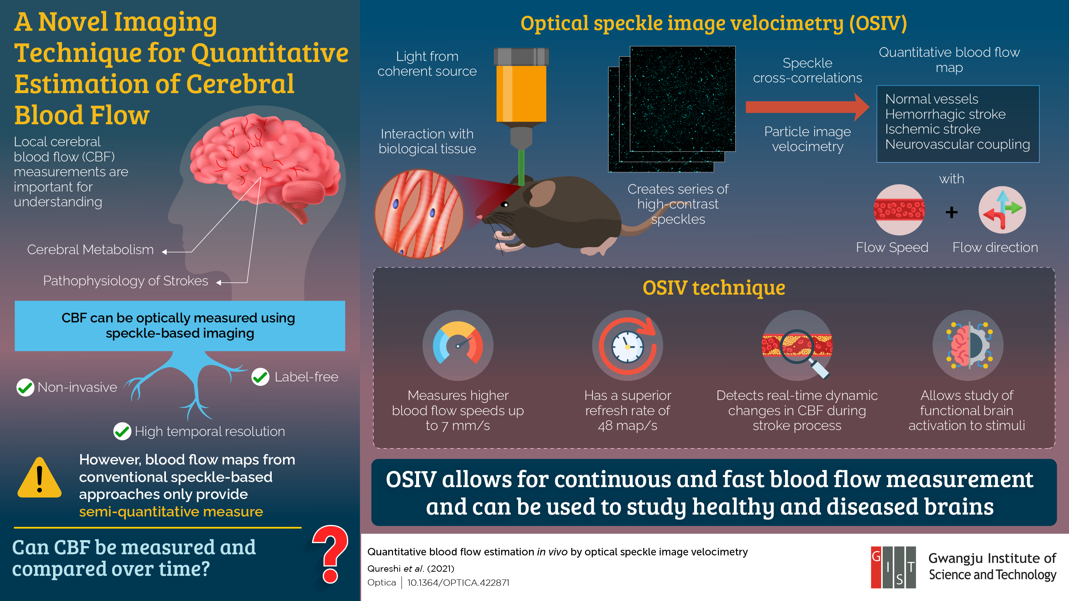

The brain is arguably the most crucial aspect of our existence. Our brain health governs how well we function. In turn, our brain health is determined by the blood supply to our brain via “cerebral blood flow” (CBF), which regulates the supply of oxygen and nutrients and removes metabolic by-products. An imbalance in CBF can lead to brain disorders such as headache, seizures, Alzheimer’s disease (AD), and stroke.

Observing local CBF during neural activity could, therefore, help unravel the origins of brain disorders. Speckle imaging, a technique based on the analysis of large number of short exposures, is particularly popular in this regard because it is non-invasive, label-free, simple, and provides high time resolution. However, it cannot provide information on both blood flow direction and speed, making it difficult to analyze and monitor changes in blood flow.

In a recent study,researchers led by Prof. Euiheon Chung from the Gwangju Institute of Science and Technology (GIST) in Korea came up with an innovative solution to this problem. The team developed a technique called “optical speckle image velocimetry” (OSIV) that creates an absolute flow map in real time with information on both speed and direction and a superior time resolution. Prof. Chung explains, “*We intended to create a new technique that, unlike its predecessors, allows for a quantitative analysis of CBF and does not require complex mathematical modeling for flow measurements*.” This paper was made available online on 13 August 2021 and was published in Volume 8, Issue 8 of the journal *Optica* .

OSIV utilizes particle image velocimetry and speckle cross-correlations to detect blood flow velocities up to 7 mm/s and can measure flow maps at up to 190 Hz. To put OSIV to the test, the team used it to image blood flow during a stroke in a mouse brain *in vivo*, obtaining quantitative flow measurements without needing a tracer or a high-speed camera.

The technique can be successfully deployed to diagnose healthy and diseased brains. *“Our study can be used to understand the vascular mechanisms and test new drugs for treating vascular-related diseases such as stroke, AD, and diabetes,”* speculates Prof. Chung, excitedly.

We certainly hope this is soon realized!

**Reference**

|  |  |
| --- | --- |
| Authors: | Muhammad Mohsin Qureshi,1 Yan Liu,2 Khuong Duy Mac,1 Minsung Kim,1  Abdul Mohaimen Safi,3 Euiheon Chung1,4,5,* |
| Title of original paper: | Quantitative blood flow estimation in vivo by optical  speckle image velocimetry |
| Journal: | *Optica* |
| DOI: | 10.1364/OPTICA.422871 |
| Affiliations: | 1 Department of Biomedical Science and Engineering, Institute of Integrated Technology (IIT), Gwangju Institute of Science and Technology (GIST), Republic of Korea  2 School of Optometry, Indiana University, USA  3Department of Electrical Engineering, University of South Florida, USA  4Department of Physics and Photon Science, GIST, Republic of Korea  5AI Graduate School, GIST, Republic of Korea |

**About the Gwangju Institute of Science and Technology (GIST)**

The Gwangju Institute of Science and Technology (GIST) is a research-oriented university situated in Gwangju, South Korea. As one of the most prestigious schools in South Korea, it was founded in 1993. The university aims to create a strong research environment to spur advancements in science and technology and to promote collaboration between foreign and domestic research programs. With its motto, “A Proud Creator of Future Science and Technology,” GIST has consistently received one of the highest university rankings in Korea.

Website: <http://www.gist.ac.kr/>

**About the author**

Dr. Euiheon Chung is a professor in the Department of Biomedical Science and Engineering at Gwangju Institute of Science and Technology (GIST) and the director of Gliopathic Pain Research Center (GPRC) at the Joint Project of Institutes of Science and Technology in Korea. His translational research aims to create biophotonic technologies to resolve unmet clinical needs with animal disease models. His neurophotonics laboratory focuses on neurovascular diseases and neuropathic pain with functional optical imaging and neuromodulation. Before joining GIST, he completed a postdoc at MGH/Harvard Medical School and received his Ph.D. from the Harvard-MIT Health Sciences and Technology Medical Engineering Medical Physics program.