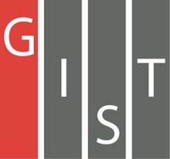
Gwangju Institute of Science and Technology

Official Press Release (https://www.gist.ac.kr/)

Section of Mi-Yeon Kim Nayeong Lee
Public Affairs Section Chief Senior Administrator
(+82) 62-715-2020 (+82) 62-715-2024

Contact Person Sang-hoon Yoon, Administrator
for this Article Joint Secretariat of Science and
Technology Institutes
(+82) 42-350-1223

Release Date 2019.05.24

Combining scientific skills... establishing the 'Joint Secretariat of Science and Technology Institutes'

□ Korea's four major science and technology institutes will set up a joint secretariat to create greater innovation.

∘ GIST (President Kiseon Kim) held a ceremony with KAIST (President Sung-Chul Shin), DGIST (President Young Kuk) and UNIST (President Mooyoung Jung) on the 24th (Friday) at 2:00 p.m. at KAIST to launch the 'Joint Secretariat of Science and Technology Institutes,' which is a key initiative for the four major science and technology institutes in Korea to push for creative collaboration and vision while establishing a system for further cooperation.

□ KAIST was established in 1971 in Daejeon to nurture advanced science and technology manpower needed for national development and to provide a model for science and engineering research universities. Since then, a science and technology institute has been created in Gwangju (GIST in 1993), Daegu (D-GIST in 2004), and Ulsan (UNIST in 2015). Korea has made remarkable changes and development in the education and research of science and engineering universities. However, as the era of the rapidly changing fourth industrial revolution begins, there are more challenges and crises both at home and abroad.

□ The Joint Secretariat of Science and Technology Institutes aims to utilize its "economy of scale" and "synergy" by pooling the capabilities of science and technology institutes that are locate in different regions. The plan is to establish a system of close cooperation between the science institutes and to find ways to reform the their role and responsibilities to serve as a key point of innovation and cooperation in education, research, and industry-academia partnerships. In addition, the establishment of a joint secretariat will also promote a strategy to expand its model of development.

∘ For this purpose, the four major science institutes signed an agreement on March 8 to set up a joint secretariat for the science and technology institute. The organization was established on April 4 as a provisional organization under KAIST's planning department, and it has sent representatives from each science institute to begin work since early May.

□ The Joint Secretariat of Science and Technology Institutes Director Bo-won Kim (KAIST Director of Planning) said, "It is time to set up a new vision in order for the four major institutes to become 'leading universities creating global value.' The Joint Secretariat is planning to carry out various tasks that are essential for the joint development of the four major institutes."

∘ In addition, he said, "The Joint Secretariat will plan and direct projects from a multidimensional point of view while simultaneously seeking individual and independent development of each project as well as the organic development of the joint project. We will continue to play a leading role in the innovation of science and technology through close communication and collaboration with the Ministry of Science and Technology, Ministry of Information and Communication, and the four major institutes."

□ The event was attended by more than 20 officials, including the Director of the Ministry of Science and Technology, Ministry of Information and Communication, GIST President Kiseon Kim, the presidents of KAIST, D-GIST, and UNIST as well as the planning director of each institute.

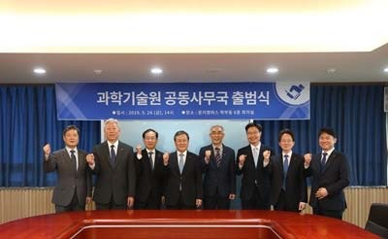
▲ Participants of the Joint Secretariat of Science and Technology Institutes

