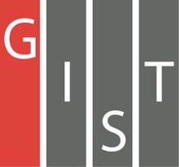
Gwangju Institute of Science and Technology

Official Press Release (https://www.gist.ac.kr/)

Section of Hyo Jung Kim Nayeong Lee
Public Affairs Section Chief Senior Administrator
(+82) 62-715-2061 (+82) 62-715-2062

Contact Person Soyoung Kim, Administrator
for this Article Section of Public Affairs
(+82) 62-715-2025

Release Date 2019.08.02

GIST signs MoU with the Korea Internet & Security Agency to promote the convergence of artificial intelligence (AI) and internal cyber security

□ GIST (President Kiseon Kim) and the Korea Internet & Security Agency (KISA, Director Suk-hwan Kim) signed a memorandum of understanding (MoU) to integrate industries in Gwangju, such as energy, automotive, and healthcare, with artificial intelligence (AI) and strong internal cyber security.

□ The MoU signing ceremony was held on August 2, 2019, and was attended by key officials from both organizations, including GIST President Kiseon Kim, Vice President Jong-In Song, GIST Research Institute Director In S. Kim, Office of Planning Dean Joon Ha Kim, Office of International and Public Affairs Dean Sung-Gyoo Park, Artificial Intelligence Research Institute Director Hyuk Lim, AI Industry Convergence Project Promotion Team Senior Researcher Deuk-jo Kong, KISA Director Suk-hwan Kim, KISA Public Affairs Director Ran-young Cho, Director of the Information Protection Industry Division Won-tae Shim, Director of the Personal Information Protection Division Hyun-joon Kwon, Diretor of the Future Research Policy Division Sang-ho Ji, Sang-hwan Park Director of the Information Protection R&D Technology Sharing Center, Director of the Regional Information Protection Center Sang-soo Jang, and Ho-seong Kim Director of the Honam Information Protection Support Center.

∘ The main agreement of the MoU includes: ▲ performing cyber security technology exchanges and joint research tasks based on artificial intelligence ▲ exchanging personnel specialized in the field of artificial intelligence and cyber security ▲ cooperating on industrial convergence security centered on artificial intelligence ▲ balancing regional development and realizing social values.

∘ In the future, the two organizations plan to cooperate on the integration of artificial intelligence into Gwangju's specialized industries such as energy, automobiles and healthcare. They will also cooperate to identify big data, to perform joint research on the security verification of artificial intelligence machines, and to train cyber security personnel.

□ GIST President Kiseon Kim said, "Because GIST and Gwangju are creating an AI cluster in the city, we will also establish a convergence R&D cluster in the areas of AI-based 4th Industrial Revolution sectors, such as energy, automotive, and healthcare, which will become successful as a future growth engine that will contribute to regionally-oriented global industrial development."

□ KISA Director Suk-hwan Kim said, "KISA will work hard to internalize security in all areas so that the next generation convergence services can be used safely and conveniently. We will lead the innovation and growth of an AI-based internet economy by verifying safety and securing the security of AI."

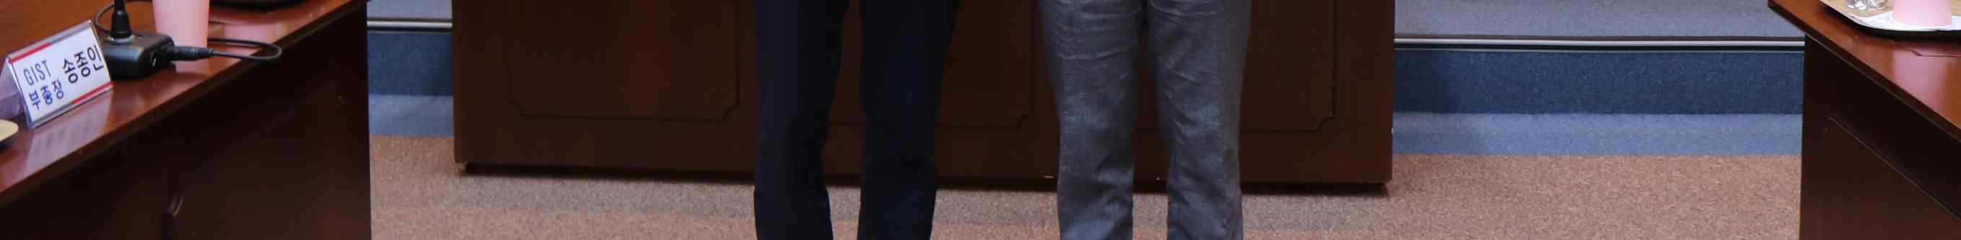
▲ [From left] GIST President Kiseon Kim and KISA Director Suk-hwan Kim

