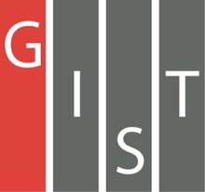
Gwangju Institute of Science and Technology

Official Press Release (https://www.gist.ac.kr/)

Section of Hyo Jung Kim Nayeong Lee
Public Affairs Section Chief Senior Administrator
(+82) 62-715-2061 (+82) 62-715-2062

Contact Person Yuna Roh, Administrator
for this Article Section of Undergraduate Administration Services
(+82) 62-715-3613

Release Date 2019.08.28

2019 G-SURF hosts poster session

□ GIST (President Kiseon Kim) College (Dean Yong-Ju Lee, Professor of Liberal Arts and Sciences) held the "2019 G-SURF * Poster Session" in the lobby of GIST's Oryong Hall on August 27, 2019.

* G-SURF: GIST Summer Undergraduate Research Fellowship that is benchmarked with Caltech's SURF program

∘ G-SURF, which has been held every summer since 2011, is a research program that was modeled after the Caltech Summer Undergraduate Research Fellowship, and it is very popular with students.

□ GIST College students who participate in G-SURF gain essential laboratory experiences by applying their scientific knowledge to real-world research in a GIST graduate laboratory while receiving mentorship during their summer vacation.

∘ This year, a total of 48 students carried out research projects with 33 graduate professors and had the opportunity to present their results through a poster presentation.

∘ G-SURF participant Jae-young Ahn, a junior EECS major who performed research in the School of Electrical Engineering and Computer Science Professor Jonghyun Choi's Computer Vision Lab, said, "It was a most rewarding and meaningful experience to write my research topic in the form of a journal paper, to make a poster, and to carry out the research from start to finish."

∘ G-SURF participant Dong-ho Kim, a senior materials science major who performed research in the School of Materials Science and Engineering Professor Sanghan Lee's Functional Nanostructures & Nanoelectronics Laboratory, said, "Although I was frustrated at first because the results of the experiment were not coming out well, it was a meaningful time for me to learn how to systematically design and proceed with the experiment systematically from seniors in the lab."

□ GIST College will select the best G-SURF reports submitted by the students to have them published in the Korean Journal of Undergraduate Research (KJUR), an English language journal.

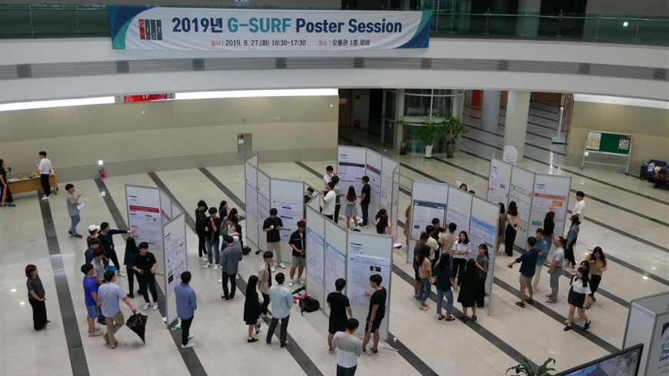
[Photo 1] 2019 G-SURF Poster Session at GIST Oryong Hall

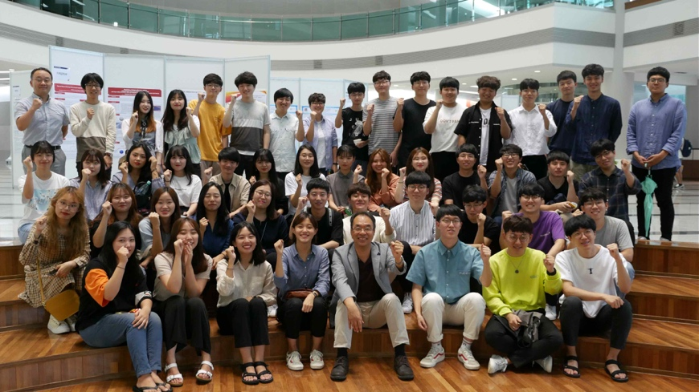
[Photo 2] 2019 G-SURF Poster Session Commemorative Group Photo

