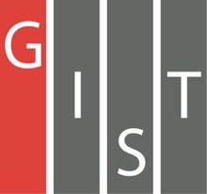

**Gwangju Institute of Science and Technology**

**Official Press Release (https://www.gist.ac.kr/)**

**Section of** Hyo Jung Kim Nayeong Lee

**Public Relations** Section Chief Senior Administrator

(+82) 62-715-2061 (+82) 62-715-2062

**Contact Person** Hyejin Lee / Lina Ryu

**for this Article** Section of Public Affairs

(+82) 62-715-2026/2023

**Release Date** 2020.05.14

**GIST Social Development Team donates scientific books and PCs to spread scientific culture**

□ GIST (Gwangju Institute of Science and Technology, President Kiseon Kim) Social Development Group (Director Sung-Gyoo Park, Dean of International and Public Affairs) recently donated scientific books and PCs to local children's centers in the learning yard to establish a support system for social contribution activities, strengthen mutual links, and promote non-face-to-face online education.

∘ The GIST Social Development Team has been donating scientific books to local child centers every year since 2003, and it has recently donated 14 PCs to 14 children's centers and donated science-related books worth six million won to to six local children's centers in Gwangju, including the Clear Nuri Station Children's Center.

□ In particular, the PC donation was made to encourage online learning as an alternative to fill the gap in learning by supporting 14 local children's centers in Gwangju with PCs, as the activities of GIST Learning Center were converted to offline programs in the aftermath of COVID-19.

∘ The GIST Learning Center is a knowledge-sharing volunteer activity in which GIST students visit local children's centers once a week to engage after-school teaching activities. In 2020, it has expanded to 44 locations, but recently, in the aftermath of COVID-19, face-to-face classes were discontinued and were switched to real-time online learning courses.

∘ In addition, GIST Learning Center mentors actively support online learning of local children's centers by producing video contents such as experimental science kit videos and science-related series about scientists.

□ Dean of International and Public Affairs Sung-Gyoo Park said, "Our goal is to raise the interest of science and technology of the children in our region by providing them with opportunities to explore science through books and media so that they will grow into global leaders who will be able to respond responsibly to future changes and developments related to science."

∘ The Director of the Pine Tree Children's Center said, "GIST's donation of PCs will be a great help for children who have difficulties in online learning using a PC due to the sudden change in the educational environment. I am grateful that students in Gwangju will have the opportunity to experience various aspects of science through this program."

□ The GIST Social Development Team is actively engaged in various projects to support the local community, including: GIST Science Outreach Program (GSOP), GIST Science School, science book donations, the Hope Water Purifier, Global Science Camp (international), Science Camp (domestic), GIST Science Outreach Program, ICT Volunteer program, and a program for children from remote Korean islands.

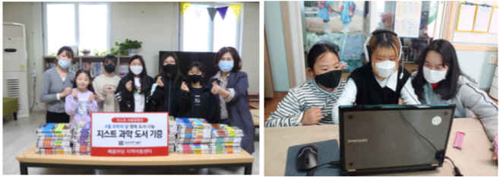

▲ (From left): Science book donation to the Bobae Children's Center and using a PC donated to the Pine Tree Children's Center