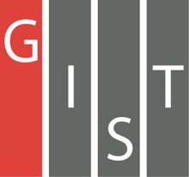

**Gwangju Institute of Science and Technology**

**Official Press Release (https://www.gist.ac.kr/)**

**Section of** Hyo Jung Kim Nayeong Lee

**Public Affairs** Section Chief Senior Administrator

(+82) 62-715-2061 (+82) 62-715-2062

**Contact Person** Section of Public Relations

**for this Article** (+82) 62-715-2061 ~ 2063

**Release Date** 2020.02.03

**GIST declares vision for Gwangju to be a center for artificial intelligence, creating new growth engines by nurturing AI convergence specialist**

□ Gwangju Institute of Science and Technology (GIST, President Kiseon Kim) plans to actively cooperate with Gwangju City to become a center of artificial intelligence by fostering AI convergence specialists and securing AI core technologies in connection with local industries.

∘ GIST declared its "Gwangju Vision, a Center for Artificial Intelligence" at the Kimdaejung Convention Center on January 29, and GIST is committed to training talented people who will lead the AI cluster while securing AI core technologies and innovation for regional economic development.

□ To this end in the era of the 4th Industrial Revolution, GIST has begun efforts to secure world-class AI research capabilities with national competitiveness in human resource development and AI fields, led by the AI Research Institute and AI Graduate School.

∘ There are five domestic AI graduate schools supported by the Ministry of Science and ICT, including GIST, which will open in March of this year. This will provide exceptional benefits to current students by operating global internships to prominent universities and industry research institutes such as those in the U.S. and Germany, providing full scholarships, and building the best research facilities in Korea.

∘ In addition, GIST has secured eight full-time and 23 joint-duty faculty members who are global AI experts to strengthen the education and research of 'AI+X' (artificial intelligence convergence). GIST organized a full-cycle curriculum to conduct industry-oriented research starting with the basics of AI and will select 50 to 60 students every year. 22 new students for the combined master's and doctorate programs have already been selected for the first semester and are taking a winter camp.

□ The GIST AI Research Institute is responsible for planning and managing the regional 'AI-oriented industrial convergence complex,' which is a regional commitment by the nation. With the vision of creating AI technologies that enrich people and businesses, it will work on developing basic AI research and industrial convergence technologies.

∘ In particular, the AI Research Institute plans to create a new growth engine by focusing on consumer-centered AI core technologies and start-ups by developing AI specialists and industry-academia cooperation necessary for energy, automobile, healthcare, cultural contents, etc. in connection with the local industries.

□ GIST President Kiseon Kim said, "GIST will actively cooperate in establishing a successful artificial intelligence ecosystem in Gwangju. GIST will strive to train convergence specialists necessary to secure world-class core AI technologies and will build an industry-academia-research ecosystem for innovative growth with local industries."

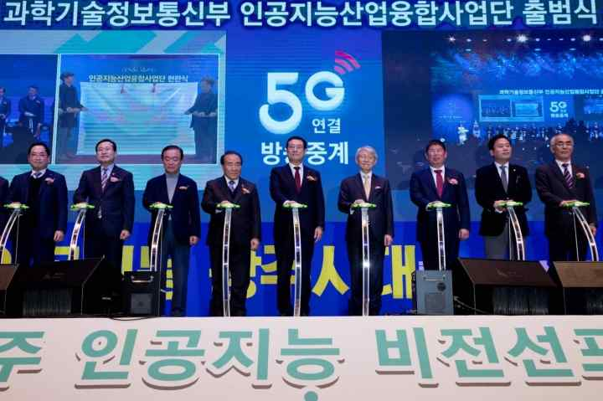

▲ 2020 proclamation ceremony for Gwangju to be a center for artificial intelligence