

**Gwangju Institute of Science and Technology**

**Official Press Release (https://www.gist.ac.kr/)**

**Section of** Hyo Jung Kim Nayeong Lee

**Public Affairs** Section Chief Senior Administrator

(+82) 62-715-2061 (+82) 62-715-2062

**Contact Person** Hyun-jin Kim, Administrator

**for this Article** Section of Undergraduate Admissions

(+82) 62-715-2956

**Release Date** 2019.12.10

**GIST College hosts invitational event for**

**successful 2020 students and their parents**

□ GIST (President Kiseon Kim) College held an invitational event for successful 2020 student applicants and their parents at Oryong Hall on December 6, 2020.

∘ At the event, about 400 people including President Kiseon Kim, Vice President Jong-In Song, College Dean Yong-Ju Lee, Graduate School Dean Sungho Jeong, seven major professors, and GIST students along with successful applicants participated in the event and shared information about GIST's educational philosophy and programs.

□ Starting with welcoming remarks, President Kiseon Kim introduced the curriculum of seven major majors and three minor majors at GIST College and provided the participants with the current status of the courses and future prospects.

∘ In addition, Professor Chang Wook Ahn, the head of the SW Education Center, gave a presentation on 'Participation in Foreign Exchange Programs' and 'Student Start-up Programs,' which received a positive response from the participants.

□ In particular, successful applicants and their parents had a chance to learn about all of the majors in detail through meetings with the major professors, and they also had the opportunity to learn about the life and the educational environment at GIST through meetings with current students and President Kiseon Kim.

∘ The event concluded with a dinner for all of the participants after addressing questions and concerns from successful applicants and their parents about their choice of attending GIST as well as how to best plan their future college life.

□ President Kiseon Kim said, "Congratulations and welcome to GIST College as freshmen for the 2020 academic. With your own eyes witnessing this atmosphere, you can feel the excitement and anticipation of your future college life. I hope you will enjoy your studies and research at GIST and that you will grow up to be a leading scientist in the future."

∘ A parent who participated in the event said, "This invitational event was a very meaningful time for me to learn about GIST College's educational philosophy, major courses, and programs. I think it will be of great help in understanding my child's school life and hardships in the future."

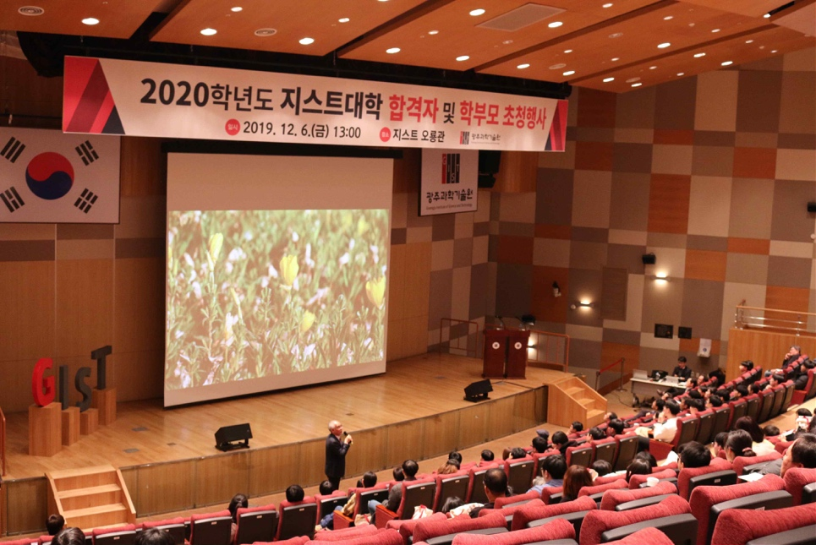

[Photo 1] President Kiseon Kim speaks at a ceremony

for successful 2020 students and their parents

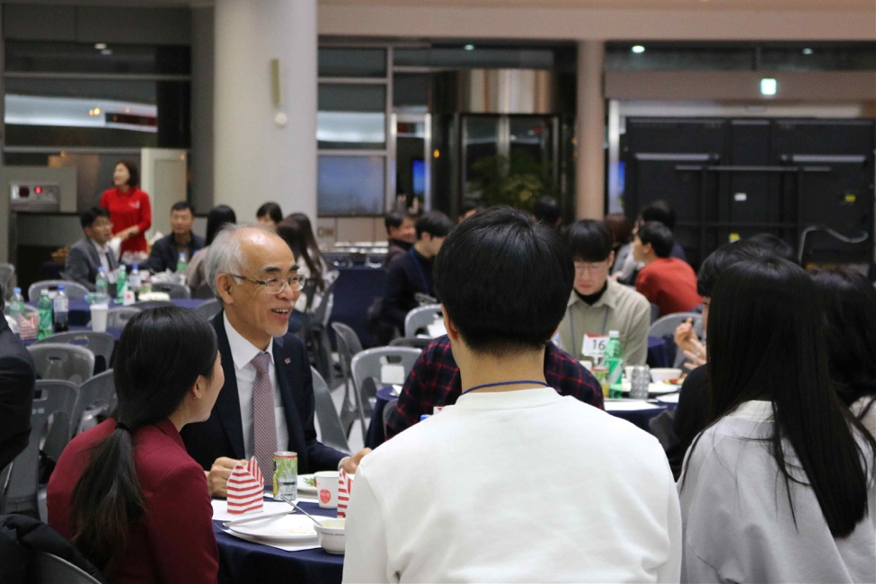

[Photo 2] President Kiseon Kim having dinner and exchanging

various information on school life with successful applicants