

**Gwangju Institute of Science and Technology**

**Official Press Release (https://www.gist.ac.kr/)**

**Section of** Hyo Jung Kim Nayeong Lee

**Public Affairs** Section Chief Senior Administrator

(+82) 62-715-2061 (+82) 62-715-2062

**Contact Person** In-ho Hwang, Administrator

**for this Article** Section of Planning

(+82) 62-715-2975

**Release Date** 2019.07.11

**GIST President and Vice President meets**

**with professors of the Faculty Council**

□ GIST (President Kiseon Kim) leadership held a meeting with professors of the Faculty Council on the fourth floor of the main administrative building on July 10, 2019.

∘ The joint meeting was presided over by President Kiseon Kim and Vice President Jong-In Song. Professor Chang-Duk Jun, chairman of the Faculty Council, and eight professors of the Faculty Council attended the meeting to present the following position of the Faculty Council members: ▲ determining the future role of the Faculty Council ▲ creating a center for professors ▲ improving human rights for students as well as better communication ▲ maintaining the system of specialized research personnel ▲ improving cooperation between manangement and the Faculty Council on research ethics.

□ President Kiseon Kim said, "My hope is to promote greater cooperation and involvement at GIST on major projects by actively communicating with various professors regardless of their rank or position."

□ Chairman of the Faculty Council Professor Chang-Duk Jun said, "I would like the management of our institution to enhance the self-esteem of our community members, and the Faculty Council will make every effort to promote research ethics and respect of students' human rights."

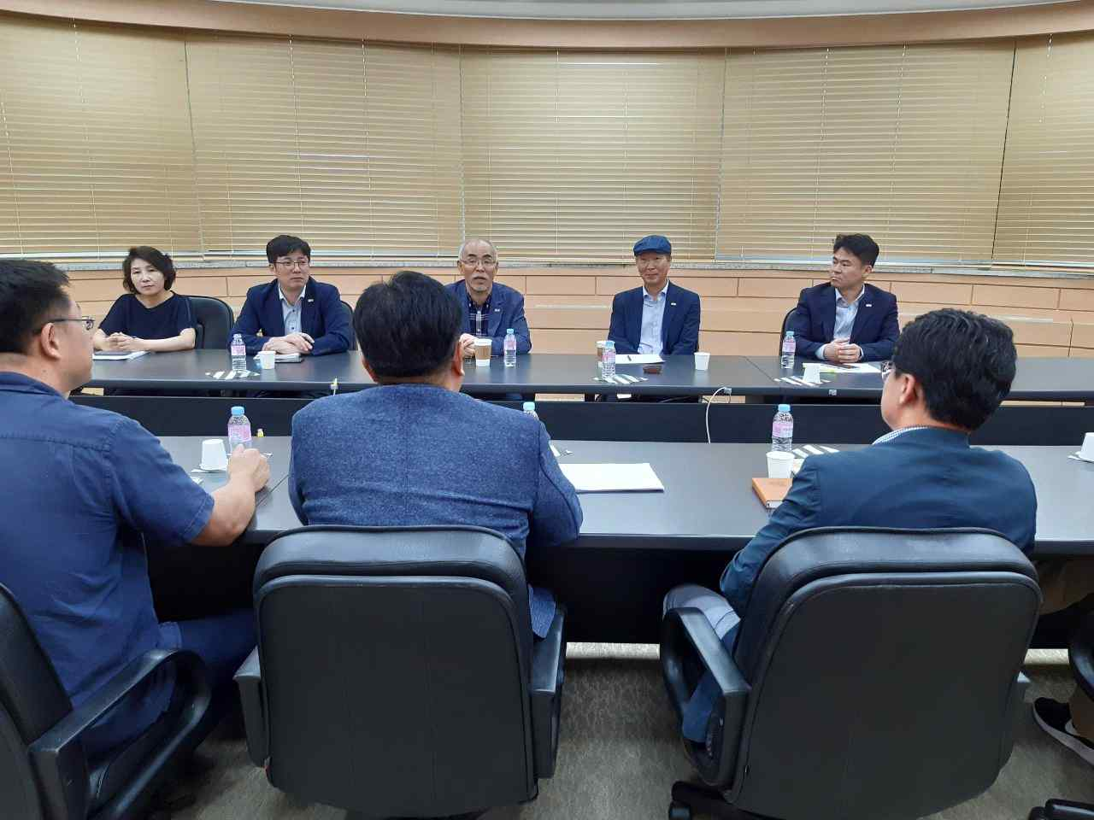

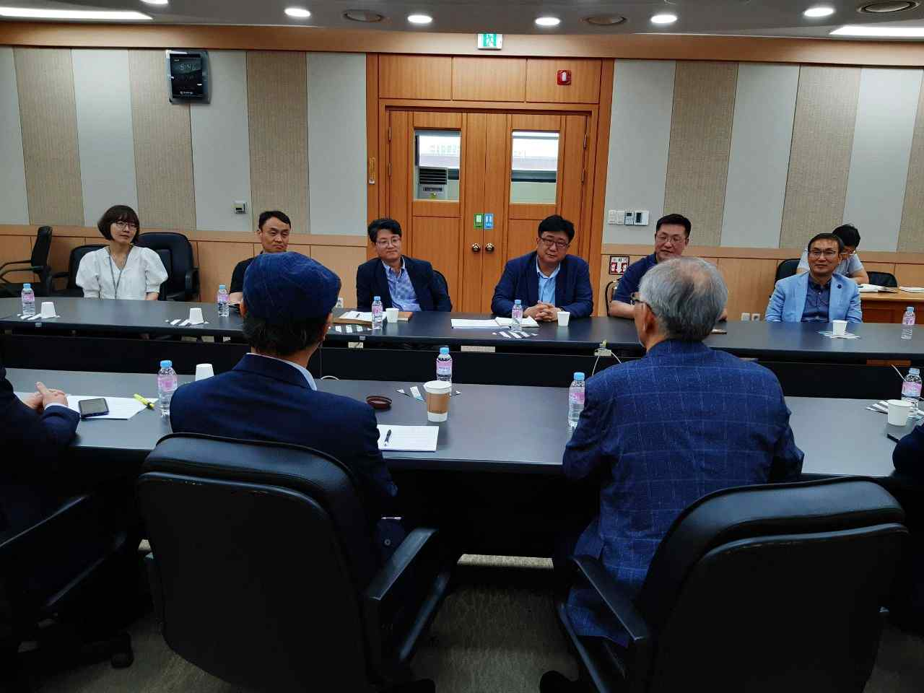

▲ GIST President and Vice President meets with professors of the Faculty Council