Gwangju Institute of Science and Technology

Official Press Release (https://www.gist.ac.kr/)

Section of Mi-Yeon Kim Nayeong Lee
Public Affairs Section Chief Senior Administrator
(+82) 62-715-2020 (+82) 62-715-2024

Contact Person Jin-sook Choi, Administrator
for this Article Section of Public Relations
(+82) 62-715-2026

Release Date 2019.02.28

GIST collaborates with Haeyang City Gas to conduct 'Learning Zone Reading Classes' at local
children's center

□ GIST (Acting President Hor-Gil Hur) – The Social Outreach Team collaborated with Haeyang City Gas (CEO Hyung-soon Kim) to conduct 'Learning Zone Reading Classes' for elementary school students enrolled in local children's center.

□ For the 'Learning Zone Reading Classes,' a Haeyang City Gas employee visits a reginal children's center once a month and: ▲ read science books with students ▲ divide reading roles ▲ choose and express characters ▲ make sentences with new words. The purpose of the program is to help improve students by reading books and sharing stories.

∘ Starting on February 27, 2019, the program plans to provide instructional guidance to 106 elementary school students in 12 regional children's centers annually.

□ Office of International and Public Affairs Dean Yong-Chul Kim said, "GIST's 'Learning Zone Reading Classes,' which will start this year with Haeyang City Gas, will contribute to the local spread of a culture of science. I hope that elementary school students at the nearby children's centers will be instilled with dreams of becoming future scientists."

□ GIST's Social Outreach Team began in 2017 and has the following programs: GIST Science School, science book donations, Hope water filter, overseas Global Science Camp, domestic Science Camp, GIST Science Outreach Program, ICT Corps, and hosting science programs for children from remote islands. Haeyang City Gas has donated 100 million won to the GIST Development Fund in 2017.

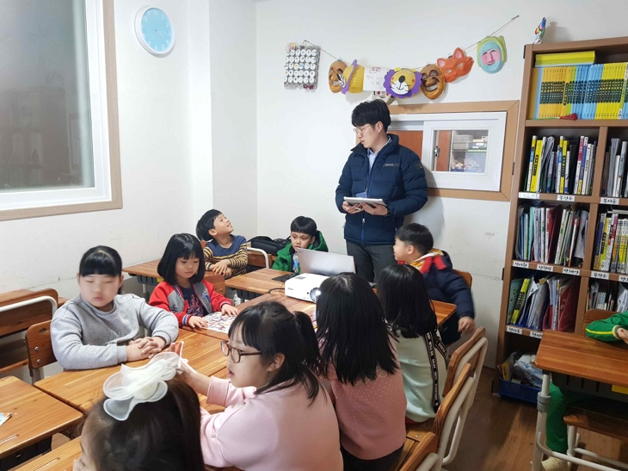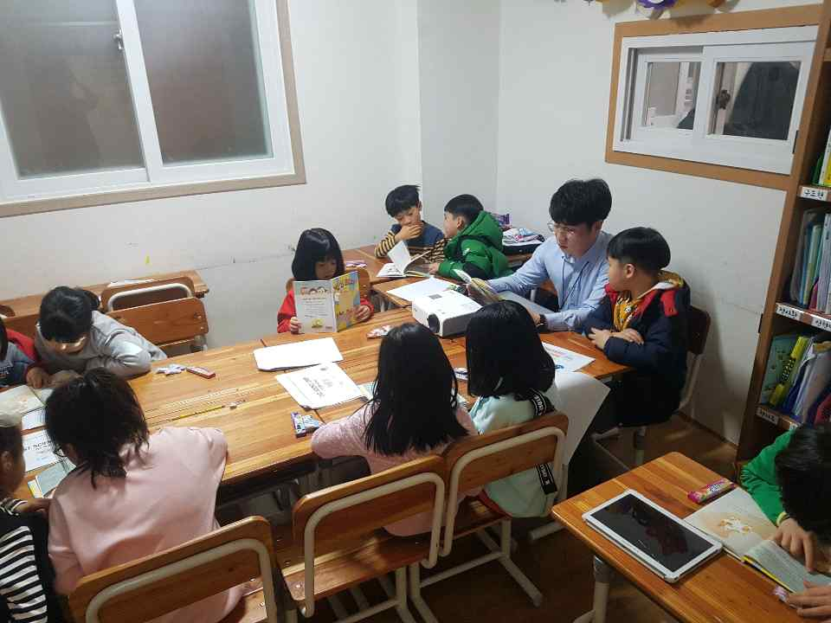
▲ Conducting 'Learning Zone Reading Classes' at a local children's center

