

**Gwangju Institute of Science and Technology**

**Official Press Release (https://www.gist.ac.kr/)**

**Section of** Mi-Yeon Kim Nayeong Lee

**Public Affairs** Section Chief Senior Administrator

(+82) 62-715-2020 (+82) 62-715-2024

**Contact Person** Hye-jin Lee, Administrator

**for this Article** Section of Public Affairs

(+82) 62-715-2022

**Release Date** 2018.07.19

**Soo Yong ING President Min-sun Hwang donates**

**10 million won to the GIST Development Fund**

□ GIST (President Seung Hyeon Moon) – Soo Yong ING President Min-sun Hwang has donated 10 million won to the GIST Development Fund.

∘ Soo Yong ING was founded in 2010 as a manufacturer of structural metal plates and metal workpieces, and it has been growing steadily since it was selected as a promising medium/small sized company by Gwangju Metropolitan City in 2012.

∘ Soo Yong ING President Min-sun Hwang has completed the third GIST Climate Change Academy course, which he started earlier this year in March.

□ The donation ceremony was held at Oryong Hall on July 18, 2018, during the graduation ceremony for the 3rd Climate Change Academy, which was attended by more than 60 people.

□ President Min-sun Hwang said, "In commemoration of the graduation ceremony for the Climate Change Academy, I am making this donation to support the good cause of the GIST Hope Water Purifier Project. I will closely watch with great interest the continued growth of GIST as one of Korea's leading research institute in science and technology."

□ The donation will be used as a social contribution for the GIST Development Fund, which also supports the GIST Hope Water Purifier Project, which hopes to create a better world through science and technology.

□ The GIST Climate Change Academy held the "3rd GIST Climate Change Academy Graduation Ceremony" on July 18, 2018, and 34 students graduated after completing 13 weeks of courses.

∘ The graduation ceremony was attended by 60 people including GIST Vice President Hor-Gil Hur, GIST Climate Change Academy Director In Seop Chan, and Dean of International and Public Affairs Yong Chul Kim.

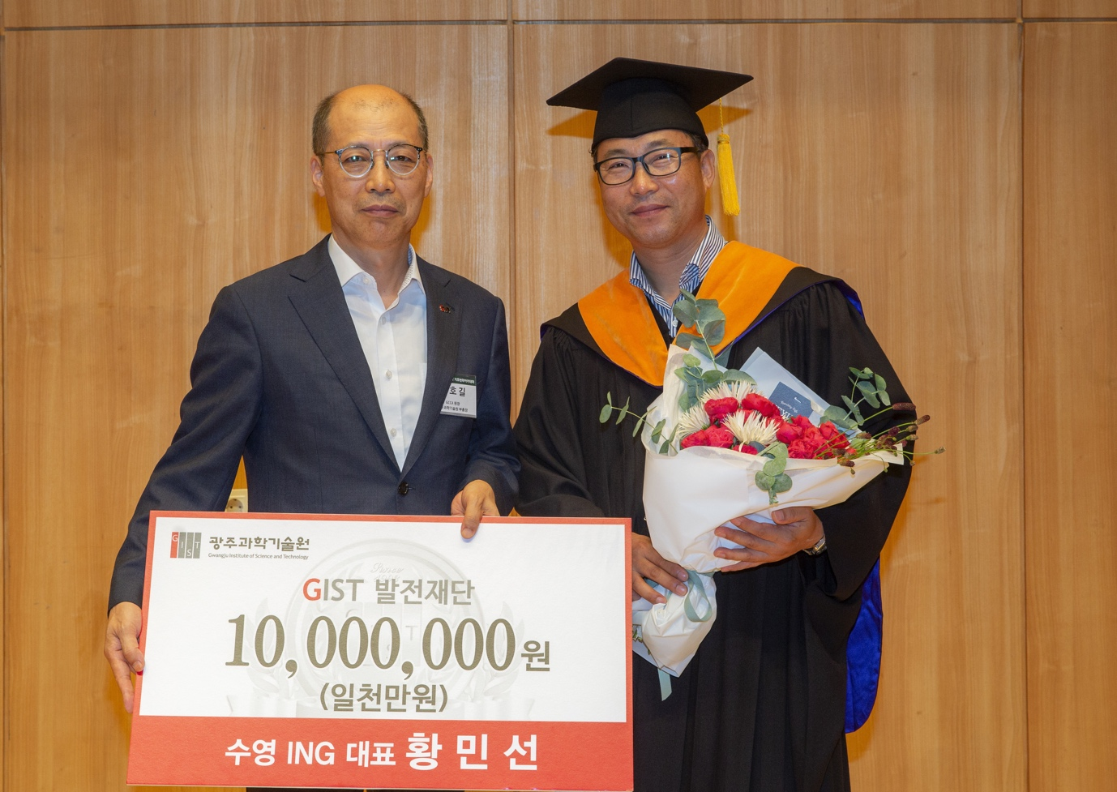

▲ (from left) GIST Vice President Hor-Gil Hur receives a donation

of 10 million won from Soo Yong ING President Min-sun Hwang