

**Gwangju Institute of Science and Technology**

**Official Press Release (https://www.gist.ac.kr/)**

**Section of** Hyo Jung Kim Nayeong Lee

**Public Relations** Section Chief Senior Administrator

(+82) 62-715-2061 (+82) 62-715-2062

**Contact Person** You Seung Su

**for this Article** Section of Public Affairs

062-715-2021

**Release Date** 2020.11.13

**Dongyang Metal Co., Ltd., CEO Jeong-soon Park donated 10 million won to the GTMBA**

**development fund**

□ GIST (Gwangju Institute of Science and Technology, President Kiseon Kim) Techno Management Business Academy held the 10th opening ceremony at Oryong Hall and received a donation of 10 million won Dongyang Metal Co., Ltd., CEO Jeong-soon Park for the development fund.

∘ CEO Jeong-soon Park, the 9th GTMBA alumni president, is a professional engineer who has led the mold industry in the home appliance field and has been devoted to mold technology for more than 30 years, including powder metallurgy products and aluminum molds. In 2012, he was selected as a skilled Korean by the Ministry of Employment and Labor and the Human Resources Development Service of Korea.

□ CEO Jeong-soon Park said, "Looking closely at GIST's brilliant development and growth, I decided to donate in the hope that GIST will share its success with a wider world. I hope that GIST will establish itself as a world-renowned educational institution."

∘ Vice President for Public Affairs Young-jip Kim said, "I would like to sincerely thank the members and executives of GTMBA who safely conducted the training program under the difficult situation of COvid-19, and I would like to express my gratitude to CEO Jeong-soon Park for making a valuable contribution that can be used to create a warm and clean world through science and technology."

□ The GIST Techno Management Business Academy was established as a top technology management course in 2011 to serve the business community through a systematic education program and has since produced a total of 350 graduates as of its 9th term last year. The program is currently conducting its 10th program this year. The donations will be used for the development of the GIST Techno Management Business Academy.

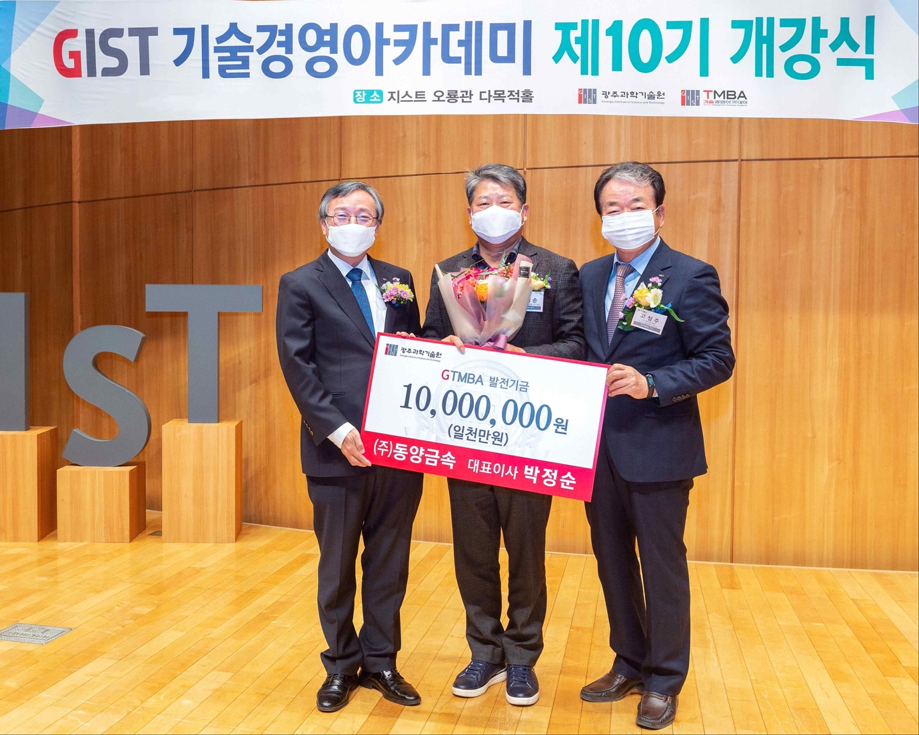

▲ From left: GIST Vice President of Public Affairs Young-jip Kim, Dongyang Metal Co., Ltd., CEO Jeong-soon Park, and GIST Development Foundation Chairman Jung-joo Ko