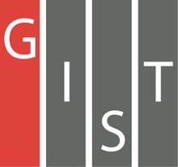

**Gwangju Institute of Science and Technology**

**Official Press Release (https://www.gist.ac.kr/)**

**Section of** Mi-Yeon Kim Nayeong Lee

**Public Affairs** Section Chief Senior Administrator

(+82) 62-715-2020 (+82) 62-715-2024

**Contact Person** Jin-sook Choi, Administrator

**for this Article** Section of Public Affairs

(+82) 62-715-2026

**Release Date** 2018.11.20

**[25th Anniversary Celebration]**

**2018 GIST Learning Zone exchange event**

□ GIST (President Seung Hyeon Moon) held a "GIST Learning Zone" exchange event on November 15th, 2018, at Oryong Hall with about 200 people attending, including the teachers of the Learning Zone (GIST students), the heads of local children's centers, welfare workers, and center students.

∘ The GIST Learning Zone is a knowledge-sharing volunteer activity in which GIST students visit local children's centers once a week to teach after-school activities. Starting in 2010 with 9 centers, it has since expanded to 35 centers. The Learning Zone exchange event is held every year with the aim of providing an opportunity for the GIST student volunteers to interact with the children from the local centers.

□ At this event, 26 local children's centers attended the exchange and viewed the GIST research achievement exhibition on the first floor or Oryong Hall. In addition, 29 awards were given out, and GIST College Progessor Hisam Kim gave a lecture on "Learning and Dreaming," which was well-received by the children.

□ GIST Vice President Hor-Gil Hur said, "The GIST Learning Zone is representative of GIST's social contribution activities by fulfilling our social responsibilities to the local community. GIST established the social contribution group last year and strengthened mutual ties with the local community. This is in line with the educational philosophy of GIST to nurture talented people with creative thinking, sharing, and caring."

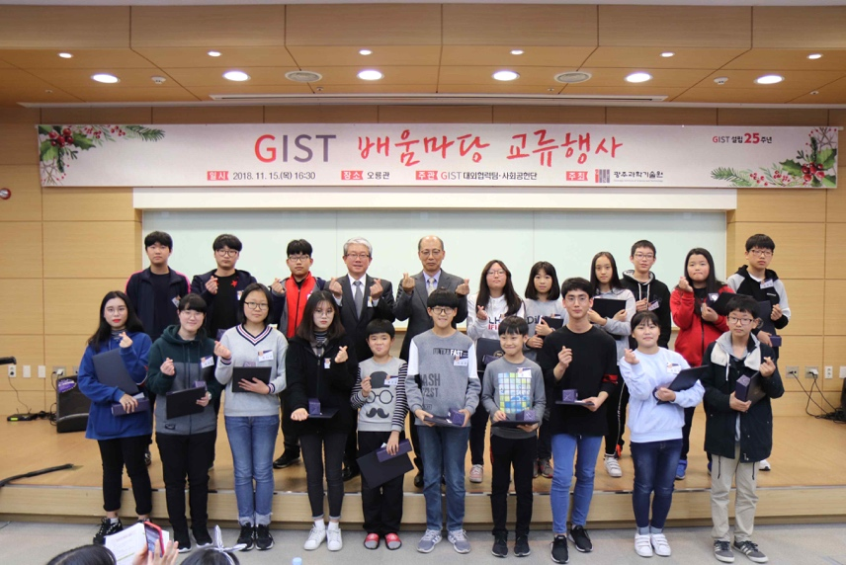

▲ GIST Learning Zone Exchange Event Award Ceremony

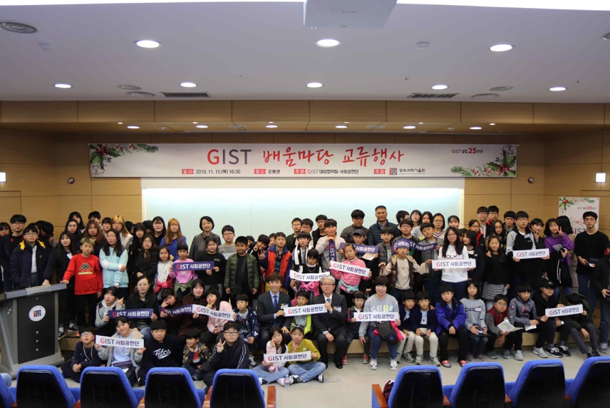

▲ GIST Learning Zone Exchange Event Group Photo