

**Gwangju Institute of Science and Technology**

**Official Press Release (https://www.gist.ac.kr/)**

**Section of** Mi-Yeon Kim Nayeong Lee

**Public Affairs** Section Chief Senior Administrator

(+82) 62-715-2020 (+82) 62-715-2024

**Contact Person** Youn-joo Oh, Administrator

**for this Article** Center for Human Rights

(+82) 62-715-6802

**Release Date** 2019.02.13

**GIST's Center for Human Rights**

**holds opening ceremony**

□ GIST (President Seung Hyeon Moon) – The Center for Human Rights held an opening ceremony on February 12, 2019, with a speech by Director Gunwoo Kim who is also a professor in the Division of Liberal Arts and Sciences.

∘ As problems such as sexual harassment, sexual violence, and labor exploitation have emerged as social issues at universities, it has become necessary to establish a human rights center to protect the human rights of university members.

□ GIST's Center for Human Rights was established in June of last year to create an academic, research, and work environment on campus that respects the human rights of all members, including students and faculty.

∘ Main tasks of the Center for Human Rights includes: △ counseling and investigating cases of sexual harassment, sexual violence, and human rights violation △ preventing human rights violation and secondary damage △ education and promoting human rights awareness △ conducting semi-annual surveys to identify the current human rights situation on campus.

□ President Seung Hyeon Moon said, "GIST's Center for Human Rights is an important department. I hope that the center will work diligently to make special programs and systems to create a human rights-friendly atmosphere so that all of our members can concentrate on their studies, research, and work."

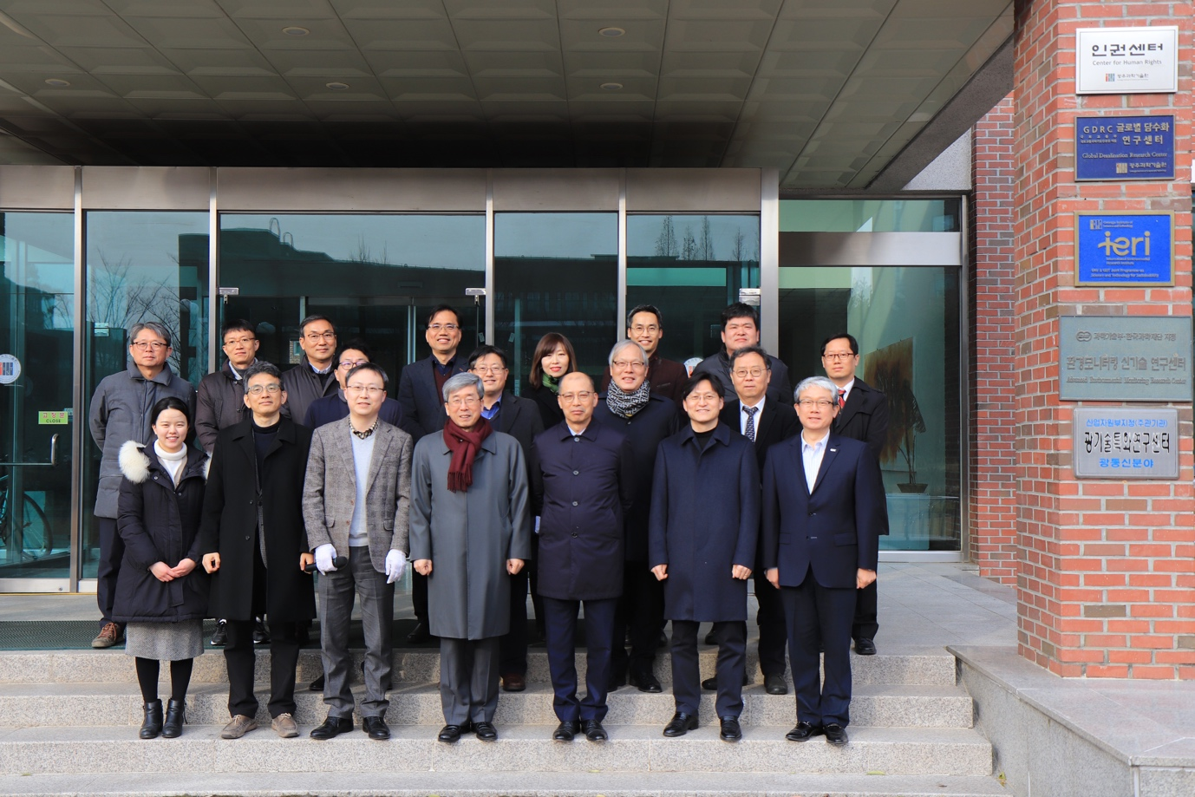

▲ Photo of the people attending the opening ceremony for the Center for Human Rights,

including President Seung Hyeon Moon who is pictured in front