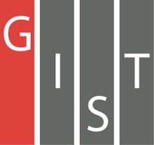

**Gwangju Institute of Science and Technology**

**Official Press Release (https://www.gist.ac.kr/)**

**Section of** Mi-Yeon Kim Nayeong Lee

**Public Affairs** Section Chief Senior Administrator

(+82) 62-715-2020 (+82) 62-715-2024

**Contact Person** Dr. Eui-kwon Kim

**for this Article** GIST Research Institute

(+82) 62-715-2935

**Release Date** 2018.07.12

**GIST and KTL (Korea Testing Laboratory) sign**

**an MoU to cooperate on AI industrial development!**

□ GIST (Seung Hyeon Moon) – Korea Testing Laboratory (KTL, Director Dong-hee Jeong), the only public testing institute in Korea, signed an agreement with GIST on July 11, 2018, for joint research and development and mutual cooperation on artificial intelligence.

∘ Based on the excellent technical capabilities of the two organizations, this agreement will help to enhance the competitiveness of the national industry in the world of artificial intelligence: ▲ "A project to develop an artificial intelligence campus" with collaborative planning, consultations, and analysis ▲ Commercialization of R&D from the joint collaboration ▲ Testing and evaluation of artificial intelligence products.

□ "Project for the Development of Artificial Intelligence Business Ventures" is one the government's 100 largest national government projects intended to attract private investment in establishing an artificial intelligence research center (center), developing human resources based on artificial intelligence, and establishing a business ecosystem.

∘ This is a national business plan to nurture start-up businesses, to cultivate talented artificial intelligence research and development, to promote artificial intelligence integration, and to enter global markets.

□ In particular, the 'Gwangju Consortium' consisting of GIST, the Gwangju Information and Culture Industry Promotion Agency (GITCT), and Technovation was selected to negotiate for the research service of the project on June 27, 2018, which will accelerate the promotion of the artificial intelligence business.

∘ The 'Gwangju Consortium' will carry out joint research projects from July to November of this year, incorporating the opinions of experts from domestic and overseas artificial intelligence fields, and will submit a preliminary feasibility study in the first quarter of 2019.

□ GIST President Seung Hyeon Moon said, "GIST and KTL will play an important role in preemptively responding to the development of AI research and development, a core technology in the era of the 4th Industrial Revolution, and the creation of a specialized business field. We hope that both institutes will be able to create good research results through combined synergy."

□ KTl Director Dong-hee Jeong said, "We will actively cooperate with GIST so that in the future we will support the testing and certification of AI-based R&D achievements for the 'Project for the Development of Artificial Intelligence Business Ventures' so that start-up companies can enter markets overseas and develop into the best artificial intelligence hubs."

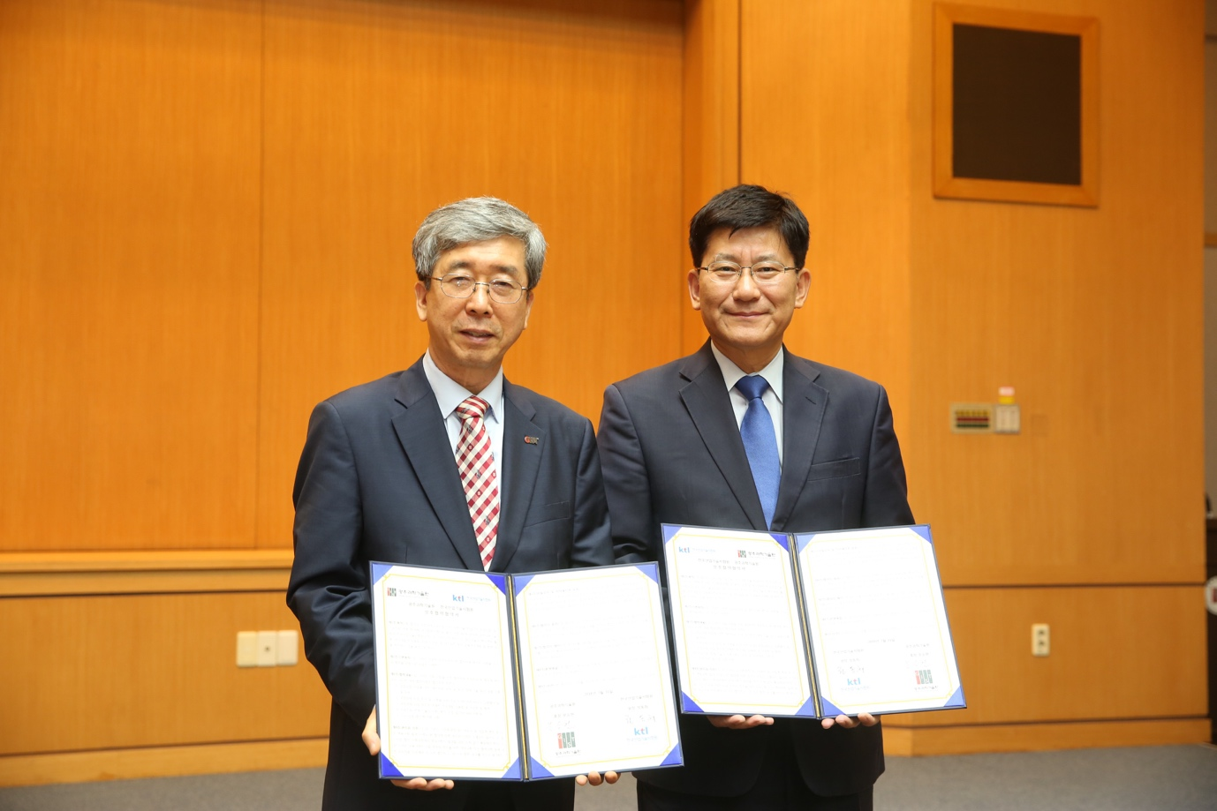

Picture 1: President Seung Hyeon Moon (left) with KTL Director Dong-hee Jeong

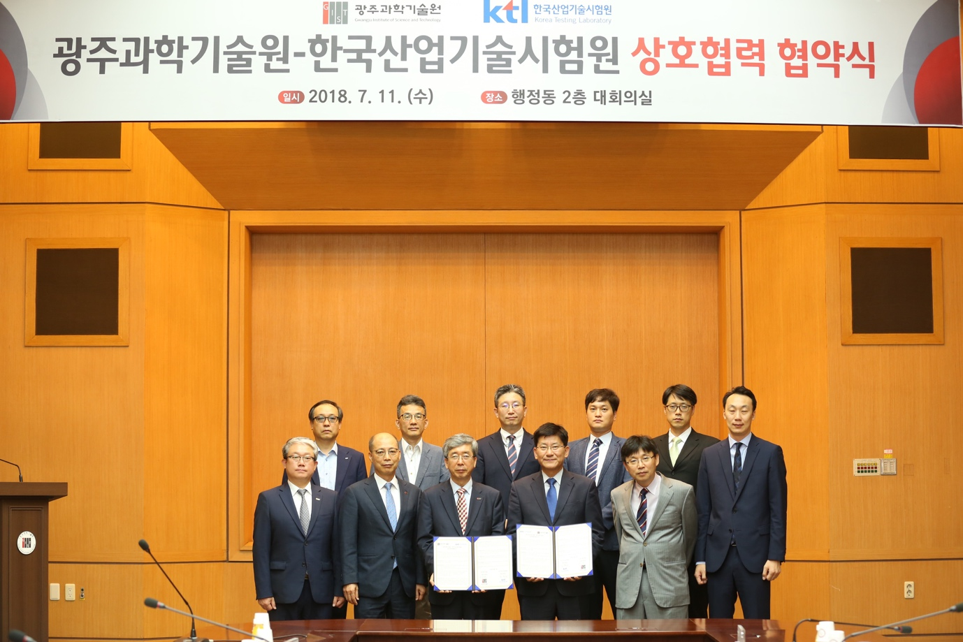

Picture 2: President Moon (third person first row) with KTL Director

Dong-hee Jeong after signing the agreement on July 11, 2018, at GIST.