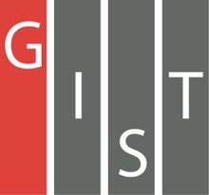

**Gwangju Institute of Science and Technology**

**Official Press Release (https://www.gist.ac.kr/)**

**Section of** Hyo Jung Kim Nayeong Lee

**Public Relations** Section Chief Senior Administrator

(+82) 62-715-2061 (+82) 62-715-2062

**Contact Person** Da-som Cho, Administrator

**for this Article** Integrated Institute of Biomedical Research

062-715-2531

**Release Date** 2020.10.14

**GIST Integrated Institute of Biomedical Research hosts an unveiling ceremony for a new signboard**

□ GIST (Gwangju Institute of Science and Technology, President Kiseon Kim) Integrated Institute of Biomedical Research (Director Chul-Seung Park) hosted an unveiling ceremony for a new signboard on the afternoon of October 13, 2020.

∘ The event began with the Integrated Institute of Biomedical Research Director Chul-Seung Park (School of Life Sciences Professor) providing a progress report that was followed by commemorative remarks and the unveiling of the new signboard by the Vice President for R&D In S. Kim. Members of the Integrated Institute of Biomedical Research and project managers attended the ceremony, including Director of Biomedical Engineering Raekil Park, School of Life Sciences Dean Zee-Yong Park, Professor Jang-Soo Chun, Professor Chang-Duk Jun, and Professor Inchan Kwon.

□ Previously known as the Aging Research Institute, the name was changed to the Integrated Institute of Biomedical Research to better reflect the extensive nature of its research, which includes life science, medical science and medical engineering, a new operation starting in 2020 (discovery of AI-based anticancer metabolic function targets, convergence research on overcoming biohazard factors), and the creation of the Antiviral Research Center.

∘ Life sciences and medical sciences studies diseases that continuously threaten the health and longevity of humankind, such as cancer and dementia, as well as newly emerging deadly infectious diseases such as the novel coronavirus. Through organic joint research in biomedical engineering, the Integrated Institute of Biomedical Research will research the etiology of diseases and develop treatments.

□ The Integrated Institute of Biomedical Research is conducting multidisciplinary research for each project to understand the nature of life phenomena and promote human welfare, prevent and diagnose diseases, and develop original technologies to overcome and improve the quality of life.

∘ Joint research tasks currently being conducted include: ▲ development of bio-aging control technology, ▲ convergence projects to overcome harmful factors in life (development of bio-convergence technology to overcome alcohol addiction and its harmfulness, multi-omix analysis of harmful bio-hazardous factors, and development of mitigation technologies), and ▲ an AI-based anticancer metabolic function target discovery project (AI-based cancer cell-specific metabolic mechanism target discovery, cancer cell-specific energy generation metabolic pathway target verification), which has a total of 30 GIST researchers participating in the project.

□ Vice President for R&D In S. Kim said, "I hope that GIST will be able to increase the competitiveness of schools by enhancing the research capabilities of the Integrated Institute of Biomedical Research so that it can become a hub for creative and innovative convergence research that will surpass the world's leading research universities."

□ The Integrated Institute of Biomedical Research has proposed future development plans for GIST with key concepts such as artificial intelligence, anti-cancer, anti-viral, infection, fine dust, and immunotherapy and has and organized research groups within the institution to carry out innovative convergence research.

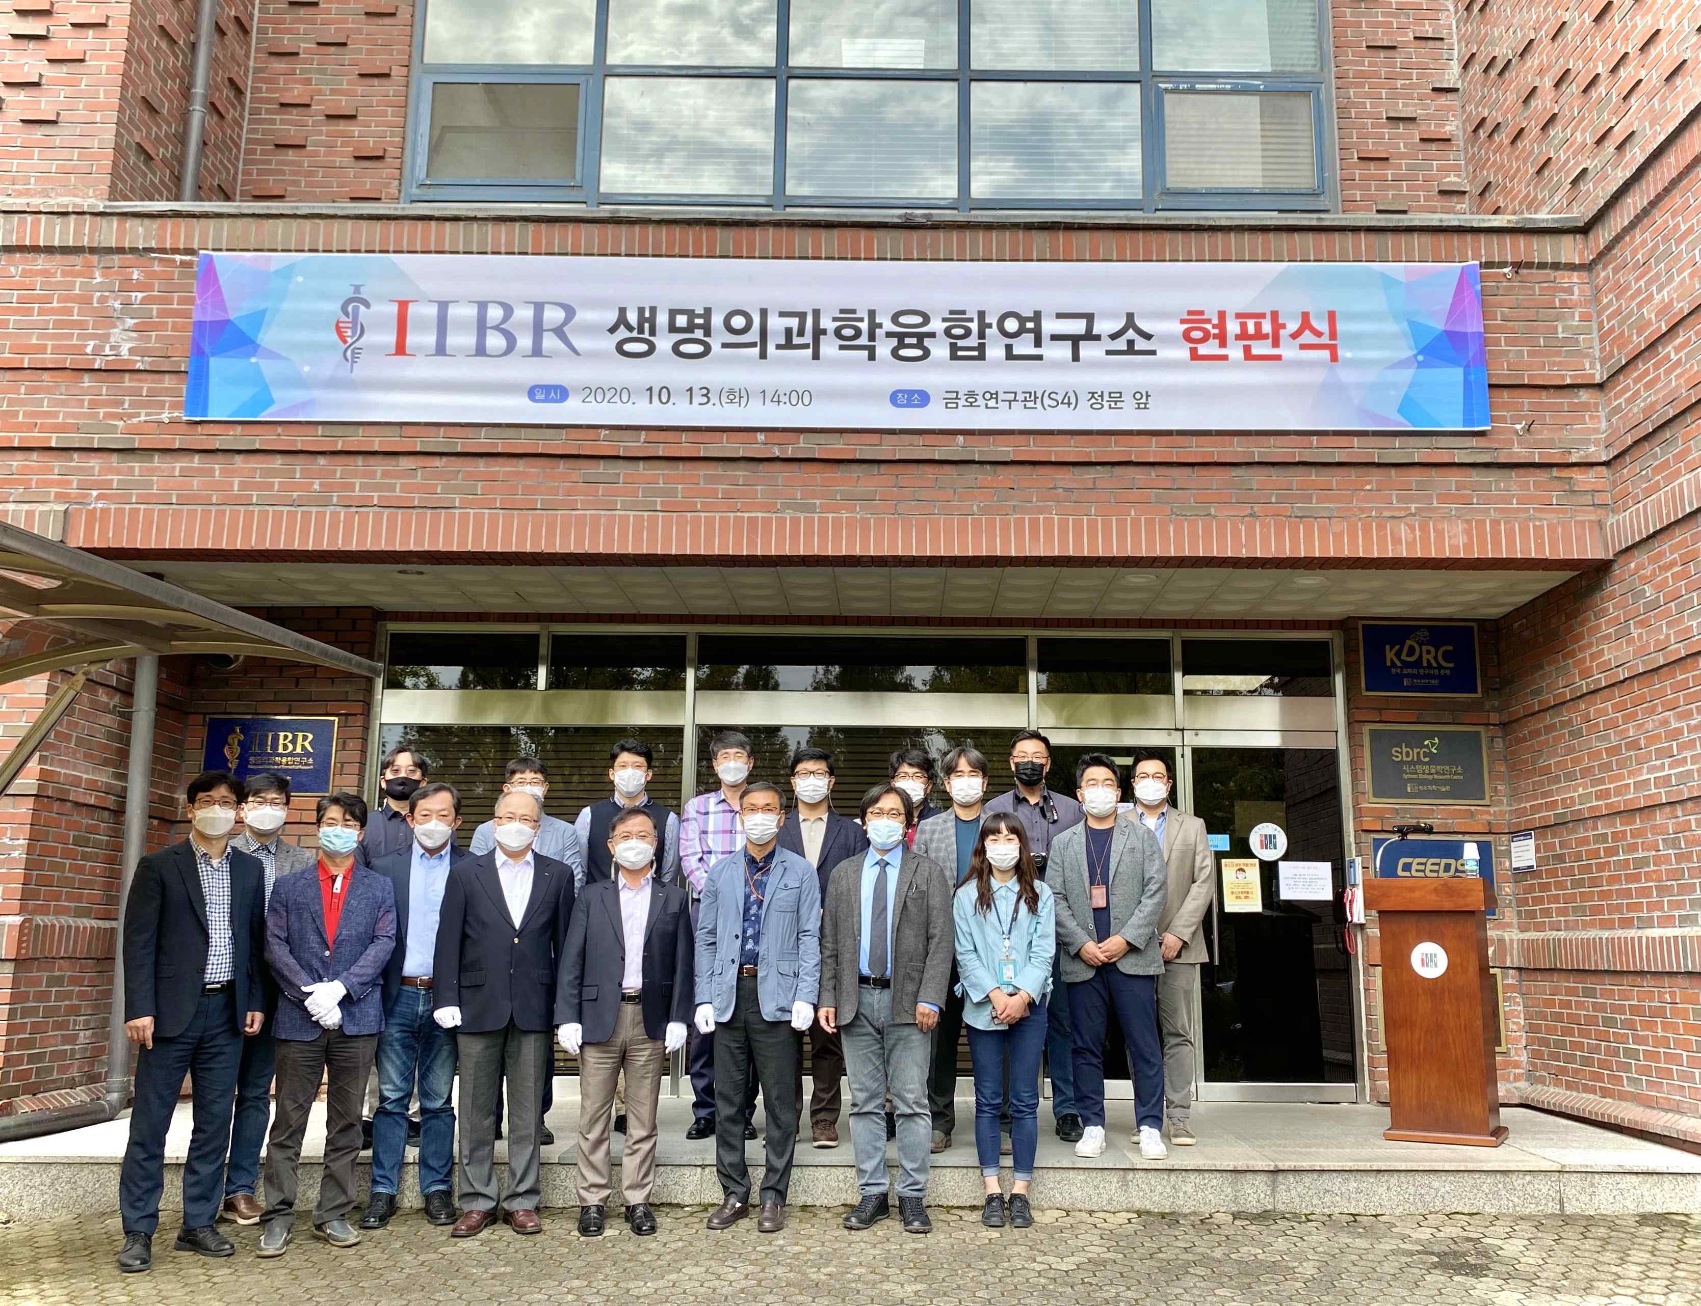

▲ Integrated Institute of Biomedical Research unveiling ceremony group photo