**“Share the Joy of Science with Island Friends”**

**GIST Social Contribution Group Holds Visiting Science Camp**

**-Pium, GIST’s social contribution group, visits Bigeum Middle School in Shinan-gun to provide science classes and career mentoring.**

**- Held every year… Taking the lead in bridging regional education and career gaps through talent donation.**

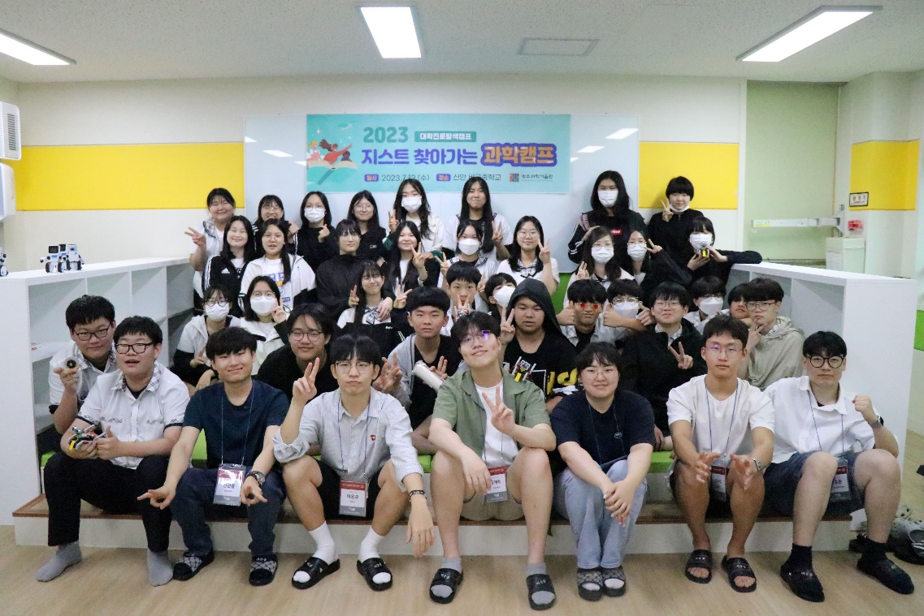

▲ GIST’s social contribution group Pium visiting Bigeum Middle School in Sinan-gun and holding its Visiting Science Camp there takes commemorative photos with students.

GIST’s (Gwangju Institute of Science and Technology, President Lim Kichul) social contribution group, Pium, visited Bigeum Middle School on Bigeum Island in Shinan-gun, Jeollanam-do, for two days on July 12-13 and held the GIST Visiting Science Camp, a social contribution activity to share knowledge.

Pium, a social contribution group composed of GIST students, has been organized to contribute to narrowing the educational gap by providing various science classes and experience programs to teenagers in underprivileged areas in an easy and interesting way.

GIST’s Visiting Science Camp, which is in its third year this year, is one of Pium's representative social contribution programs. The program provides interesting and diverse science classes, experience programs, and career mentoring through direct visits to middle schools in underprivileged areas such as islands and remote areas in Gwangju and Jeonnam.

This year's Visiting Science Camp was held for two days and one night for the entire 34 third-year students of Bigeum Middle School in Sinan-gun. In this camp, the following classes in interesting fields were conducted: (a) understanding automobile brakes (mechanical engineering), (b) blood type determination and appropriate technology╶ centrifugal separation (life science/appropriate technology), (c) making eco-friendly ooho water bottles (earth/environment), and (e) understanding self-driving vehicles (AI/machinery).

In particular, the mentor group of GIST students who participated in the camp drew attention and response from the students of Bigeum Middle School by preparing classes on topics covering the core fields of the future high-tech industry with obstacle avoiding self-driving car kits and car brake making kits.

GIST Department of Mechanical Engineering Professor Ji Sol-geun also visited Bigeum Middle School and gave a special lecture and career mentoring on the topic of “Fluid Mechanics, Airplanes, and Bigeum Island.”

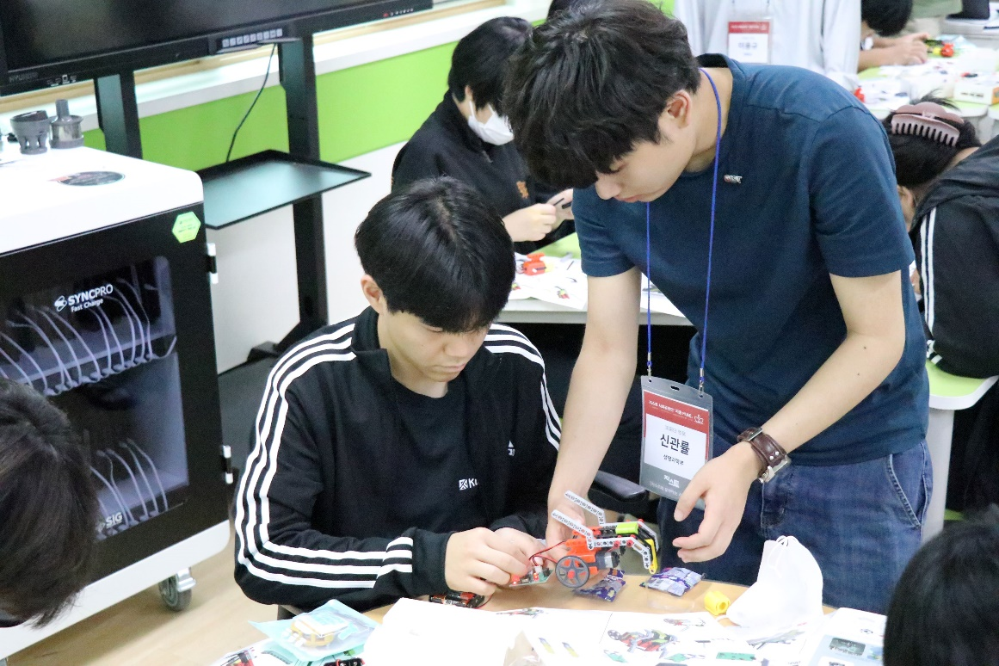

▲ Bigeum Middle School students making an obstacle-avoiding self-driving car at the Visiting Science Camp hosted by GIST’s social contribution group Pium.“

A student from Bigeum Middle School who participated in the science camp said, “At first, I was not interested in science because I thought it was boring, but I think I was able to approach science more enjoyably through this science camp,“ and added, “I think I would be interested in studying science in the future.”

Meanwhile, in addition to the Visiting Science Camp, which is being held three times* this year, the social contribution group Pium also actively carries out knowledge-sharing volunteer work through (a) online mentoring (online learning/career mentoring) (b) AI youth camp (in-person experiential AI education program), and (c) Science Camp with GIST (Science Camp held on the GIST Campus).

* Bigeum Middle School in Sinan-gun, Jeonnam; Anyang Middle School in Jangheung-gun, Jeonnam; Hadang Middle School in Mokpo, Jeonnam.

Thanks to these various knowledge-sharing program activities of Pium, GIST has been selected as a participating organization for the University Career Exploration Camp Project, administered by the Ministry of Education and the Korea Science and Creativity Foundation for three consecutive years since 2021.

President Lim Kichul stated, "Through GIST's social contribution project, we intend to bridge the educational gap in the local community and lay the foundation for fostering future scientific talent." He added, “Celebrating the 30th anniversary of our foundation this year, we will further expand our social contribution activities and strive to provide better educational opportunities to future science students in underprivileged areas.”