

**Gwangju Institute of Science and Technology**

**Official Press Release (https://www.gist.ac.kr/)**

**Section of** Hyo Jung Kim Nayeong Lee

**Public Relations** Section Chief Senior Administrator

(+82) 62-715-2061 (+82) 62-715-2062

**Contact Person** Kyung-min Lee, Administrator

**for this Article** Energy Valley Institute

062-715-6971

**Release Date** 2020.09.02

**GIST wins grand prize at competition to**

**develop new services using power data**

□ GIST (Gwangju Institute of Science and Technology, President Kiseon Kim) students won the first prize and excellence award in a new service development contest using electric power data.

∘ The 「2020 Power Data Utilization New Service Development Contest」 was hosted by the Ministry of Trade, Industry and Energy and jointly organized by GIST, KEPCO, and the Korea Electric Power Group. It was held at the KEPCO Art Center in Seocho-dong, Seoul on March 20, 2020, to discover a new business model that utilizes big data from electrical consumption.

□ The competition was divided into business and individual (student) categories, and teams and individuals who passed the first document screening developed services using the provided power data. If data cannot be exported out of the country, it was developed by the data sharing center established at the KEPCO Art Center.

∘ To prevent the spread of COVID-19, the results of the screening were announced online on August 26. In the student and public categories, 10 of the 15 teams selected were selected as winners.

□ Several teams from GIST participated in the student section and included: △ EBS Lab "Scheduling Smart Home Appliances for Energy Prosumers" (School of Electrical Engineering and Computer Science: team leader Ji-hoon Lee, Myung-sun Kim, Hye-bin Kim, and So-young Park) won the Grand Prize (President of the Korea Power Exchange) △ Young People "Green DR Notification and Reservation Service by Predicting Timing of Excessive Wind Power Supply" (School of Electrical Engineering and Computer Science: team leader Hyun-il Lee, Moo-gap Kim, and Sang-hyu Yoon) △ ESP "Artificial Intelligence-based P2P Power Transaction Matching Service" (School of Mechanical Engineering: team leader Joon-ho Song, Ji-seok Yoon, and Seung-wook Yoon) received the Western Power Generation President Award and KEPCO KDN President Award for excellence respectively.

□ GIST Energy Valley Institute Director Kwanghee Lee (School of Materials Science and Engineering Professor) said, "I hope this competition will contribute to raising the public's interest in utilizing power data. In the future, we will make efforts to revitalize the new energy industry by developing new energy services in the power sector."

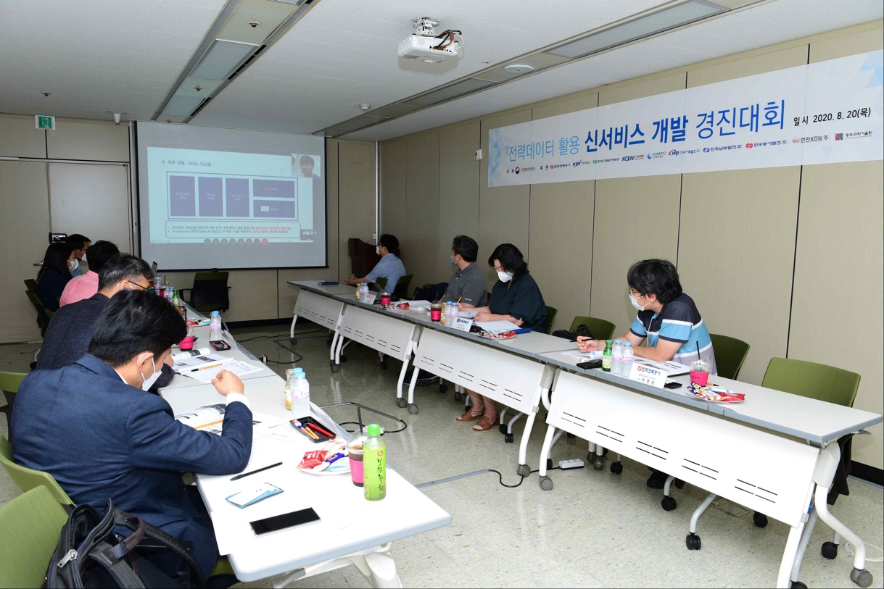

Photo: Evaluation of the competition to develop new services using power data