

**Gwangju Institute of Science and Technology**

**Official Press Release (https://www.gist.ac.kr/)**

**Section of** Hyo Jung Kim Nayeong Lee

**Public Relations** Section Chief Senior Administrator

(+82) 62-715-2061 (+82) 62-715-2062

**Contact Person** Moon-seop Yoon, Administrator

**for this Article** Section of Public Affairs

062-715-2021

**Release Date** 2020.10.08

**Chairman Kyung-hyun Song of Kyunghyang Industrial Co., Ltd., donates an additional 50 million won to the GIST Development Fund**

□ GIST (Gwangju Institute of Science and Technology, President Kiseon Kim) received 50 million won for the GIST Development Fund from Kyung-hyun Song, chairman of Kyunghyang Industrial Co., Ltd.

∘ Chairman Kyung-hyun Song donated 150 million won to GIST by donating 50 million won at this time after previously donating 55 million won to GIST.

□ Chairman Kyung-hyun Song is a professional manager who has led Kyunghyang Industrial Co., Ltd., for more than 20 years and has succeeded in localizing sources for rubber foam insulation material that have been highly dependent on imports since 1994 and has been regarded as a successful representative business in the region.

∘ Chairman Song, along with the position of GIST Development Foundation Vice President, is the GTMBA Alumni Chairman, striving both inside and outside the community to expand the base of science and technology, including support for education and research activities and the dissemination of research results.

□ Chairman Kyung-hyun Song said, "Recently, I decided to make an additional donation to GIST in the hopes of contributing to the development of the local community and the country in an effort to attract excellent talent, such as the establishment of an AI graduate school. Please make an effort to improve the research environment and human resources to increase GIST's research competitiveness."

□ GIST President Kiseon Kim said, "I would like to thank Chairman Kyung-hyun Song, who is a member of the GIST family. By attracting successful students for the Artificial Intelligence Graduate School, we will make efforts to train future science and technology specialists and build the AI-centered Industrial Convergence Complex."

∘ Kyunghyang Industrial Co., Ltd., as the only company with specialized production technology in Korea, was honored with the Presidential Award at the National Quality Management Competition in 2014 and the Grand Prize in the Labor-Management Win-Win Growth category at the 7th Gwangju Commerce and Industry Awards in 2019.

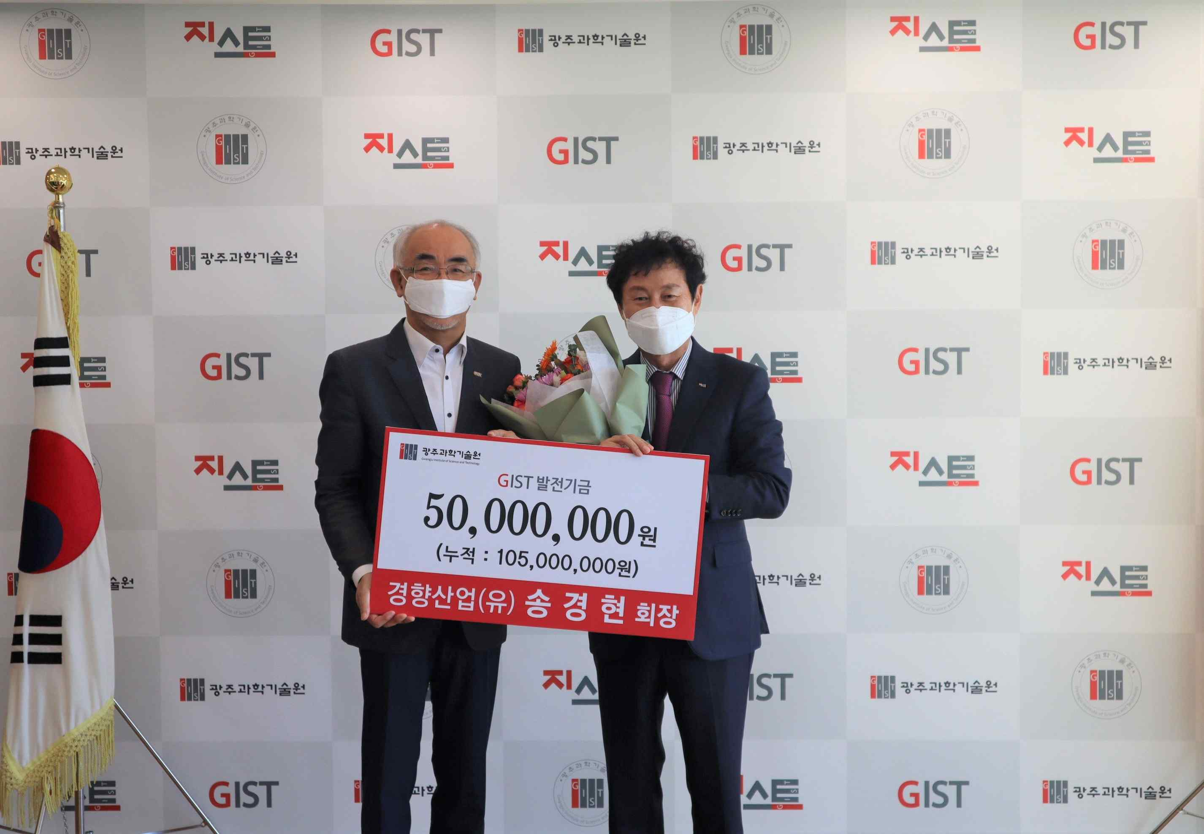

▲ From left: GIST President Kiseon Kim and Chairman

Kyung-hyun Song of Kyunghyang Industrial Co., Ltd.