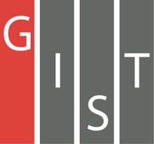

**Gwangju Institute of Science and Technology**

**Official Press Release (https://www.gist.ac.kr/)**

**Section of** Hyo Jung Kim Nayeong Lee

**Public Relations** Section Chief Senior Administrator

(+82) 62-715-2061 (+82) 62-715-2062

**Contact Person** Gyul Jung

**for this Article** Section of General Affairs

062-715-2102

**Release Date** 2020.11.17

**GIST holds a ceremony to celebrate**

**its 27th anniversary**

□ GIST (Gwangju Institute of Science and Technology, President Kiseon Kim) celebrated its 27th anniversary (November 17) with a commemorative ceremony on November 16, 2020, at Oryong Hall that was attended by about 50 key officials, faculty members and students.

∘ This year's event was held on a small scale to prevent the spread of Covid-19 and was meant to appreciate and encourage GIST members who have devoted themselves in various fields to share their future vision and help develop the institution.

□ President Kiseon Kim said, "For GIST to grow into a university that makes the region proud and fulfills its social responsibility, we are researching and developing new technologies that will lead the future, such as artificial intelligence. We also need to cultivate the right talents to prepare for a new transformation and respond to changes."

∘ In addition, he said, "In the future, GIST plans to actively cooperate to make the national and regional economies more stable and robust, focusing on regional specialized industries through an artificial intelligence-oriented digital New Deal and environment and energy-oriented Green New Deal."

□ GIST was established in 1993 with the aim of fostering high-quality science and technology specialists, conducting basic and applied research for national R&D, and revitalizing the Gwangju high-tech science industry base. Starting with a master's and doctorate program in 1995, GIST opened an undergraduate college in 2010, which is an innovative model of science and engineering education.

∘ For the success of the'Artificial Intelligence-Centered Industrial Convergence Complex Project,' which was selected as a national project with Gwangju Metropolitan City, GIST is actively responding with its 6 major research centers, including the artificial intelligence research center within GIST. By opening a graduate school, GIST plays a key role in nurturing human resources for future social innovation.

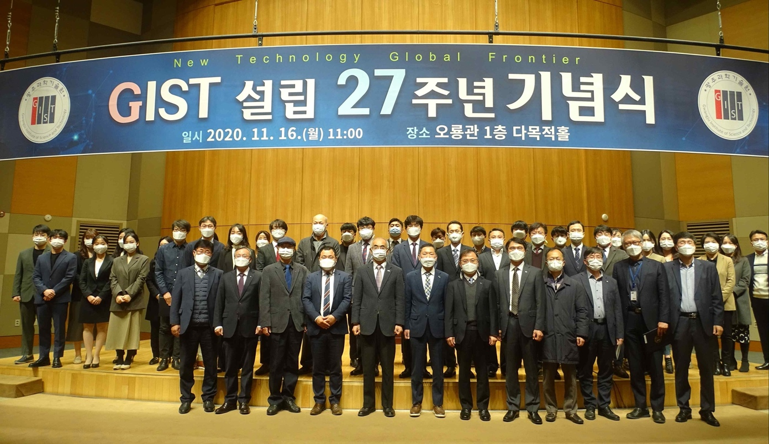

▲ GIST's 27th anniversary ceremony