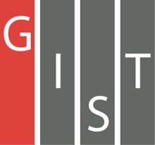
Gwangju Institute of Science and Technology

Official Press Release (https://www.gist.ac.kr/)

Section of Mi-Yeon Kim Nayeong Lee
Public Affairs Section Chief Senior Administrator
(+82) 62-715-2020 (+82) 62-715-2024

Contact Person Mina Choi, Administrator
for this Article GIST Academy
(+82) 62-715-2622

Release Date 2019.06.11

GIST president hosts meeting on industry-academic cooperation with major businesses in Gwangju and Jeonnam Province

□ GIST President Kiseon Kim held a meeting on June 10, 2019, with major business leaders in Gwangju and Jeonnam Province to discuss industry-academic cooperation.

∘ The meeting was held at the GIST Techno Management Business Academy (GTMBA Director Kyung-hyun Song) and some 20 key local business leaders attended the meeting to discuss measures for industrial and academic cooperation between GIST and local companies to successfully carry out the "Artificial Intelligence-based Industrial Convergence Complex Project."

□ President Kiseon Kim introduced the MoU GIST signed with Seoul National University on June 5th to promote education and research on AI, and said, "We hope to strengthen the cooperation and interest of entrepreneurs in our region to carry out successful business activities."

∘ President Kim continued by saying, "Based on the achievements of the GIST over the past 25 years, GIST members, GTMBA, and local businesses must work together to show new growth for the next 25 years. If we put our heads together, we can double our performance." He also emphasized the new slogan that "We are GIST."

□ GTMBA Director Kyung-hyun Song said, "We will encourage the active participation of GTMBA alumni in the 'Artificial Intelligence-based Industrial Convergence Complex Project' so that the project can be carried out smoothly."

∘ The Artificial Intelligence-based Industrial Convergence Complex Project will be built in Gwangju's Special R&D High-Tech Zone 3 with a budget of 400 billion won over the next five years.

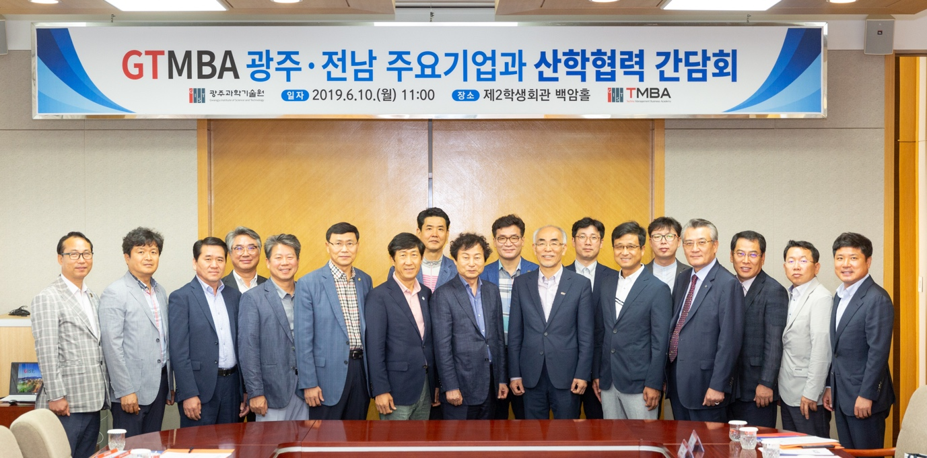▲ Commemorative photo of the meeting

