Gwangju Institute of Science and Technology

Official Press Release (https://www.gist.ac.kr/)

Section of Hyo Jung Kim Nayeong Lee
Public Affairs Section Chief Senior Administrator
(+82) 62-715-2061 (+82) 62-715-2062

Contact Person Professor Yong Gu Lee
for this Article School of Mechanical Engineering
(+82) 62-715-2396

Release Date 2019.09.04

Coalition to strengthen national competitiveness
for self-driving vehicles holds a meeting to collect opinions on creating a 'Korean self-driving data set'

□ GIST (President Kiseon Kim) A joint research team held a gathering at GIST's Seoul office on September 2, 2019, to collect opinions on 'Korean self-driving data set' that is being developed by School of Mechanical Engineering Professor Yong Gu Lee and Pohang University of Science and Technology (POSTECH, Moo-hwan Kim) Professor Dae-jin Kim.

∘ This meeting was attended by three members who are top experts in image recognition technology: Bong-jin Jeon (Strad Vision), Jong-yeol Park (Korea Electronics and Telecommunications Research Institute), and Byung-gwan Park (SK Telecom). The discussed ▲ data quantity and type ▲ collected filming environment ▲ labelling format ▲ data distribution.

□ 'Korean self-driving data set' enables development of self-driving algorithms specialized in the Korean market, especially since the shape, location, signaling system, road system, and signage system are different from other countries. Therefore, if Korea's self-driving data is shared among self-driving research institutes and businesses that are aiming to enter the Korean market, especially small and medium-sized companies that lack capital, it can greatly contribute to creating self-driving infrastructure in Korea and strengthening national competitiveness in developing self-driving algorithms.

□ Since May 2018, Professor Yong Gu Lee's joint research team developed an open data set and cognitive processing technology * for atypical dynamic characteristics that affect autonomous driving (project period: 18.05.01 ~ 21.12.31 [44 months]). The company is building 300,000 Korean-style data sets for autonomous driving research labs and companies.

∘ The Korean self-driving data set is essential for the development of autonomous driving algorithm specialized for the Korean market. The constructed data was recorded in high quality (4k) compared to the existing data, over 1500 hours in duration, and over 100TB in data size.

* Cognitive processing technology: It refers to technology that detects a specific object from an image, finds location information, and recognizes behavior. Developing autonomous driving algorithms that recognize atypical dynamics requires special large-scale data sets, such as police and safety personnel hand signals and pedestrian behaviors.

□ When using the results of this research as a cognitive processing technology, the vehicle can recognize the hand signals of police officers and safety personnel, which could not be recognized before, and gives instructions such as deceleration or avoidance after recognizing a potential accident. It also enables vehicles to carry out autonomous driving on their own in complex and diverse situations.

□ Professor Yong Gu Lee said, "The development of algorithms using the Korean self-driving data set is expected to bring stable and successful technology to the new self-driving market in Korea, and it will serve as a foundation for users to gain trust."

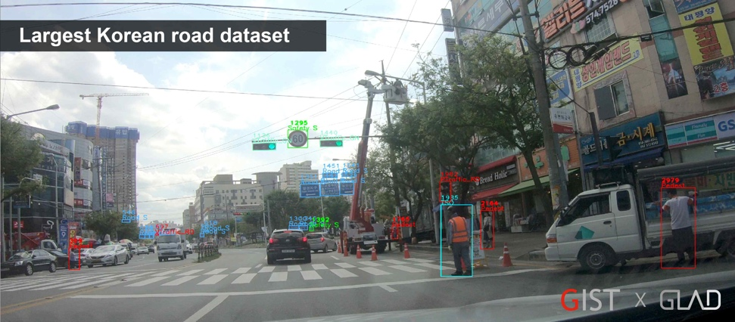
[Figure 1] Image that can show characteristics of Korean data (signal type, signal system, sign system, etc.)

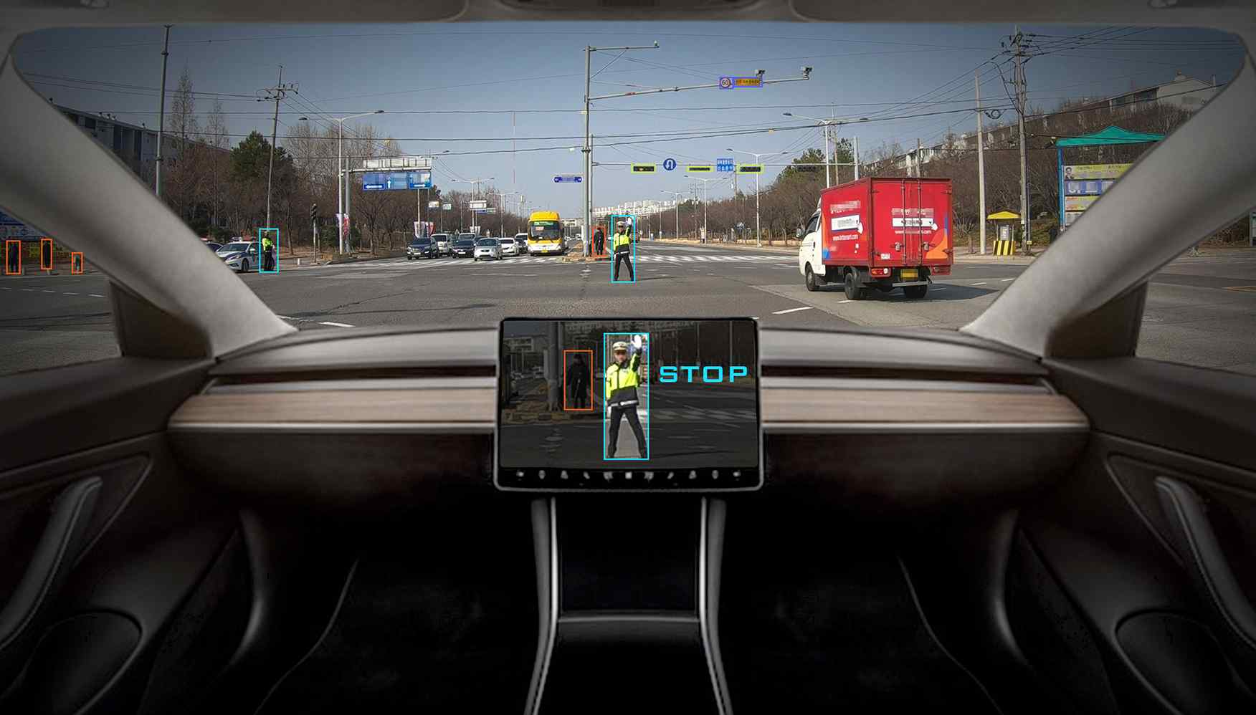
[Figure 2] Recognizing a policeman and hand signals in a self-driving vehicle (Korean Image)

