Gwangju Institute of Science and Technology

Official Press Release (https://www.gist.ac.kr/)

Section of Hyo Jung Kim Nayeong Lee
Public Relations Section Chief Senior Administrator
(+82) 62-715-2061 (+82) 62-715-2062

Contact Person Professor Hong Kook Kim
for this Article School of Electrical Engineering
and Computer Science
062-715-2228

Release Date 2020.08.07

GIST achieves AI speech research prominence

□ GIST (Gwangju Institute of Science and Technology, President Kiseon Kim) School of Electrical Engineering and Computer Science Professor Hong Kook Kim participated in the "2020 AI Grand Challenge"* hosted by the Ministry of Science and ICT from July 27 to July 31 and set a record for winning two consecutive years in the field of voice recognition.

* 2020 AI Grand Challenge is part of the government's plan for building a "digital inclusive society realized with artificial intelligence technology" by proposing challenges that are currently difficult to achieve at this time. These challenges will progress in four stages by 2022.

∘ This year, there are four tracks to select the 20 best teams with the AI skills in a particular field to solve these challenges: ▲ Track 1 behavioral recognition to recognizes abnormal behavior of emergency patients based on image analysis for quick response when an emergency occurs ▲ Track 2 voice recognition to recognizes the CCTV blind spots to reinforce the social safety net ▲ Track 3 object recognition to quickly and accurately classify recycled items to improve quality of life ▲ Track 4 AI model weight reduction to optimize and lighten AI equipment.

□ GIST joined Track 2 by forming the 'WisenetAI-GIST' (Director: Professor Hong Kook Kim) team in collaboration with Hanwha Techwin, which is a global security company, and was selected as the final three among 13 participating teams in the field. The 'WisenetAI-GIST' team, which also won second place in the voice recognition track during the 2019 AI Grand Challenge, showed outstanding achievements in the voice recognition field for two consecutive years, demonstrating its true expertise in the field.

∘ The outstanding teams selected in this year's first stage competition (those ranked 1st to 5th in each track with 20 teams in total) will receive 4 billion won worth of annual research funds to continue their follow-up R&D. The 'WisenetAI-GIST' team plans to continue its research for the second stage of the competition, which will be held in November, with a total of 200 million won in research funds.

□ Professor Hong Kook Kim said, "I am very proud and happy that the result of our continuing research has led to good results, especially with students who have the conviction that our research path was never wrong. In the future, we will strive to contribute to the development of national AI through research that can contribute to building a social safety net based on AI auditory intelligence."

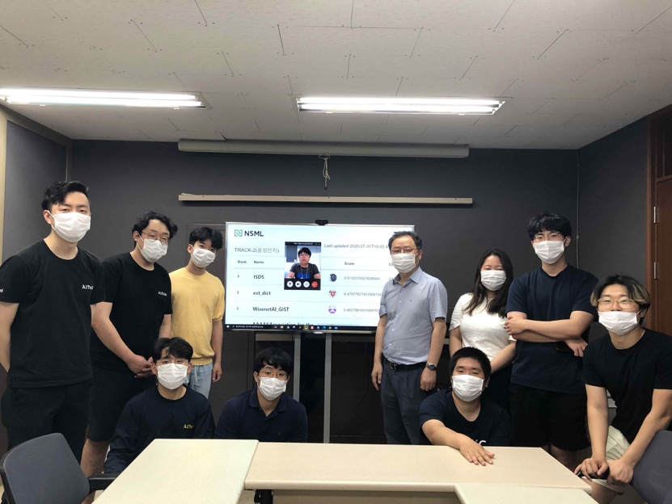
▲ GIST School of Electrical Engineering and Computer Science Audio Intelligence
Technology and Research Lab and Hanwha Techwin's joint 'WisenetAI-GIST' team

