Gwangju Institute of Science and Technology

Official Press Release (https://www.gist.ac.kr/)

Section of Hyo Jung Kim Nayeong Lee
Public Affairs Section Chief Senior Administrator
(+82) 62-715-2061 (+82) 62-715-2062

Contact Person Joo-hwan Lim, Administrator
for this Article Global Desalination Research Center
(+82) 62-715-3048

Release Date 2019.08.30

GIST Global Desalination Research Center hosts
12th International Desalination Workshop

□ GIST (President Kiseon Kim) Global Desalination Research Center (GDRC, Director In S. Kim/GIST Research Dean) hosted 12th International Desalination Workshop.

∘ This workshop, co-hosted by the Global Desalination Research Center, the Korea Desalination Plant Association, and the European Desalination Chemical Society, is the only international conference on desalination in Korea, and the event was attended by 200 people from 12 countries during August 20 to 30, 2019, at Jeju Island.

∘ The event was sponsored by the Ministry of Environment, the Korea Environmental Industry & Technology Institute, FOHC Research Group, seaHERO2 Research Group, KORAE Research Group, DREAMS Research Group, and domestic desalination R&D related organizations such as MD+ participated as partner organizations.

□ Key participants included the Secretary General of the European Desalination Society Miriam Balaban, the IDA President Miguel Angel Sanz, and Chairman Kwang-hee Nam of the Korea Institute of Environmental Industry and Technology (KEITI) gave the keynote speech at the opening ceremony.

∘ There was a total of 107 presentations (53 oral and 54 posters) at the International Desalinization Workshop, which provides the latest information and global status of desalinization technology, such as membrane based desalination technology, membrane distillation based desalination technology, new materials and nanotechnology, membrane contamination and reduction, low energy desalination technology, and renewable energy desalination convergence technology.

□ In particular, the five best papers were selected after a rigorous review by the Award Committeee, including the Ministry of Environment "SeaHERO Award," the Korea Institute of Environmental Industry and Technology Award, the Korea Desalination Plant Association President's Award, the K-Water Award, and the President of the Korea Environmental Engineering Association Award.

∘ On the second day of the workshop, Miguel Angel Sanz, current president of IDA and Director of Strategic Development for Treatment Infrastructure Division of SUEZ, met with Hyundai Engineering & Construction, Doosan Heavy Industries & Construction, POSCO, Geosong General Shing, Danfoss, and Zitech & Co., Ltd., which introduced those domestic companies' technology and specializations to overseas markets.

□ GIST GDRC Director In S. Kim said, "IDW, Korea's only international desalination association that has pioneered desalination technology and led the development of the industry-academic relations, is hosting a meaningful conference this year with more interest and participation than ever before. In the future, the Global Desalination Research Center will do its best to play the role of a hub connecting not only domestic but also foreign institutions and people."

□ The GIST Global Desalination Research Center was established as a follow-up project to SeaHERO and is responsible for such activities as R&D and education related to seawater desalination at home and abroad. The company operates KOLAS, an international certification agency, evaluates new technologies and processes, and provides information at home and abroad by establishing a database related to seawater desalination.

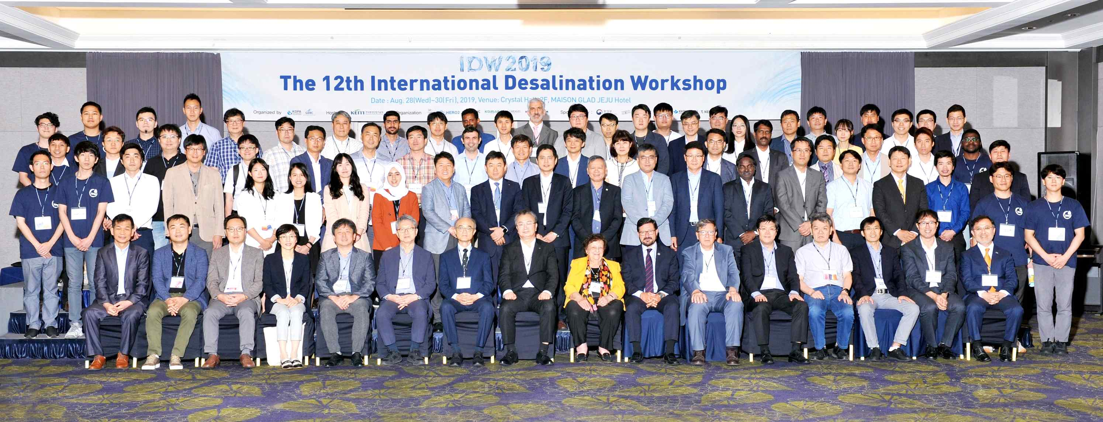
[Photo 1] Group photo of key people and participants attending IDW2019

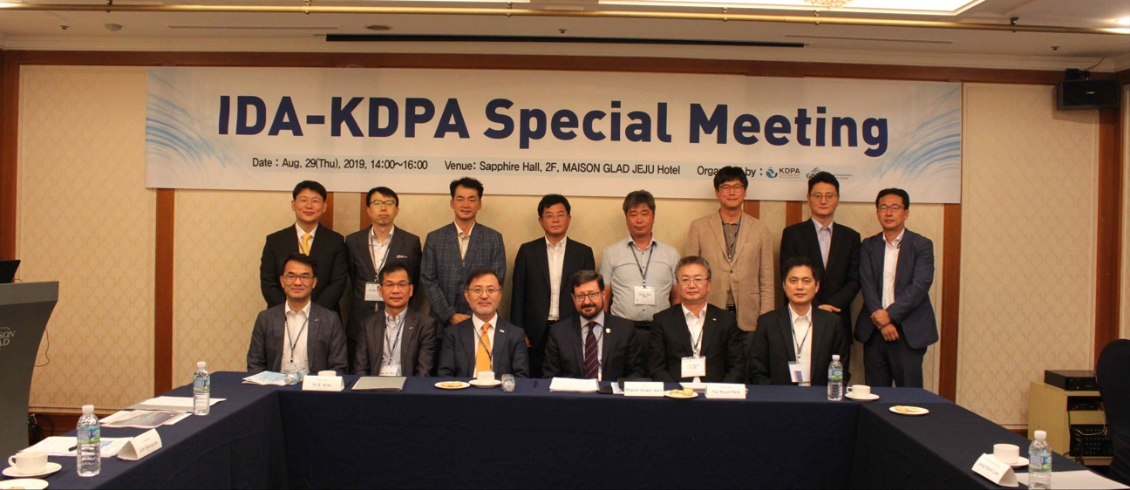
[Photo 2] Special Meeting between IDA President and Korean business leaders related to desalination

