Gwangju Institute of Science and Technology

Official Press Release (https://www.gist.ac.kr/)

Section of Mi-Yeon Kim Nayeong Lee
Public Affairs Section Chief Senior Administrator
(+82) 62-715-2020 (+82) 62-715-2024

Contact Person Juhee Kang, Administrator
for this Article Section of International Cooperation
(+82) 62-715-2063

Release Date 2019.03.14

GIST has become a popular destination for overseas science and engineering students: GIP successfully concludes online applications process

□ GIST (President Kiseon Kim) has successfully concluded its online application process for the Global Intern Program (GIP), which allows selected foreign students the opportunity to participate in research projects and Korean cultural experiences during summer vacation.

∘ The GIP program allows highly-qualified foreign students a chance to stay on GIST's campus for eight-weeks during the summer as interns who will perform research under the guidance of a graduate school professor while gaining valuable laboratory experience. The interns will also learn about Korean culture through various special lectures and Korean language classes. The GIP program began in 2008 and has included participants from 190 different countries.

□ During the current application period, 1,600 students from 80 countries are competing for a total of 40 GIP spots, which is a ratio of 40 to 1. The number of applicants has increased 130% over the previous year.

□ In particular, this year's pool of applicants has confirmed that GIST's popularity has increased significantly in South America and Africa, including Brunei, Argentina, Guatemala, Algeria, Ghana, Kenya, Morocco, and El Salvador.

∘ The quality of GIP applicants can be seen from the various schools from which they have applied: Duke University n the US (26th in QS Ranking, 18th in THE Ranking), McGill University in Canada (33rd in QS Ranking, 44th in THE Ranking), Hong Kong University of Science and Technology (37th in QS Ranking, 41th in THE Ranking), Al-Farabil Kazakh National University in Kazakstan (256th in QS Ranking, 801th in THE Ranking), and INSA Centre Val de Loire in France (478th in QS Ranking, 601th in THE Ranking).

□ International and Public Affairs Dean Yong-Chul Kim said, "The national diversity of this year's GIP applicants has shown that GIST's global popularity has increased significantly from the previous year. I hope that students who participate in GIP will have an opportunity to learn about Korean culture through various cultural experiences and field trips, which will help them them decide to continue their studies at GIST with its excellent research environment and professors."

□ Successful GIP applicants will be announced in mid-April, and the 2019 Global Intern Program will be held this summer from June 21 (Friday) to August 16 (Friday).

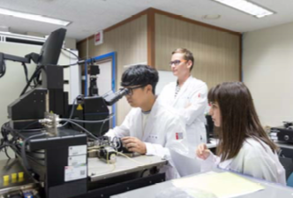
▲ 2018 GIP Intern participates in a joint research project

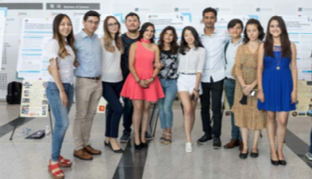
▲ Poster presentations by 2018 GIP Interns

