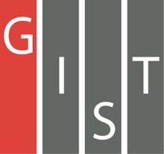
Gwangju Institute of Science and Technology

Official Press Release (https://www.gist.ac.kr/)

Section of Hyo Jung Kim Nayeong Lee
Public Affairs Section Chief Senior Administrator
(+82) 62-715-2061 (+82) 62-715-2062

Contact Person Professor Dong-Seon Lee
for this Article School of Electrical Engineering
and Computer Science
(+82) 62-715-2248

Release Date 2019.08.06

GIST Nobel Amano Center for Advanced LEDs
hosts 2019 2nd ACALED Symposium

□ GIST (President Kiseon Kim) Nobel Amano Center for Advanced LEDs (ACALED, Director Hiroshi Amano of Nagoya University who won 2014 Nobel Prize in Physics and Deputy Director GIST Professor Dong-Seon Lee) organized the 2019 2nd ACALED Symposium at GIST on August 8, 2019.

∘ GIST ACALED was opened in November 2016 to develop high-tech devices based on nanostructure technology of nitrate semiconductors and to secure world-class research capabilities and technology in conjunction with Nagoya University Professor Hiroshi Amano.

□ Recently, ACALED research conducted by Professor Hiroshi Amano and GIST Professor Dong-Seon Lee (co-authors) and conducted by GIST master's student Jeong-hwan Park published a paper in the Advanced Materials Interfaces journal entitled "Influence of Temperature-Dependent Substrate Decomposition on Graphene for Separable GaN Growth."

□ At the opening ceremony of GIST ACALED on November 3, 2016, Professor Amano gave a lecture to students on “Blue LEDs, DUV LEDs and Future Electronics for Establishing Sustainable Smart Society” to share the content of early LED research difficulties and challenges facing advanced LED development in the future. [Photo 1]

∘ The symposium was conducted by inviting speakers who are conducting outstanding research in the field of nitrate semiconductors and various 2D materials as well as their manufacturing process and analysis, including seven guest lectures such as ▲ MIT mechanical engineering Professor Ji-hwan Kim's "Challenges and opportunities in remote epitaxy" ▲ Nagoya University Dr. Xu Yang's "MOVPE and characterization of two-dimensional hexagonal boron nitride layers."

□ GIST Professor Dong-Seon Lee said, "Hopefully, the symposium will serve as a venue for active exchange of views and heated discussions and contribute a little to the development of this field, and I look forward to your unwavering affection and interest toward the GIST Nobel Amano Center for Advanced LEDs."

∘ Currently, GIST ACALED has 14 GIST researchers working with Professor Amano of Nagoya University and is conducting continuous joint research for future nanostructure-based LEDs with the aim of developing technologies to produce micro LEDs for displays.

□ GIST has developed collaborations with Nobel Prize winners, who are the most prestigious in their fields, to create the best research environment and to secure the world's best research capabilities and competitive technology with the ▲ Heeger Center for Advanced Materials ▲ Ertl Center for Electrochemistry and Catalysis ▲ Steitz Center for Structural Biology ▲ Grünberg Center for Magnetic Nanomaterials ▲ Amano Center for Advanced LEDs ▲ Grubbs Center for Polymers and Catalysis.

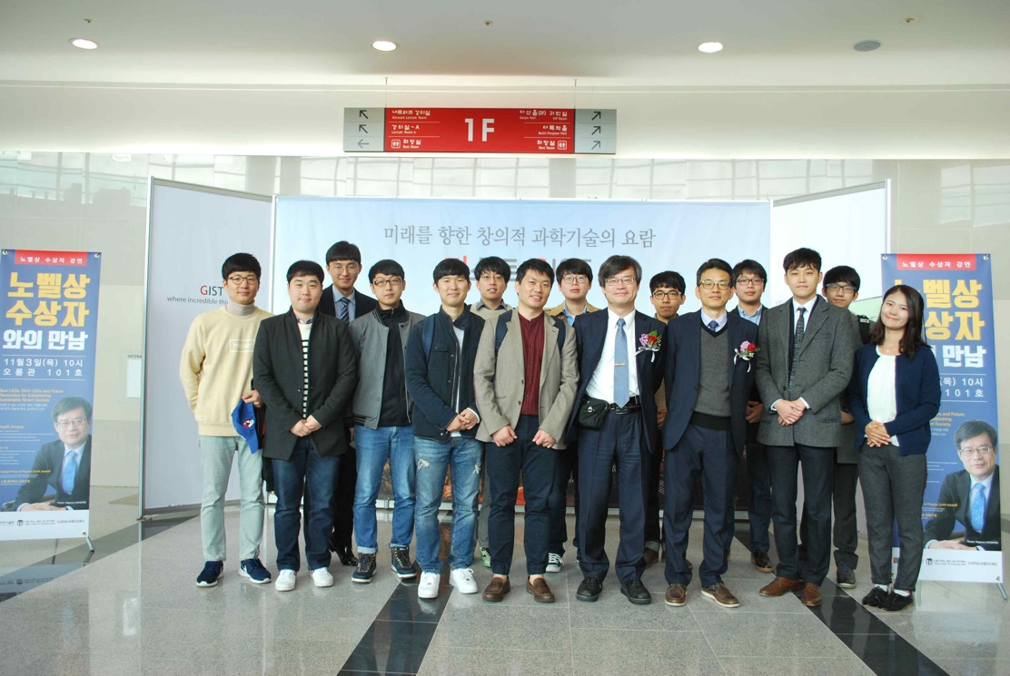
▲ Photograph at the opening of ACALED in 2016 with GIST Professor Dong-Seon Lee (third from right front row) and Professor Amano of Nagoya University (fourth from right front row)

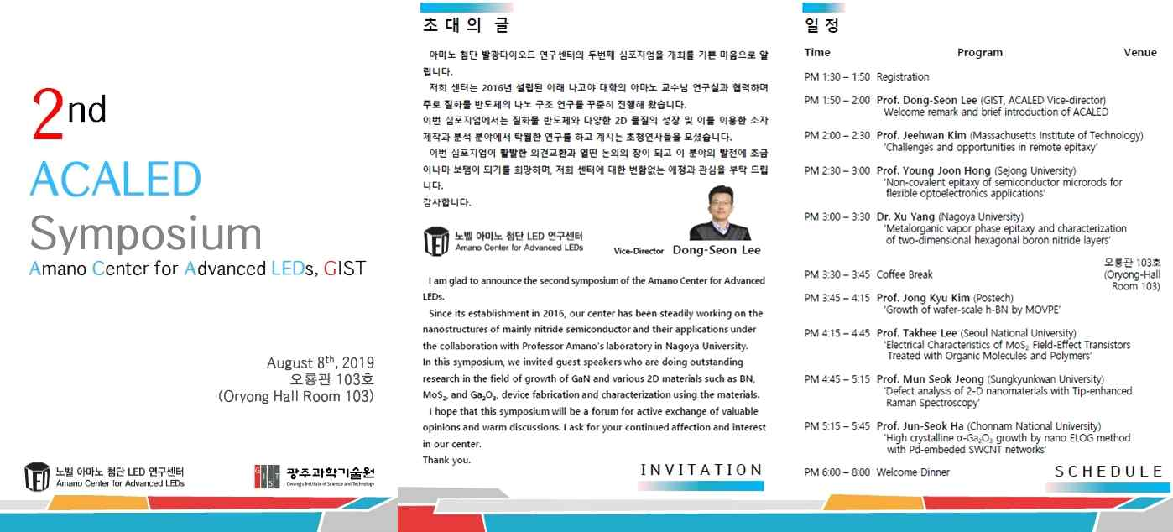
▲ 2019 2nd ACALED Symposium program guide

