“Government-Business-Citizens Must Practice Carbon Neutrality”
GIST Academy, June Breakfast Forum

- June Breakfast Forum Held on the 26th (Mon) ... Special Lecture by Chairman Choi Yeol of Korea Green Foundation

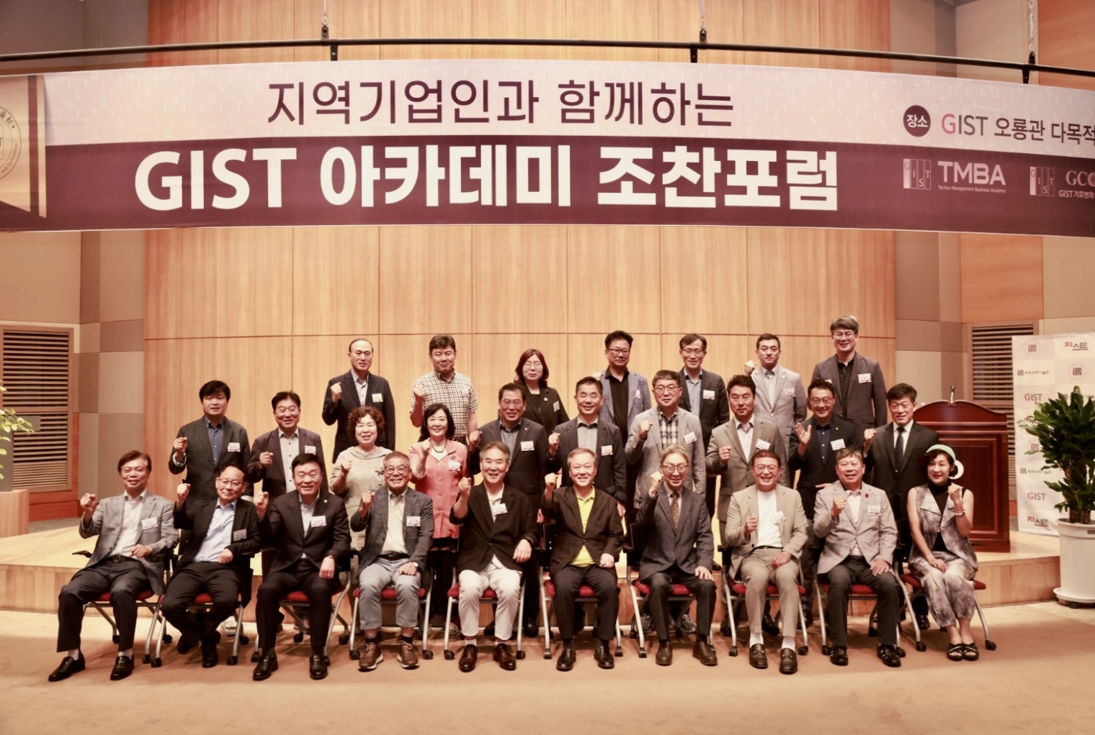
▲ Commemorative photo of the June Breakfast Forum hosted by GIST Academy at Oryong-gwan.

GIST (Gwangju Institute of Science and Technology, Acting President Park Rae-gil) Academy held the June Breakfast Forum on Monday, June 26, with the theme “The Role of Local Governments, Businesses, and Civil Society for Carbon Neutrality” at Oryong-gwan with 60 leading businessmen from Gwangju and Jeonnam regions attending.

Choi Yeol, chairman of the Korea Green Foundation, who was a speaker at the forum, began his presentation by reminding everyone that excessive use of fossil fuels has already exceeded the capacity of the earth in the 1980s, and that 40 years later, it is now a “climate emergency.” In particular, he drew the attention of the participants by suggesting that a series of climate disasters such as heat waves, forest fires, typhoons, and floods have occurred since the 2000s.

Chairman Choi Yeol said that the current goals and action plans for reducing greenhouse gas emissions are insufficient and that the Korean economy will have to bear enormous risks if special measures are not taken, emphasizing the importance of the role of local governments, businesses, and civil society.

He added that local governments must establish policies targeting “zero-energy cities” through a “15-minute cities” concept, where living zones are created within a 15-minute distance, eco-friendly transportation systems, and building insulation. He also explained that businesses must establish corporate philosophies that are an answer to the climate crisis and abide by social responsibility and governance.

Chairman Choi concluded his lecture by proposing the application of the “Ten Commandments for Climate and Environment” proposed by the United Nations Environment Program, saying that civil society should speak out and take action in this era of climate emergency.

The Ten Commandments for the Climate and Environment are as follows: (1) Speak up. (2) Apply political pressure. (3) Change your mode of transportation. (4) Reduce your power consumption. (5) Change your diet. (6) Buy locally and sustainably. (7) Don't waste food. (8) Dress smart according to the climate. (9) Plant trees. (10) Focus on earth-friendly investments.

GIST Academy operates the Technology Management Academy (opened in 2010) and the Climate Change Academy (opened in 2016) as non-degree programs. The GIST Academy Breakfast Forum is held on the last Monday of every month, inviting experts from various fields as lecturers to alumni and executives of local businesses.

In particular, the Forum supports managers in each field to deeply understand changes in the business environment and global management strategies through lectures by the best experts in Korea, encourages wide networking, and contributes to the vitalization of the local economy and industry−academia cooperation.

