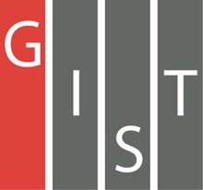
Gwangju Institute of Science and Technology

Official Press Release (https://www.gist.ac.kr/)

Section of Mi-Yeon Kim Nayeong Lee
Public Affairs Section Chief Senior Administrator
(+82) 62-715-2020 (+82) 62-715-2024

Contact Person Ji-yong Park, Administrator
for this Article Advanced Photonics Research Institute
(+82) 62-715-3332

Release Date 2019.04.18

GIST's Advanced Photonics Research Institute
hosts "The World of Science" with Cheomdan
elementary school students

□ GIST (President Kiseon Kim) – The Advanced Photonics Research Institute (APRI, Director Hyyong Suk), which has the only world-class laser in Korea, invited Cheomdan elementary students to the "The World of Science" on April 18, 2019.

□ APRI's "The World of Science" has been held every April since 2007. This event provides elementary school students with an opportunity to easily experience and learn about lights and laser. A total of 35 people participated in the event, including Jeongam Elementary School and other Cheomdan elementary school students.

∘ APRI researchers participated in the program as instructors, and they conducted five learning modules, including holography, drawing laser pictures, popping a box of balloons, laser Christmas tree, and optics.

□ APRI Director Hyyong Suk said, "I hope that these elementary school students who will become the future leaders of Korean science will have a meaningful time directly learning about the phenomenon of optics and lasers at 'The World of Science.' Next year, we will expand the program to include students from the local mountainous areas as well as from Cheomdan."

⌘

