GIST Academy September Breakfast Forum Held... Professor Sang Yun Lee Invited to ‘The Future of Quantum Computers’

- GIST Physics and Photonics Department Professor Sang Yun Lee invited to the event on September 24, attended by about 50 local businesspeople... Introduction of basic knowledge of quantum mechanics and the current status and future of quantum computer development
- “Quantum technology will have a significant impact on national security and the future across all fields including technology, economy, and society... Technology independence and human resource development are necessary to prepare for the future society.”

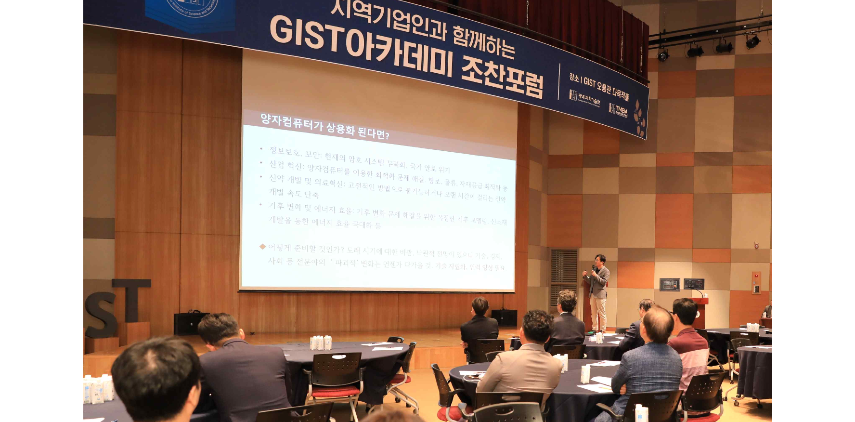▲ GIST Academy is holding the September Breakfast Forum at Oryong Hall on Tuesday, September 24th.

The Gwangju Institute of Science and Technology (GIST, President Kichul Lim) announced that it held the GIST Academy (Director Jae Gwan Kim) September Breakfast Forum on Tuesday, September 24th at Oryong Hall, inviting Professor Sang Yun Lee of the Department of Physics and Photon Science, with the attendance of approximately 50 businesspeople from the Gwangju and Jeonnam regions.

Professor Sang Yun Lee, who came to GIST in 2020, is contributing to the development and expansion of Korea's quantum science and technology through domestic and international academic exchanges and human resource development based on his outstanding research achievements in the fields of quantum computing and quantum networks.

Since 2011, he has been conducting research on spin qubit implementation and spin-photon interface using solid point defects in diamond and silicon carbide, and has published 38 research papers in major journals such as 《Nature Nanotechnology》 and 《Nature Materials》. In recognition of his contributions to the development of quantum science technology and expansion of the ecosystem, he received the Minister of Science and ICT Award at the opening ceremony of 'Quantum Korea 2024' held in June of this year.

Currently participating in major national research and development projects such as the Quantum Internet Core Source Technology Development Project.

On this day, Professor Sang Yun Lee explained the basic knowledge of quantum mechanics for implementing quantum computers under the theme of ‘Quantum Computers and Quantum Information Technology,’ while analyzing the current status of quantum computer development and presenting future prospects.

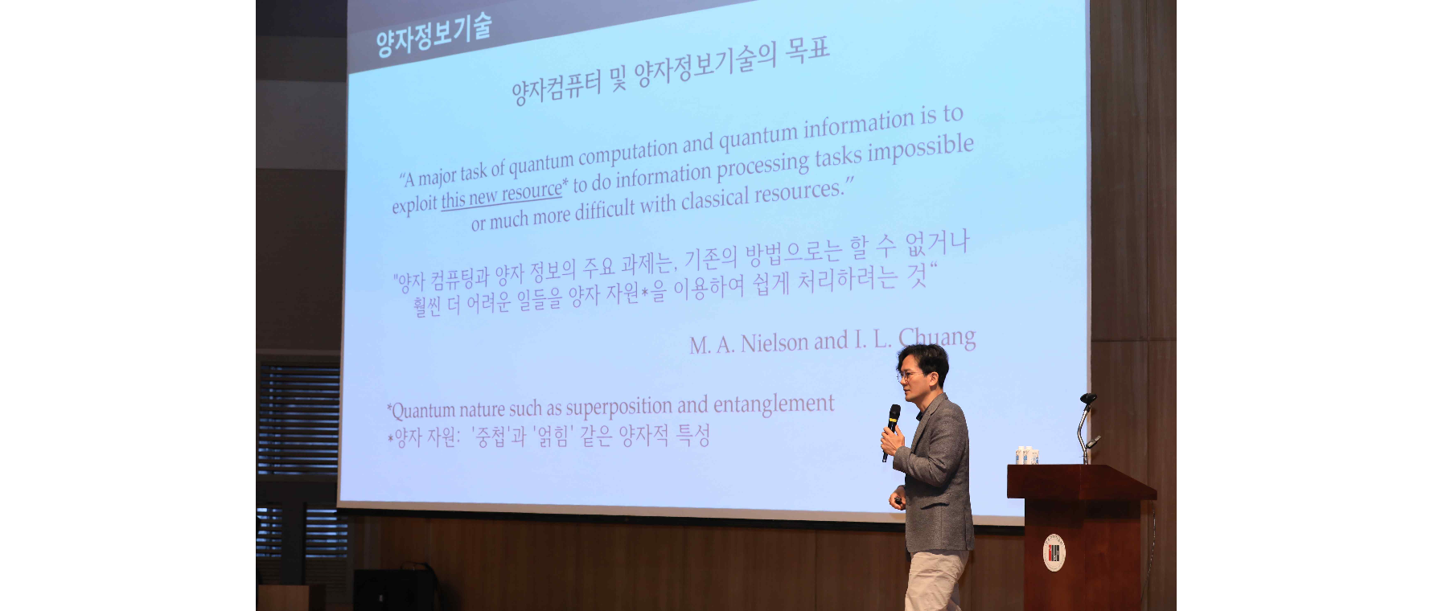▲ Professor Sang Yun Lee is giving a lecture on the topic of quantum information technology at the GIST Academy September breakfast forum.

Professor Sang Yun Lee started his lecture by asking the question, “Will quantum computers be faster than classical computers?” and responded, “It is partly true,” while adding, “Quantum computers are not intended to completely replace classical computers,” which drew interest.

Professor Lee stated that the goal of today's lecture was to provide a proper understanding of the basics of quantum computers.

He also explained related terms such as quantum mechanics and quantum superposition in an easy-to-understand manner, and explained that the purpose of quantum computing is to easily process tasks that are impossible or much more difficult to do using existing methods using quantum resources.

Professor Lee said, "If quantum computers are commercialized, they will greatly improve efficiency in solving problems in areas such as information security, industrial innovation, and climate change. There are pessimistic or optimistic outlooks on the timing of their arrival, but quantum technology will have a significant impact on national security and the future across all areas including technology, economy, and society. In order to prepare for the future society, technological independence and human resource development are necessary."

GIST Academy operates GIST's non-degree program, the Technology Management Academy (GTMBA, opened in 2010), and hosts the 'GIST Academy Breakfast Forum' on the last Tuesday of every month in March, May, June, September, and October, inviting experts from various fields as lecturers for academy alumni and local business executives.



