GIST, Main Gate Design Contest...
to be a local landmark

- Design contest from October 14 to 28 in accordance with the plan to promote the construction of the main gate... Discovering a design using steel that has the identity and symbolism of GIST while being in harmony with the surroundings
- Awarded the grand prize winner with a plaque and a prize of 10 million won... The winning work will be confirmed after a preference survey of Gwangju Metropolitan City citizens and GIST members “We will do our best to create a landmark representing the region”

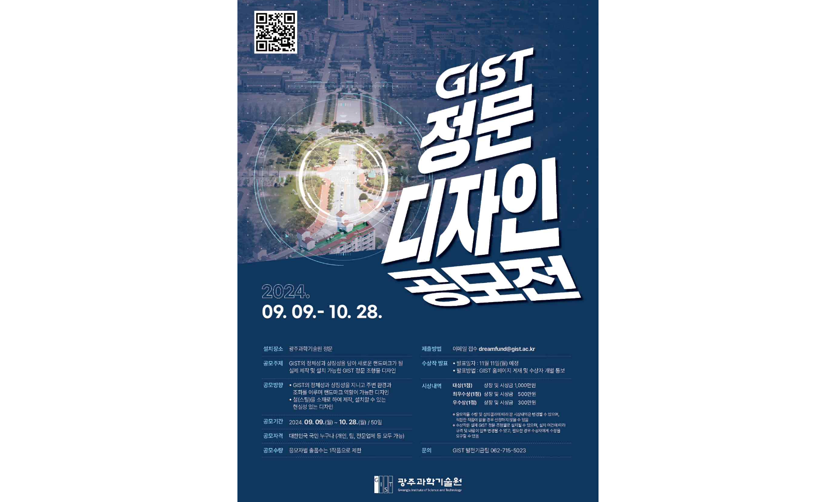▲ GIST Main Gate Design Contest poster

The Gwangju Institute of Science and Technology (GIST, President Kichul Lim) announced that it is holding a contest for the design of its main gate that embodies GIST’s identity and symbolism based on its 30-year history of growing together with the region.

GIST, which has been operating the ‘Campus Design TF (Chairman Sang-Don Kim, Vice President for Academic Affairs)’ since February 1st of this year, has decided to push forward with the construction of a main gate that will become a local landmark.

This contest seeks to discover a design that ▴ has the identity and symbolism of GIST, ▴ is in harmony with the surrounding environment, and ▴ can serve as a landmark. The design must be made of iron (steel) and can be installed.

GIST will evaluate the submitted works based on criteria such as suitability, creativity, and potential for field use, and each applicant will be limited to one work.

The final selection will be announced on Monday, November 11th through a committee of experts, and one Grand Prize, Excellence Award, and Excellence Award will be selected and awarded at the 31st anniversary of GIST.

The winners will be awarded a trophy and prize money of 10 million won for the grand prize, 5 million won for the excellence prize, and 3 million won for the excellence prize.

GIST plans to complete construction of the main gate by next year by finalizing the winning design through a preference survey targeting citizens of Gwangju Metropolitan City and GIST members and applying it to the actual design.

President Kichul Lim said, "It was regrettable that GIST, which has been dedicated solely to cutting-edge science and technology education and research since its establishment, does not yet have a proper main gate. We will strive to build a landmark representing the region through a contest in which anyone can participate."

Any Korean citizen can participate in the contest, and applications will be accepted from Monday, October 14 to Monday, October 28 at 6:00 PM. Download the application form and related forms from the notice board on the GIST homepage, fill out the following documents: 1 Application Form, 2 Description of Work, 3 Production Drawing, 4 Work Image, and 5 Agreement to Use Award-Winning Works, and submit them via email (dreamfund@gist.ac.kr).

For inquiries regarding the contest, please contact the GIST Development Fund Team (062-715-5023).



