“Opening a new horizon for Korean mathematics” GIST holds ‘Mathematical Science Challenges and Opportunities’ forum

- Providing a venue for discussing vision and strategies for inheriting the tradition of mathematics in Korea and leading the world of mathematics... Presenting a new paradigm for mathematics research and education through the development strategy of the GIST Department of Mathematical Sciences, which is about to be established
- Keynote speeches by Professor Jong-hae Geum of the Korea Advanced Institute of Science and Technology, and IBS President Do-Young Noh... Public lecture by Professor Hyung-joo Park of Ajou University “GIST will grow into a center of global mathematics research and education”

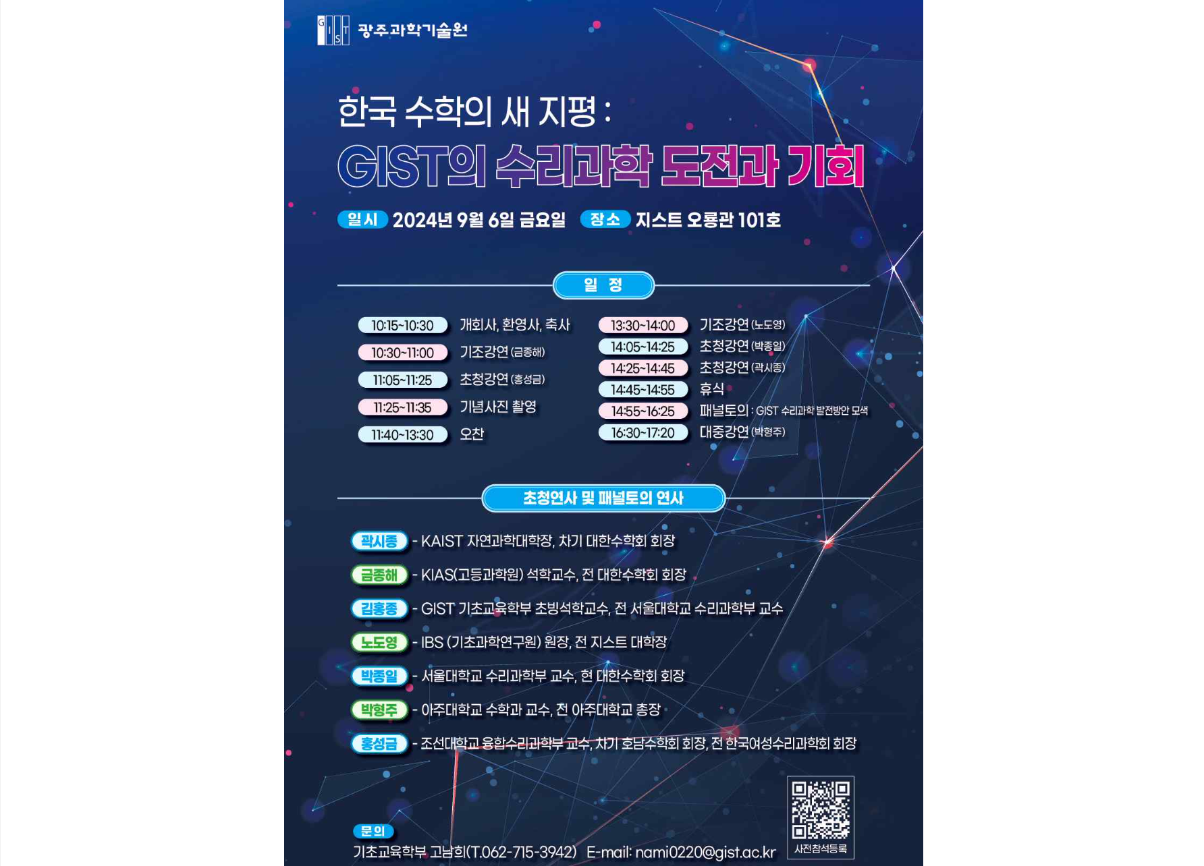▲ New Horizons for Korean Mathematics: GIST’s Mathematical Science Challenges and Opportunities Poster

Mathematics scholars and science leaders will gather together to discuss in-depth ways to strengthen the international status of Korean mathematics.

The Gwangju Institute of Science and Technology (GIST) announced that it will hold a forum to discuss the establishment and development of GIST’s Department of Mathematical Sciences under the theme of “New Horizons for Korean Mathematics: GIST’s Challenges and Opportunities in Mathematical Sciences” on September 6 (Fri) in Room 101 of Oryong Hall.

This forum was organized to establish a mid- to long-term development strategy for the Department of Mathematical Sciences at GIST, scheduled to be established in January next year, and to present a new paradigm for mathematical research and education.

At the forum on this day, the status of Korean mathematics in the world will be diagnosed and development strategies will be announced, while ▴ the establishment vision and strategic mid- to long-term development plan for the Department of Mathematical Sciences at GIST and ▴ the development plan for GIST's mathematical science research and education program linking basic science and engineering will be discussed.

To this end, there will be keynote speeches by Distinguished Professor Jong-hae Geum of the Korea Institute for Advanced Study and Director Do-Young Noh of the Institute for Basic Science (GIST Department of Physics and Photon Science, former Dean of GIST College), expert invited lectures and panel discussions by President Jong-il Park of the Korean Mathematical Society (Seoul National University Department of Mathematical Sciences), Dean Si-jong Kwak of the College of Natural Sciences at KAIST, and Professor Seong Geum Hong of the Department of Convergence Mathematical Sciences at Chosun University, as well as a public lecture by Distinguished Professor Hyung-joo Park of Ajou University (former President of Ajou University).

The public lecture by Professor Hyung-Joo Park of Ajou University, which will be held under the theme of ‘Popularization of Mathematics and Social Applicability’, is expected to provide insight into how mathematics can play an important role in modern society. In addition, the expert panel discussion will cover the international status of Korean mathematics and GIST’s role in the mathematical sciences, and the networking session that follows will discuss ways for cooperation and exchange among participants.

Jeong Ok Choi, Dean of the Division of Liberal Arts and Sciences, said, "We ask for your interest and participation in this event to enhance the development direction of GIST's Department of Mathematical Sciences and the international status of Korean mathematics. GIST plans to grow into a global center of mathematics research and education by exploring new possibilities for Korean mathematics research."

Anyone interested in mathematical sciences, including those from academia, industry, and education, as well as students and the general public, can attend this forum. Applications for participation can be made through [application link or QR], and inquiries can be made to the GIST Department of Basic Education at 062-715-3942 / E-mail: nami0220@gist.ac.kr.



