Regarding the report on “GIST Union, Focus on Background of Survey on President Evaluation after 1st Year in Office” (August 29, 2024 / Gwangju Ilbo)

< Explanatory material >

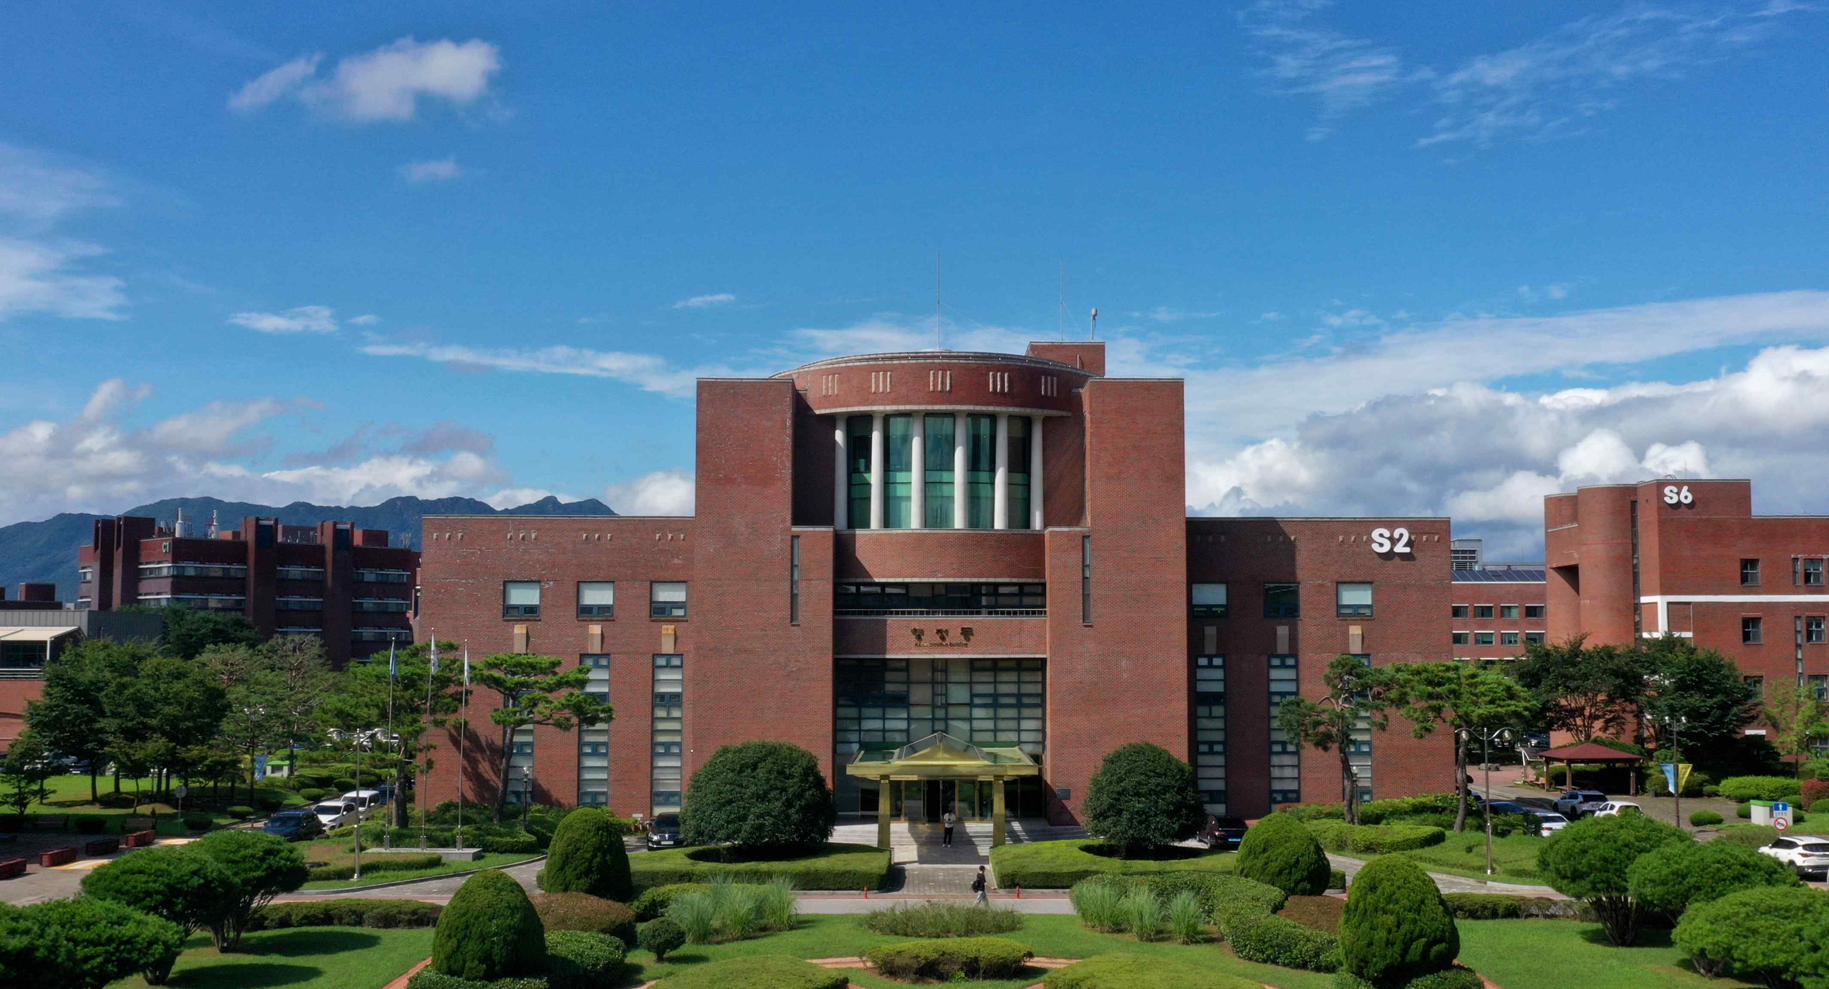
▲ Panoramic view of GIST Administrative Building

○ Report content

- The Gwangju Institute of Science and Technology (GIST) labor union conducted a survey for nine days from August 27 as a mid-term evaluation of President Lim Ki-chul’s first anniversary since his inauguration. Attention is being paid to the outcome as it coincides with an internal whistleblower’s accusation of involvement in the hiring corruption scandal of the former administration.

○ Related facts

➀ The GIST Labor Union sent an email to GIST members, including faculty, researchers, staff, and students, at approximately 11:17 a.m. on Wednesday, August 28, 2024, saying, “We would like to use this opportunity to collect opinions from not only union members but also staff, researchers, professors, and students, as well as to conduct a strict evaluation of the current GIST executive board and to seek a progressive direction,” and provided a link to an online survey.

➁ However, the objectivity and reliability of the survey have not been verified, and there is a possibility that the results will be compiled based on biased responses.

➂ In addition, as of August 29, 2024 (Thursday), the GIST Labor Union only has about 120 regular employees, so it does not have the representation to collect opinions from the entire GIST membership of about 2,900 members, including faculty, students, temporary workers, and non-union regular employees, and announce the results. Currently, the faculty representative organizations are the Faculty Council (193 members) and the GIST Faculty Union (35 members), and the student representative organizations are the Graduate Student Council (approximately 1,300 students) and the Undergraduate Student Council (approximately 860 students).

➃ Meanwhile, the GIST Labor Union has continuously filed the following unfair labor practice relief applications against our university to the local and central labor committees, but all of them have been dismissed by the labor committees. In this context, this survey is interpreted as a roundabout way to enforce the union’s demands.

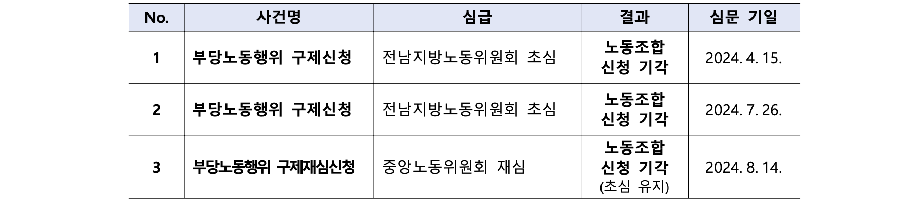

➄ Our university deeply regrets the actions of the GIST Labor Union, which lacks representation of all members, in attempting to create unnecessary public opinion through an unverified and objectivity-determining survey format.



