GIST appoints 6 AI policy, strategy and convergence experts as special professors... Accelerating practical AI+X education

- Experts from various fields ranging from management, policy, engineering, journalism, to art, including Jae-won Kwak, Editorial Director of Aju Business Daily, In-gyu Song, CEO of Incutech, Ji-hye Park, CEO of Value Creation J, Seong-beom Jo, CSO of Techready, Seok-hyeon Ahn, COO of OASYS Studio, and Seung-yu Lee, adjunct research fellow at KDI School of Public Policy and Management
- “We will foster innovative talents who can respond to domestic and international economic, social, and technological changes through convergence education and research.”

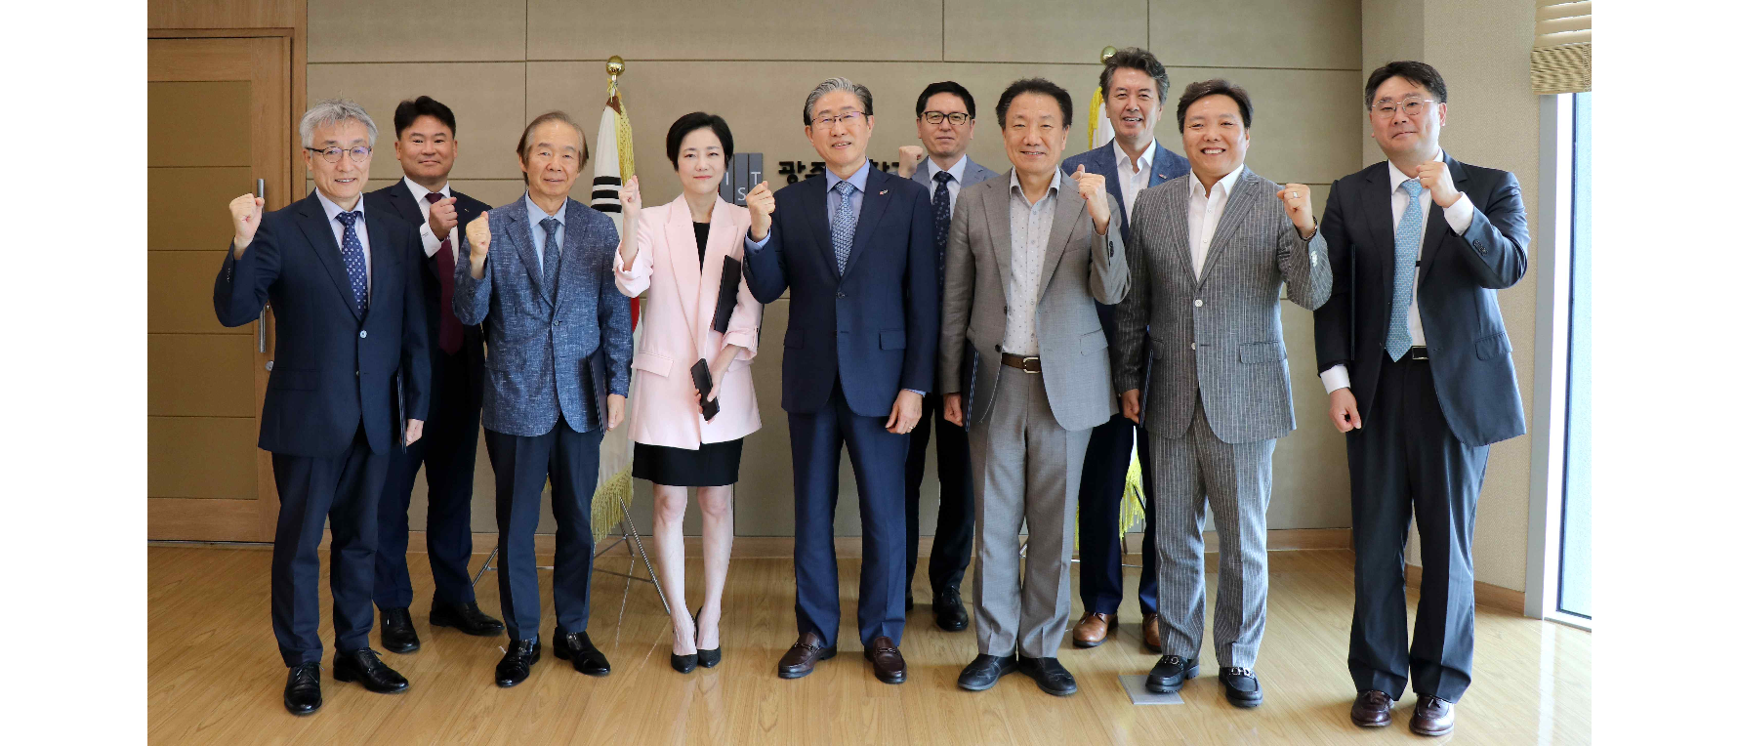▲ On Monday, the 26th, the GIST AI Policy Strategy Graduate School appointed six special professors and the attendees took a commemorative photo. (From left) Seung-yu Lee, adjunct research fellow at KDI School of Public Policy and Management, Joon Ha Kim, Dean of AI Policy Strategy Graduate School, Jae-won Kwak, Editorial Committee Chair of Ajou Economy, Ji-hye Park, CEO of Value Creation J, President Kichul Lim, Sang-Don Kim, Vice President for Academic Affairs, In-gyu Song, CEO of Incutech, Yonghwa Chung, Vice President for Public Affairs, Seong-beom Cho, CSO of Techready, and Seok-hyeon Ahn, COO of Oasis Studio.

The Gwangju Institute of Science and Technology (GIST, President Ki-cheol Lim) announced on Thursday, the 29th that it has appointed six experts in the field of artificial intelligence (AI) policy, strategy, and convergence as special professors at the AI Policy and Strategy Graduate School (Dean Joon Ha Kim), which will begin operating a degree program in September.

The special professor appointment ceremony held on Monday, the 26th in the president's office on the 5th floor of the administrative building was attended by President Kichul Lim, Vice President for Academic Affairs Sang-Don Kim, Vice President for R&DB Kwanghee Lee, and Dean Joon Ha Kim.

The experts in each field who were appointed as special professors this time are ▴ Jae-won Kwak, Editorial Director of Aju Business Daily ▴ In-gyu Song, CEO of Inqtech ▴ Ji-hye Park, CEO of Value Creation J ▴ Seong-beom Cho, CSO (Chief Security Officer) of Techready ▴ Ahn Seok-hyeon, COO (Chief Operation Officer) of Oasis Studio ▴ Seung-yu Lee, Adjunct Research Fellow at KDI School of Public Policy and Management, etc., six people.

As field experts in various fields ranging from management, policy, engineering, journalism, and art, they will be in charge of AI and convergence (AI+X) education that encompasses various fields.

President Kichul Lim said, "Faced with the crisis of population decline and regional extinction, our country must aim to become a ‘talented nation’ that fosters experts who will be active in various fields based on AI. I hope that those of you who have been appointed as special professors will foster future talents that the country and humanity need based on your field sense."

Dean Joon Ha Kim said, "We have invited experts who have observed the development of AI more deeply than anyone else and have led the convergence with AI in each field as special professors. The AI Policy and Strategy Graduate School will foster innovative talents who can respond to domestic and international economic, social, and technological changes through convergence education and research."



