GIST-National Rehabilitation Center consulting support for development of assistive devices to help disabled and elderly people in their daily lives

- GIST Senior-Friendly Industry Support Center and the National Rehabilitation Center Assistive Device Commercialization Research and Development Project Group conducted consulting for the winners of the ‘Story Contest on Difficulties in Daily Life for the Disabled and the Elderly’
- Deriving ideas for the development of ‘Wheel Acha’ (wheelchair + stroller) and listening to consumer demands... seeking practical solutions, such as discovering demand for regional-based assistive devices and suggesting policy alternatives

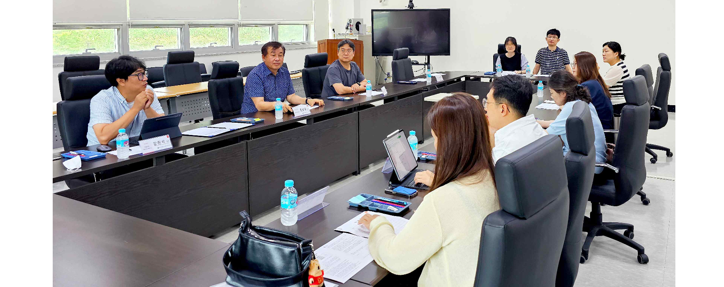▲ The GIST Senior-Friendly Industry Support Center is providing consulting to the winners of the ‘Story Contest on Daily Life Difficulties for the Disabled and the Elderly.’ (Third from the left) GIST Senior Citizen-Friendly Industry Support Center Director Chang-Myung Oh

The Gwangju Institute of Science and Technology (GIST, President Kichul Lime) announced that the Senior-Friendly Industry Support Center (Director Director Chang-Myung Oh), together with the National Rehabilitation Center Assistive Device Commercialization Research and Development Project Group, has provided consulting support for the development of a ‘Wheel Acha’ that combines a wheelchair and a stroller.

On April 20th, in celebration of the Day of Persons with Disabilities, the National Rehabilitation Center held a ‘Story Contest on Difficulties in Daily Life of the Disabled and the Elderly,’ and the Gwangju Metropolitan City selected Jin-kyung Park, who suggested the need for ‘Wheel Acha’, as the winner.

Jin-kyung Park said she entered the contest because she was looking for a way to help her husband, who is disabled due to a hard water injury, and her child, who is not yet able to walk well, solve their mobility problems, especially during outdoor activities.

The consultation was held on July 17 (Wed) at the GIST Senior-Friendly Industry Support Center with 11 participants, including GIST Senior Citizen-Friendly Industry Support Center Director Chang-Myung Oh, Kang-seok Kang, team leader of Jeonnam University's Maker Space 'Makemaru', and Kwang-ok Ahn, a researcher at the National Rehabilitation Center's Assistive Device Commercialization Research and Development Project Group, and discussed practical alternative measures to solve the daily difficulties of people with disabilities in the community, including deriving ideas for developing wheelchairs and listening to their needs, discovering demand for locally-based assistive devices, and suggesting policy alternatives.

Jin-kyung Park, who attended the day as local assistive device users, mentioned the need for assistive devices for health management such as housework, child care, and bedsore prevention. The National Rehabilitation Center presented solutions such as deriving assistive devices appropriate for the user, providing guidance on how to use them, and providing policy support for employment welfare for the disabled through an evaluation of the subject's physical function.

National Rehabilitation Center Team Leader Seon-deok Eun said, "We hope that this consulting will serve as an opportunity to discover assistive devices that disabled people and the elderly need in their actual lives, thereby improving their quality of life. We will continue to provide support and interest in the future."

GIST Senior Citizen-Friendly Industry Support Center Director Chang-Myung Oh said, "It is very important to listen directly to the voices of local disabled people and their caregivers and develop and distribute the assistive devices they need. This consulting is expected to be a starting point for practically solving the difficulties in the daily lives of local disabled people."

Meanwhile, the GIST Senior-Friendly Industry Support Center, along with the Chonnam National University Industry-Academic Cooperation Foundation, was selected this year for the Ministry of Health and Welfare's ‘Region-based Assistive Device R&SD’ project to develop and usability evaluation of assistive devices centered on local demand. It plays a role in dissemination and is taking the lead in supporting the development and development of industries friendly to the disabled and the elderly.



