GIST will be able to offer a specialized master's degree program!

- National Assembly member In-cheol Jo (Gwangju Seo-gu-gap) proposes an amendment to the Gwangju Institute of Science and Technology Act... Establishing the basis for operating a professional master's program
- GIST considers opening a professional master’s course... “Contributes to training local talent and enhancing professionalism”

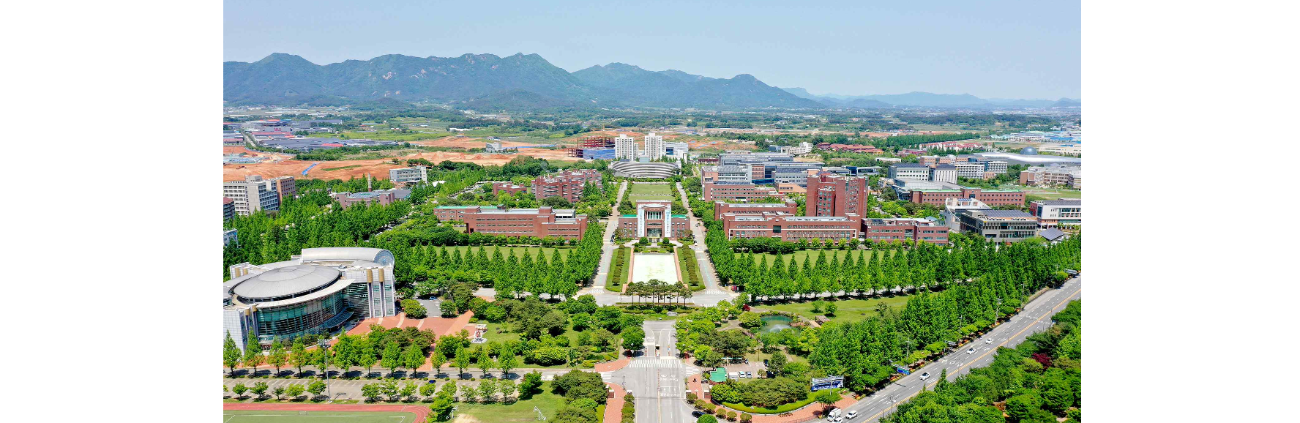▲ Panoramic view of GIST campus

It is expected that the Gwangju Institute of Science and Technology (GIST, President Kichul Lim) will be able to establish a ‘professional master’s’ degree program that will provide practical, professional knowledge education that is differentiated from existing master’s programs.

A ‘professional master’ is a master’s degree aimed at cultivating practical skills and professional knowledge in a specific field. Currently, under the 「Gwangju Institute of Science and Technology Act」, there is no legal basis for establishing and operating a professional master's degree program, unlike other science and technology institutes located in Daejeon and Ulsan.

Accordingly, In-cheol Jo, a member of the National Assembly of the Democratic Party of Korea (Gwangju Seo-gap), proposed an amendment to the Gwangju Institute of Science and Technology Act on Wednesday, July 17 to allow GIST to establish a ‘professional master’s’ degree program.

In this amendment, a provision has been made to allow GIST to create a ‘professional master’s’ course and award degrees in addition to the existing doctoral, master’s, and bachelor’s degree courses.

National Assembly member In-cheol Jo said, "In the professional master's program, talented individuals in the industrial field can develop insight into rapidly changing future technologies and practical problem-solving skills. If GIST operates a professional master's program based on its world-class science and technology education and research capabilities, it will be able to greatly contribute to helping talented people working in the local high-tech industry and public sector develop their work capabilities and expertise and pioneer their careers."

GIST expects that when a professional master's course is opened in the future, ordinary people with diverse experiences and backgrounds, such as businessmen, civil servants and public institution employees, and professionals, will have the opportunity to study at GIST.

President Kichul Lim said, "While visiting local technology companies, various local governments, and institutions, I was able to confirm that there was a lot of demand for consignment training or retraining at GIST. The professional master's program will be an opportunity to understand the latest trends in science and technology, including AI, and practical knowledge, and prepare for the future society."

