GIST holds opening ceremony and commemorative forum ahead of opening of AI Policy and Strategy Graduate School

- On the 12th (Friday), the opening ceremony of the AI ​​Policy and Strategy Graduate School and the ‘Artificial Intelligence: Social Change and Challenges’ forum were held
- This September, Korea's first AI Policy and Strategy Graduate School, which will train experts with master's and doctoral degrees in AI policy strategy, is scheduled to open

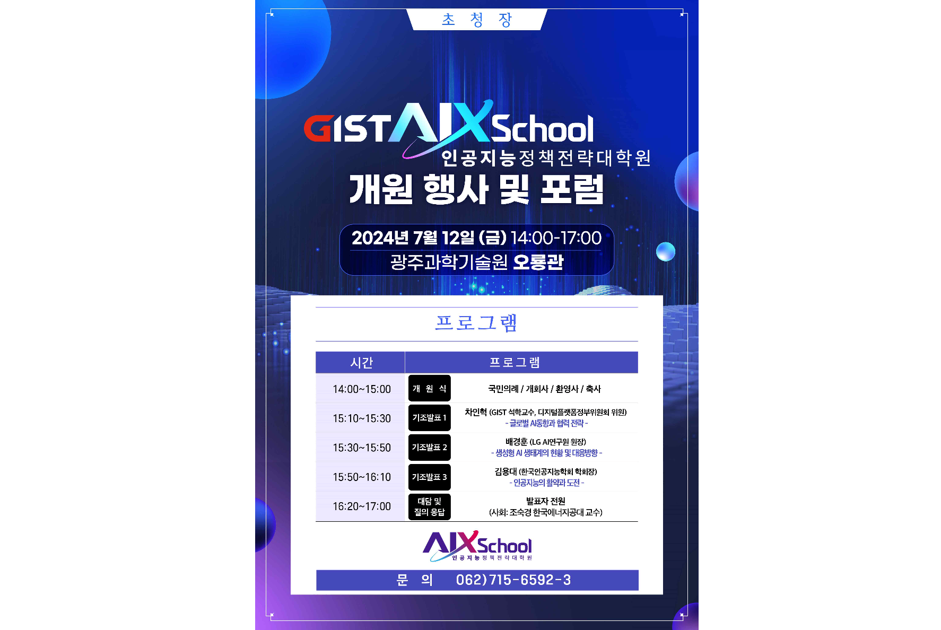▲ ‘AI Policy and Strategy Graduate School Opening Ceremony and Forum’ promotional poster

The Gwangju Institute of Science and Technology (GIST, President Kichul Lim) announced that it will hold an opening ceremony and commemorative forum at the GIST Oryong Hall on Friday, July 12 at 2 p.m. to announce the start of Korea's first AI Policy and Strategy Graduate School, which will open in September.

In particular, the AI Policy and Strategy Graduate School's regular forum, which will be held for the first time this year, will be held under the theme of 'Artificial Intelligence: Social Changes and Challenges' and will invite experts from various fields to discuss current issues and global trends in the field of artificial intelligence (AI) through keynote presentations and dialogues.

On this day, about 100 domestic and foreign figures, including those from the political world and academia, were in attendance, starting with a welcoming speech by GIST President Kichul Lim, followed by Democratic Party of Korea lawmakers Hyeong-bae Min, Jin-wook Jeong, Do-geol Ahn, Gyun-taek Park, and Jin-sook, and Gwangju City's Buk-gu mayor In Moon/ There will be on-site congratulatory remarks by Dean Jong-il Yoo of the KDI Graduate School of International Policy and video congratulatory remarks by Jin Ko, Chairman of the Digital Platform Government Committee, Representative In-cheol Jo of the Democratic Party of Korea, and Representative Sang-hwi Lee of the People Power Party.

The first forum of the Graduate School of AI Policy and Strategy included ▴'Global AI trends and cooperation strategies' (Presenter In-hyuk Cha, GIST Distinguished Professor and Digital Platform Government Committee member) ▴ 'Status of the generative AI ecosystem and response status' (Presenter Jeong-hoon Bae, LG (Director of AI Research Institute) ▴ a keynote presentation will follow with the theme of ‘Activities and Challenges of Artificial Intelligence’ (Presenter Yong-dae Kim, President of the Korean Society of Artificial Intelligence).

After the keynote presentation, a conversation and Q&A will be held, moderated by Professor Sook-kyung Cho of the Korea Institute of Energy Technology. In order to discuss global AI trends and response directions, GIST Distinguished Professor In-hyuk Cha, LG AI Research Institute Director Kyeong-hoon Bae, and President of the Korean Society for Artificial Intelligence Yong-dae Kim will participate.

AI Policy and Strategy Graduate School Dean Joon Ha Kim said, "We plan to do our best to foster AI policy experts who will contribute to AI technological innovation and building a sustainable AI ecosystem. We hope that this forum will become a venue where various stakeholders, including the public and private sectors, academia, and research circles, gather together with artificial intelligence as a topic to share their perspectives on the ripple effects that the rapid development of AI technology has on the overall economy and society and discuss major tasks."



