“Optimal path from university admission to doctorate” GIST establishes ‘Fast Track’ degree linkage course

- ‘GIFT Program’ allows you to obtain a degree in 5 years from a bachelor’s degree to a master’s degree, and 7 years to a doctoral degree… Changes to graduate school programs (master’s → combined master’s and doctoral) are also allowed
- “Opening of ‘Autobahn’ to allow students to focus on academics and research without the need to prepare for admission to advanced degree programs”... Applications for the first selection will be accepted by Friday, June 28, and full-scale selection is scheduled for July

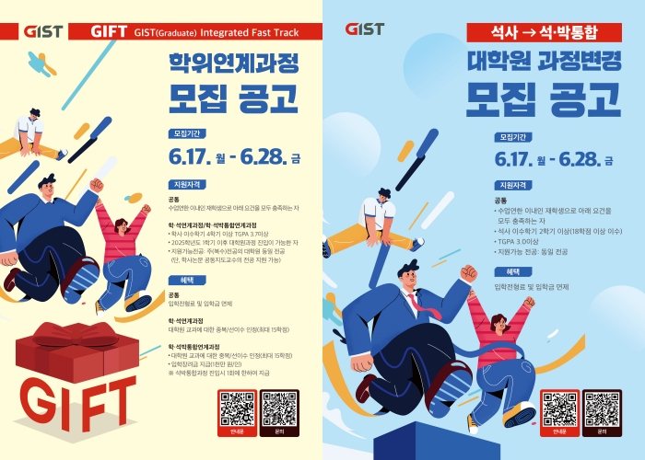▲ Degree-linked course recruitment notice poster (left), Graduate school course change recruitment notice poster (right)

The Gwangju Institute of Science and Technology (GIST, President Kichul Lim) announced that it has established an innovative degree-linked course that allows students to receive a doctoral degree within 7 years of entering the college in order to foster more efficient science and technology talent.

GIST has introduced a 'fast track' including ▴ degree linking courses (bachelor's degree linking, combined bachelor's and master's and doctoral degrees) and ▴ graduate school course changes (master's → master's and doctoral combined). Applications will be accepted until the 28th of this month and final selection will be made in August. Therefore, full-scale operation will begin from the first semester of next year.

In particular, the 'GIFT (GIST (Graduate) Integrated Fast Track) (hereinafter GIFT)', which is a combined undergraduate and graduate course and an integrated undergraduate and master's degree program, provides overlapping recognition (within 15 credits) of graduate course credits acquired during the bachelor's program. This program is designed to allow students to obtain a doctoral degree in 7 years of study, including 3.5 years of bachelor's degree. If a student enrolled in a bachelor's program satisfies all requirements for early graduation and completion of graduation requirements, he or she may be able to shorten one year to the doctoral program in the earliest case.

Students aiming to obtain a doctoral degree have the advantage of being able to obtain a master's or doctoral degree in the shortest possible time by completing graduate school course credits, conducting research, and writing a thesis through 'GIFT'.

GIST plans to select students to enter the ‘GIFT Program’ once each semester from undergraduate students who have completed at least 4 semesters and have a GPA of 3.7 or higher (out of 4.5).

Selected students are provided with a variety of benefits, including an admission incentive (KRW 10 million) and recognition of duplicate credits (up to 15 credits), and are able to pursue studies and research by following an optimized path to obtaining a degree without any additional preparation for admission to a higher degree program.

In addition, GIST introduced the ‘graduate course change (master’s → combined master’s and doctoral)’ academic system, which allows students who are completing a master’s course at a graduate school to ‘enter midway’ into the integrated master’s and doctoral program.

This system is designed to strengthen the operation of graduate school degree programs by simplifying the doctoral program admission process for master's students and creating an environment for immersion in research.

Academic Affairs Dean Sukwon Hong said, "The new degree program opens the ‘Autobahn’ so that students with qualifications as science and technology researchers can run at their own speed. In the era of competition for technological hegemony, it is expected to contribute to stably nurturing convergent science and technology talents with research capabilities."



