GIST invites author Youngha Kim to hold a public lecture on the topic of ‘Creativity in the Age of Artificial Intelligence’

- In order to realize the value of ‘sharing’, GIST’s new external cooperation vision, special lectures are held with local residents inviting prominent figures... Creative consideration of ‘human creativity’
- May 21st (Tuesday) at 2:00 PM, in room 303 of Oryong Hall... 270 people can enter on a first-come-first-served basis

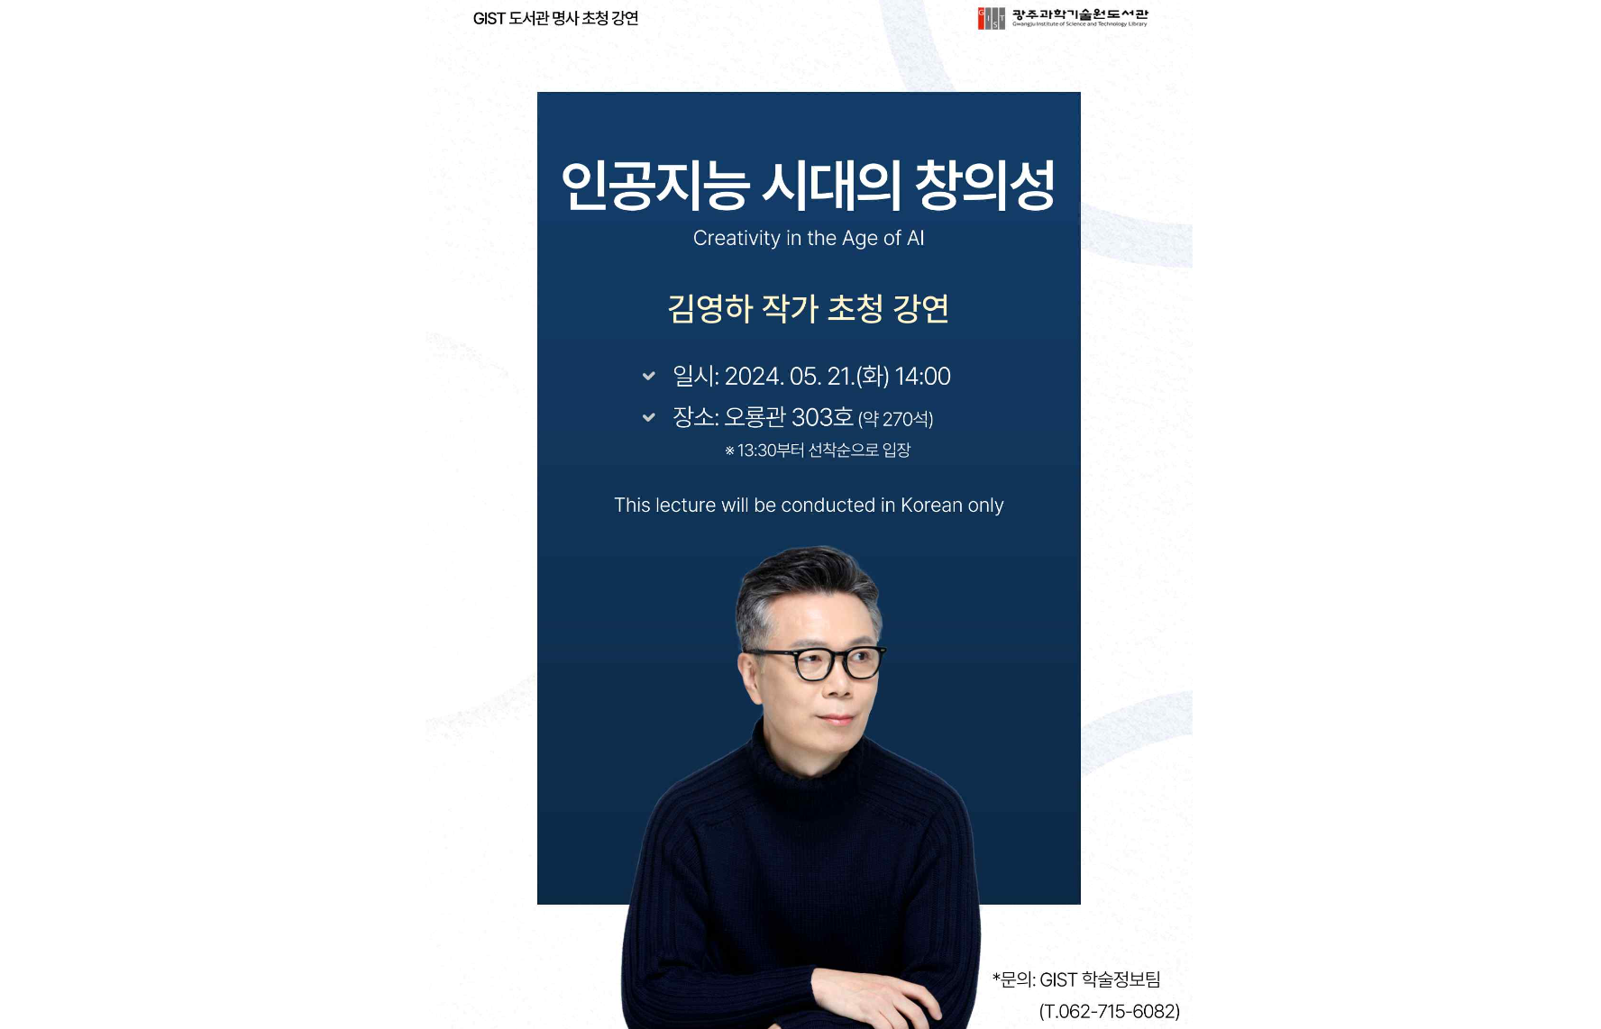▲ Poster for author Youngha Kim’s invited lecture ‘Creativity in the Age of Artificial Intelligence’

The Gwangju Institute of Science and Technology (GIST, President Kichul Lim) announced that it will invite author Youngha Kim to hold a special lecture in room 303 of Oryong Hall for about two hours from 2:00 PM to 3:50 PM on Tuesday, May 21.

This lecture was prepared by GIST, which has established a new external cooperation vision of advancing ‘towards the future with the region’ by adding ‘sharing’ to science and technology, to share humanities knowledge with local residents.

Youngha Kim will speak on the topic of 'Creativity in the Age of Artificial Intelligence': ▴ ordinary humans are originally far from creative, but have evolved to compensate for this through art ▴ it is a misconception that humans are creative, and they hate creativity ▴ how art can compensate for the creativity that ordinary humans lack ▴ how art awakens human creativity, etc. will be explained in an easy-to-understand manner.

Office of Library and Information Resources Dean Hyunju Lee said, "We expect that author Youngha Kim's lecture will be a useful opportunity to expand humanities knowledge not only for GIST members but also for interested local residents. GIST Library will continue to organize various events to serve as a place for empathy and exchange with local residents."

Meanwhile, author Youngha Kim, who debuted in the quarterly 'Review' in 1995 with 'Meditation on the Mirror', has published numerous bestsellers including 'Farewell', 'Memories of a Murderer', 'I Hear Your Voice', and 'Reason for Travel'. Recently, he has appeared on tvN's 'Useful Sinjab' and 'Useful and Influential Job', gaining public popularity and sympathy with his abundant knowledge and unique eloquence.

For inquiries about special lectures by author Youngha Kim, please contact the GIST Office of Library and Information Resources Team (062-715-6082).



