The 1st GIST Science Imagination Children’s Art Contest will be held on Saturday, May 18th on GIST campus... Application accepted for 200 kindergarten and elementary school students

- GIST declared on April 23 its first children's art contest for shared growth between local and university areas as part of realizing the vision for external cooperation (sharing)... Jointly sponsored by GIST Development Foundation and Gwangju Metropolitan Office of Education
- Pre-registration for 200 people through QR code on a first-come, first-served basis... 47 awards are scheduled to be awarded, including the Gwangju Metropolitan City Superintendent of Education Award (Grand Prize), GIST President Award (Gold Award), and GIST Development Foundation Chairman Award (Silver Award)

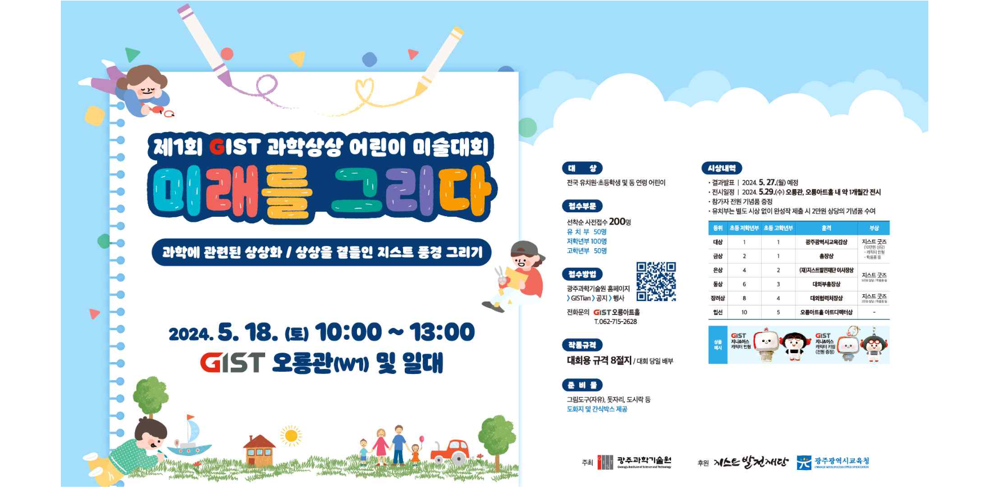▲ GIST 1st Science Imagination Children’s Art Contest event poster

The Gwangju Institute of Science and Technology (GIST) announced on Tuesday (May 30) that it will hold the "1st GIST Science Imagination Children's Art Contest" from 10 a.m. to 1 p.m. on Saturday, May 18, under the slogan “Drawing the Future."

The GIST Science Imagination Children's Art Contest, jointly sponsored by the GIST Development Foundation and Gwangju Metropolitan Office of Education, will be held at the GIST Oryong Hall and surrounding areas.

This contest is the first children’s art contest held by GIST, which has established a new external cooperation vision of advancing ‘towards the future with the region’ by adding ‘sharing’ to science and technology.

At the ‘GIST External Cooperation (Sharing) Vision Declaration Ceremony’ held on April 24, Vice President for External Affairs Yonghwa Chung announced that GIST will open its campus to contribute more to the development of the local community with ▴ May Science Imagination Art Contest ▴ October Middle School Student Science Writing Contest ▴ Citizen’s culture course in connection with local media outlets ▴ Governor Joo-bae Lee has announced that he plans to take the lead in spreading the culture of sharing, including by opening Korean language classes for Gyeongin people.

Kindergarten students, elementary school students, and children of the same age from all over the country can apply for participation through the event section of the GIST website or through the QR code on the poster. 200 students, including 50 students per grade, are accepted on a first-come, first-served basis. Drawing paper and snack boxes will be provided by GIST, and students must prepare their own drawing tools (optional), mats, and lunch boxes.

Participating children can freely draw ▴ an imaginary drawing related to science (artificial intelligence, space, biotechnology, etc.) or ▴ an imaginary GIST landscape on standard 8-section paper distributed on the day of the competition and submit the completed work.

GIST will give a souvenir to all participants, and children participating in kindergarten will receive a prize worth 20,000 won when they submit their completed work without a separate award.

Submitted works will be reviewed by a panel of professional judges to select winners and announce them on May 27th. A total of 47 works (31 from the lower grades, 16 from the upper grades) were selected and awarded the Gwangju Metropolitan City Superintendent of Education Award (1 from the lower grades, 1 from the upper grades), the GIST President's Award (2 from the lower grades, 1 from the upper grades), and the GIST Development Foundation plan to award the Chairman's Award (4 students from the lower grades and 2 students from the upper grades).

Additionally, the winning work will be displayed for approximately one month from May 29 at the exhibition space ‘Oryong Art Hall’ created by GIST on the inside walls of the 1st and 2nd floors of Oryong Hall, a multi-purpose building on campus to provide a venue for exchange and cooperation with the local community.

Vice President for External Affairs Yonghwa Chung said, "The love of the local people was a decisive factor in GIST growing into a research-oriented university representing the Honam region today. Starting with today's art contest, in addition to existing social contribution activities, members plan to practice 'sharing' in earnest in their respective positions by sharing talent, technology, goods, and cash. We also ask for the support and encouragement of local residents so that GIST can focus more efforts on regional development in the future."

Detailed information about the ‘GIST Science Imagination Children’s Art Contest’ can be found on the GIST website (announcement (event) bulletin board), and for related inquiries, please contact Oryong Art Hall (062-715-2628).

