GIST sends graduate school scholarship students to overseas research institutes... 3 million won per month for 9 months to focus on research

- A total of KRW 102 million in scholarships for 9 months will be provided to 4 ‘GIST-IREF’ scholarship students selected in March this year... Separate support of up to KRW 4 million for departure preparation expenses
- Conducted international joint research dispatched to the Max Planck Institute in Germany, the Swiss Federal Institute of Technology in Lausanne, the Australian Federal Organization for Scientific and Industrial Research, and the University of Linköping in Sweden

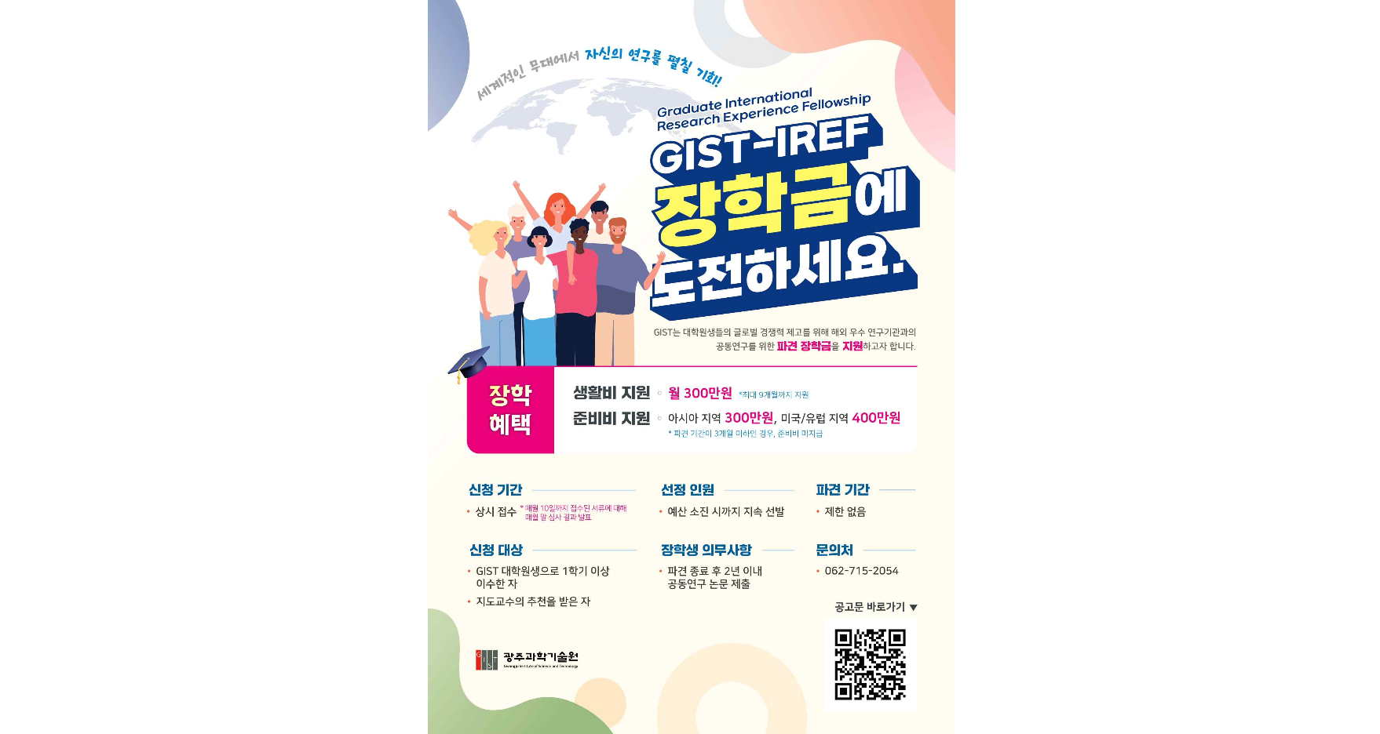▲‘Take on the GIST-IREF Scholarship’ application information poster

The Gwangju Institute of Science and Technology (GIST, President Kichul Lim) announced on the 25th (Thursday) that it has selected the first four scholarship students for the 'GIST Graduate International Research Experience Fellowship (hereinafter referred to as IREF)' and will provide 3 million won per month per person for 9 months.

In order to encourage joint research activities with overseas research institutions and support stable living conditions in other countries, GIST has established a new ‘GIST-IREF (Graduate International Research Experience Fellowship)’ scholarship system for graduate students and is starting this semester.

The four students selected as scholarship students for the 1st GIST-IREF, including ▴ Myeong-jin Park, a combined master's and doctoral student in the School of Integrated Technology, ▴ Soo-jin Shin, a doctoral student in the School of Earth Sciences and Environmental Engineering, ▴ Lee Min-woo, a combined master's and doctoral student in the School of Materials Science and Engineering, and ▴ Jong-won Lee, a doctoral student in the School of Materials Science and Engineering, will receive up to a maximum of support for departure preparation expenses. Support up to 4 million won for departure preparation expenses, and separately, 3 million won per month for living expenses will be paid for 9 months so that they can focus entirely on research at the dispatched location.

These four IREF scholarship students are students with excellent academic and research achievements in their respective fields. Starting this month, they will be dispatched to ▴ Max Planck Institute in Germany ▴ ETH Lausanne in Switzerland ▴ Australian Federal Agency for Scientific and Industrial Research ▴ University of Linköping in Sweden to carry out joint research.

Myeong-jin Park, an integrated course student who is researching intelligent robots in the Integrated Technology, has been conducting joint research at the Max Planck Institute in Germany to ‘develop microrollers for intravascular drug delivery’ since mid-March.

Student Myeong-jin Park said, "I am grateful to GIST for providing a stable environment through good systems so that I can focus solely on research. As a young researcher, I will take pride in representing GIST and strive to achieve meaningful results."

Academic Affairs Dean Sukwon Hong said, "We plan to further activate this scholarship system to enhance the research capabilities and academic growth of graduate students, and we will do our best to support GIST students so that they can demonstrate excellent research capabilities overseas and further contribute to the development of science and technology in our country."



