GIST, T3Q Co., Ltd., and Gaon Platform Co., Ltd. are working to develop an integrated artificial intelligence and big data platform to realize smart industries

- GIST Institute for Artificial Intelligence - T3Q Co., Ltd. and Gaon Platform Co., Ltd. signed an MOU on Friday the 19th to begin full-scale collaborative research and development
- T3Q Co., Ltd. and Gaon Platform Co., Ltd. will establish an affiliated research center for each institution on the GIST campus... Plans to conduct overall research and development on AI solutions and big data platforms

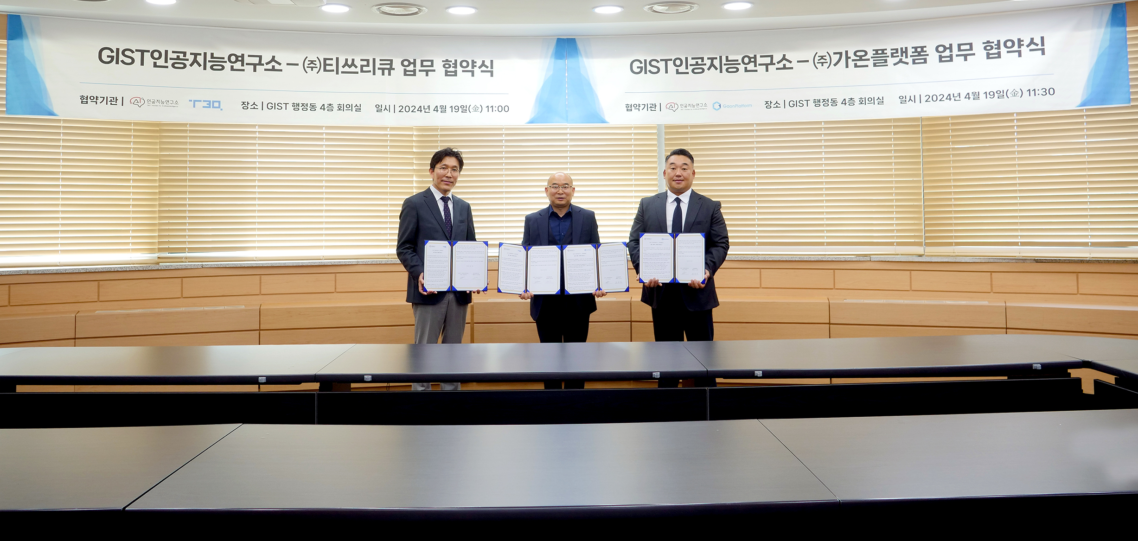▲ GIST Institute for Artificial Intelligence signed an MOU with T3Q Co., Ltd. and Gaon Platform Co., Ltd. for the purpose of joint research and development of an ‘integrated platform related to artificial intelligence (AI) and big data for the realization of smart industry’ and took a commemorative photo. (From left) T3Q Co., Ltd. CEO Byeong-hoon Park, GIST Institute for Artificial Intelligence Director Chang Wook Ahn, Gaon Platform Co., Ltd. CEO Man-young Cho

The Gwangju Institute of Science and Technology (GIST, President Kichul Lim) and the Institute for Artificial Intelligence (Director Chang Wook Ahn) announced that an MOU was signed with T3Q (CEO Byeong-hoon Park) and Gaon Platform (CEO Man-young Cho) for the purpose of joint research to develop an 'integrated platform related to artificial intelligence (AI) and big data for the realization of smart industries.'

▴T3Q Co., Ltd. is an AI specialist company that has played a leading role in helping Korea utilize it best in the world. It was the first in Korea to develop the ‘Real-time Big Data Artificial Intelligence Integrated Platform’. ▴Gaon Platform Co., Ltd. is an AI platform specialist company that provides AI image analysis, AI facility condition prediction diagnosis, AI statistical analysis, and AI security solutions through Internet of Things (IoT) convergence.

GIST Institute for Artificial Intelligence decided to pursue mutual cooperation and is developing ▴ LLM (Large Language Model) and multi-modal integrated solutions specialized for companies and organizations related to AI big data platform with T3Q Co., Ltd. and ▴ development of AI video analysis and AI security solutions with Gaon Platform Co., Ltd.

This MOU is the first fruitful achievement of GIST's Institute for Artificial Intelligence after establishing practical collaborative research with various companies in the industry as its operational direction, and it will be able to anchor the establishment and operation of a new industry-university collaborative research and development model between university research centers and companies in the future.

T3Q Co., Ltd. and Gaon Platform Co., Ltd. have each established an affiliated research institute on the GIST campus to mutually share human and material resources with the Institute for Artificial Intelligence and plan to carry out overall research and development on AI solutions and big data platforms.

Institute for Artificial Intelligence Director Chang Wook Ahn said, "In general, there is a regret that AI technology development in university research institutes does not reflect the reality of actual companies. This business agreement is expected to present a new industry-academic cooperation research and development model to realize the development of practical AI application technology that harmonizes theory and practice through close cooperation between university research institutes and companies."

Meanwhile, the Institute for Artificial Intelligence, established in 2018 to consolidate AI convergence R&D capabilities within GIST and serve as a bridgehead for the demonstration and startup of the AI Industrial Convergence Complex being built in the high-tech District 3, is currently focusing on research and development of knowledge-data synthetic AI technology and applications that can think and reason like humans with little data.

