GIST Senior-Friendly Industry Support Center signed a business agreement with Gwangju Metropolitan City Assistive Device Center

- Assistive device industry development support and service distribution infrastructure linkage... establishment of one-stop living lab
- Synergy effects are expected as one-stop promotion is possible from product development and commercialization to field verification application

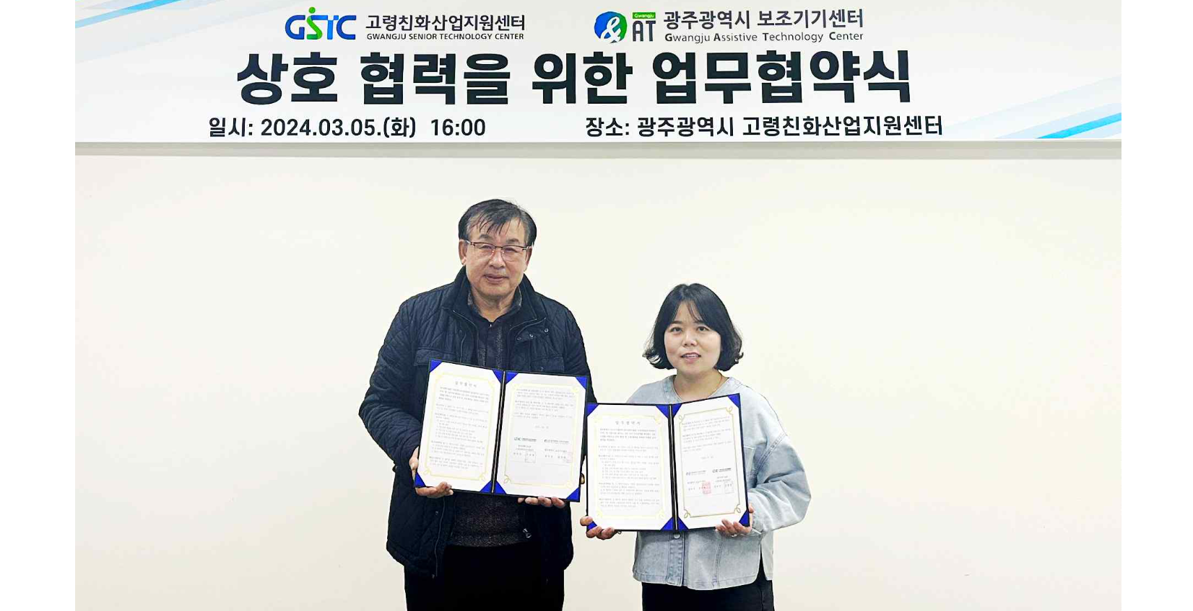▲ GIST Senior-Friendly Industry Support Center and Gwangju Metropolitan City Assistive Device Center signed a business agreement to foster the assistive device industry and link services and are taking a commemorative photo. (From left) Nam-pyo Hong, deputy director of GIST Senior-Friendly Industry Support Center, and Geum-ran Cho, team leader of Gwangju Metropolitan City Assistive Device Center.

The Gwangju Institute of Science and Technology (GIST, President Kichul Lim) announced that the Senior-Friendly Industry Support Center (Center Director Chang-Myung Oh, hereinafter "Center") signed a business agreement with the Gwangju Metropolitan City Assistive Device Center (Center Director Kyung-rae Moon) on Tuesday (May 5) to foster the assistive technology industry and link services.

The agreement ceremony was held at the Senior-Friendly Industry Support Center located in Nam-gu, Gwangju, with Chang-Myung Oh, GIST Senior-Friendly Industry Support Center Director, Kyung-rae Moon, Gwangju Assistive Devices Center Director, and related workers in attendance.

Both organizations will ▴ establish and revitalize a living lab to foster the assistive device industry and provide services ▴ suggest joint policy and business planning for regional economic development ▴ promote cooperation such as mutual exchange of infrastructure.

Since its opening in 2011, the Gwangju Metropolitan City Assistive Device Center, which provides customized assistive device rental services through exhibition hall operation, tours, consultations, and evaluations, has provided services such as assistive device remodeling, manufacturing, rental, inspection, and cleaning, as well as welfare centers and special facilities. They are working to expand the base for distributing and utilizing assistive devices by linking with local community organizations such as schools, public health centers, and hospitals.

Director Chang-Myung Oh said, "This is expected to create a great synergy effect in that it can promote related companies' product development and commercialization to field verification application in one stop together with the Gwangju Metropolitan City Assistive Device Center."

Director Kyung-rae Moon said, "This business agreement will serve as a valuable foundation for developing and servicing assistive devices tailored to life needs based on the experience and infrastructure of both organizations."

Meanwhile, the GIST Senior-Friendly Industry Support Center is leading the growth of the industry by promoting the formation of an industry-academia-research consultative body to develop assistive devices tailored to the characteristics of the Honam region, fostering the assistive device industry and making the region elderly-friendly through discovering ideas and demands, product development, usability evaluation, and commercialization.



