GIST Led by GIST Advanced Photonics Research Institute, Korea becomes the 8th board member of the International Foundation High Altitude Research Stations
‘New Space Era’ R&D in full swing

- Utilize research infrastructure that can create an environment closest to space... perform verification tests, etc.
- GIST Advanced Photonics Research Institute has laid the foundation for empirical testing of space optical network technology development research.. Expected to lead the field of space electro-optical technology

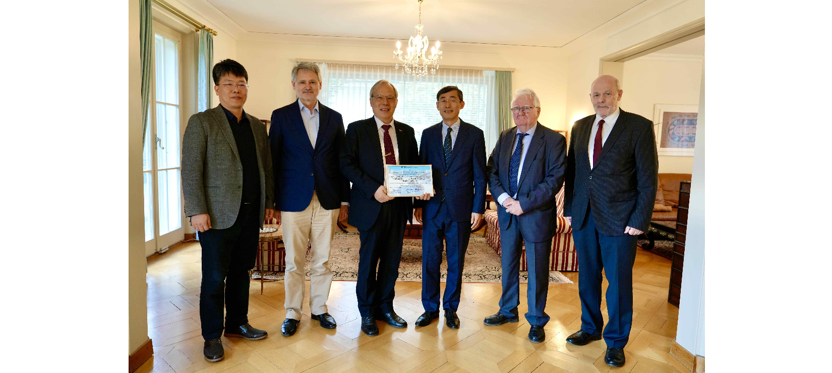▲ Korea became the 8th country in the world to join the International High Altitude Research Facility Foundation, with GIST Advanced Photonics Research Institute as its representative research institute, and is taking a commemorative photo. (From left) GIST Advanced Photonics Research Institute Senior Researcher Woojin Shin, Professor Markus Leuenberger, Director of the International Foundation High Altitude Research Stations, GIST Advanced Photonics Research Institute Director Do-Kyeong Ko, Ambassador Chang-rok Keum of the Korean Embassy, Walter Inabnit, Chairman of InaTec AG, and Silvio Decurtins, Chairman of the International Foundation High Altitude Research Stations

The Gwangju Institute of Science and Technology (GIST, President Kichul Lim) has announced that Korea has become the eighth country in the world to join the board of directors of the International Foundation High Altitude Research Stations Jungfraujoch and Gornergrat, with GIST's Advanced Photonics Research Institute (Director Do-Kyeong Ko) as its representative research institute.

The signing ceremony was held on the 28th (Wednesday) with Do-Kyeong Ko, Director of GIST Advanced Photonics Research Institute, and Silvio Decurtins, Chairman of the International Foundation High Altitude Research Stations. It was held at the residence of the Korean Embassy in Bern, Switzerland, with the attendance of Korean Ambassador to Switzerland Chang-rok Keum and domestic industry, academia, and research institute officials.

The International Foundation High Altitude Research Stations, which conducts various research in the fields of environment, bio, and medicine using the special climatic environment of the alpine region in a high-altitude environment located at an altitude of more than 3000 m above sea level in the Jungfrau and Gornergrat regions of Switzerland, is one of the 7 largest research facilities in the world. There are 8 member countries (Belgium, Germany, UK, Austria, Finland, China, and Switzerland), and Korea has joined as the 8th member through the GIST Advanced Photonics Research Institute.

The high-altitude research facility owned by the Foundation in the Swiss Alpine region, which can most closely simulate the space environment on the ground, is the only place where demonstration tests of satellite-satellite and ground-satellite long-distance laser transmission and reception and tracking alignment technology can be conducted.

The International Foundation High Altitude Research Stations operates research facilities on the eastern ridge of the Jungfrau (a research base at the former Swisscom relay station, the Sphinx Observatory and laboratory) and the southern and northern Gornergrat (two observatories) and provides the infrastructure necessary for scientific research to researchers around the world.

GIST Advanced Photonics Research Institute has been conducting joint research in the field of lasers and optics with the Institute of Applied Physics at the University of Bern, Switzerland, since 2009. The focus is on research that applies optical and laser application technologies to the aerospace field.

The research institute plans to utilize the infrastructure of the International Foundation High Altitude Research Stations for the empirical tests currently being conducted to evaluate the performance of inter-satellite laser communication technology.

Silvio Decurtins, Chairman of the International Foundation High Altitude Research Stations, said, "So far, the foundation's research facilities have been mainly used in the environmental, atmospheric, bio, and pharmaceutical fields, but with GIST joining the membership on behalf of Korea, it is expected that this will serve as an opportunity to expand the use of the foundation's operating facilities to the space satellite field."

GIST Advanced Photonics Research Institute Director Do-Kyeong Ko said, "By joining the board of directors of the International Foundation High Altitude Research Stations, a foundation for empirical testing has been laid for the space optical network technology development research being conducted by the institute. By increasing research excellence through verification in similar environments, Korea will be able to lead the field of space electro-optical technology."

In addition, Director Do-Kyeong Ko said, "The institute will expand its research collaboration on optical and laser application technologies for space and satellite applications with the Center for Space Research and Planetary Sciences at the University of Bern, Switzerland, which has an accredited space-environment certified test facility and is involved in various planetary exploration programs of the National Aeronautics and Space Administration (NASA) and the European Space Agency (ESA)."



