GIST opens up future education using artificial intelligence… ‘AI and ChatGPT Education Challenge’ held

- Various programs prepared according to the level and interests of participants, including the general public... Held on February 23rd (Friday), 26th (Monday), and March 7th (Thursday)
- ChatGPT open education is expected to strengthen practical capabilities using AI and expand the base of future education

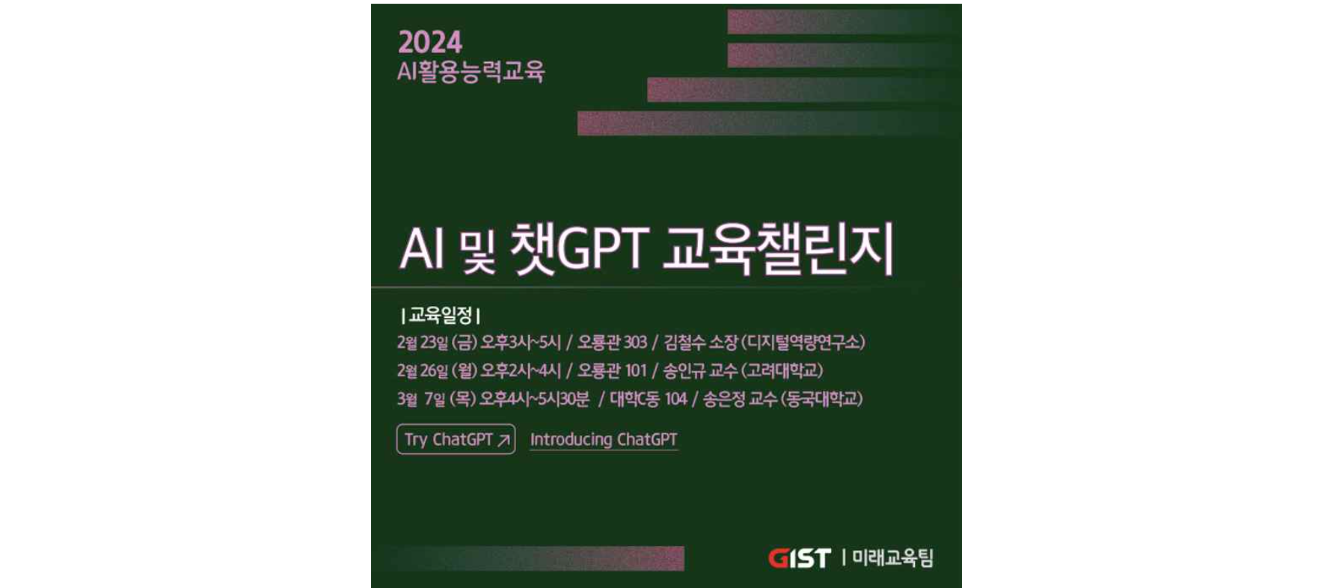▲ GIST AI and ChatGPT education challenge schedule information

While the government is promoting the 'AI Daily Life Project', which improves the quality of life for all citizens by applying artificial intelligence (AI) to essential services such as medical care and education, the Gwangju Institute of Science and Technology (GIST, President Kichul Lim) is developing the foundation for AI-based education and has announced that the 'AI and ChatGPT Education Challenge' will be held to expand and strengthen practical capabilities.

In the sense that it has boldly diversified the composition of the ChatGPT education program, which was previously conducted one-time and piecemeal targeting specific education groups, and broadened the spectrum of education participants, GIST has called this education program a 'challenge' and, through customized training sessions, not only GIST members but also the general public can take the course.

‘AI and ChatGPT Education Challenge’ includes ▴ (for GIST faculty and staff) Friday, February 23rd, 3:00-5:00 PM, Digital Competency Research Institute Director Cheol-soo Kim (Oryong Building Room 303) ▴ (for employees and the general public) Monday, February 26th, 2:00-4:00 PM, Korea University Professor In-gyu Song (Oryong Hall Room 101) ▴ (for students and researchers) a total of three lectures will be held, including a lecture by Dongguk University Professor Eun-jeong Song (University Building C Room 104) on March 7th (Thursday) from 4:00 to 5:30 p.m. In the case of the training held on February 26th (Monday), which is open to the general public, the general public can attend without prior application and follow the simple course registration process on site.

Planning Dean Hisam Kim said, "The various discussions about ChatGPT sparked by technological innovation are a signal foreshadowing changes in the education ecosystem that will be brought about by AI across the world. GIST will continue to respond nimbly to new digital technologies and contribute to the development of the local community while leading effective digital transformation in the educational field."

The GIST Division of Liberal Arts and Sciences held a seminar on ‘ChatGPT and University Education Challenges’ on Tuesday, January 30th, to explore the impact of artificial intelligence on university education and had in-depth discussions on how generative AI technology can shape the future of academics.

It was evaluated as opening a new perspective on the future of education by initiating an important discussion on the combination of university education and AI technology.

In addition, GIST established general standards for the use of generative AI in education and research by internally providing guidance on the ‘GIST Generative AI Utilization Principles’ hosted by the Future Education Team last January.

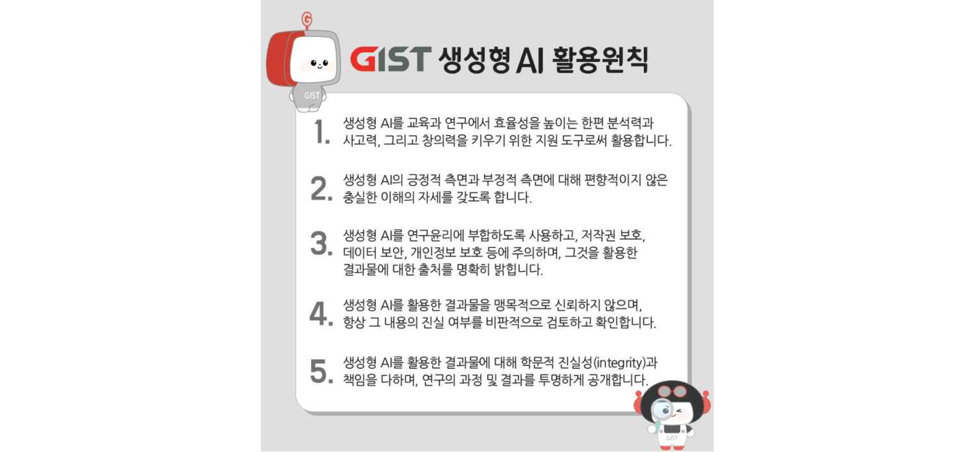▲ GIST generative artificial intelligence (AI) utilization principles

GIST College Dean Kwang Hee Ko said, "Through the ‘AI and ChatGPT Education Challenge’, GIST is quickly responding to strengthening practical capabilities using AI and creating a future-oriented educational environment. I hope this will be an opportunity to understand new digital technologies and actively consider the role of education in the era of great digital transformation."

Meanwhile, GIST, which is the only university in Korea equipped with a high-performance AI computing environment (HPC-AI, 6PF)* and a national data center (AICA) infrastructure, has excellent education and research capabilities, including opening Korea's first AI Policy and Strategy Graduate School in September, and is leading the development of AI technology and policy.

* HPC (High Performance Computing): A technology that processes at a speed more than a million times faster than that of a typical commercial desktop; 6PF means it can perform 6,000 trillion operations per second.



