GIST signs MoU with the Korean Agency for Technology and Standards to develop the senior industry

- Establishment of a cooperation system to strengthen the competitiveness of the senior industry based on Korean human body data
- Close support necessary for product development is planned to be strengthened by researching and disseminating data that meets the needs of companies in the region

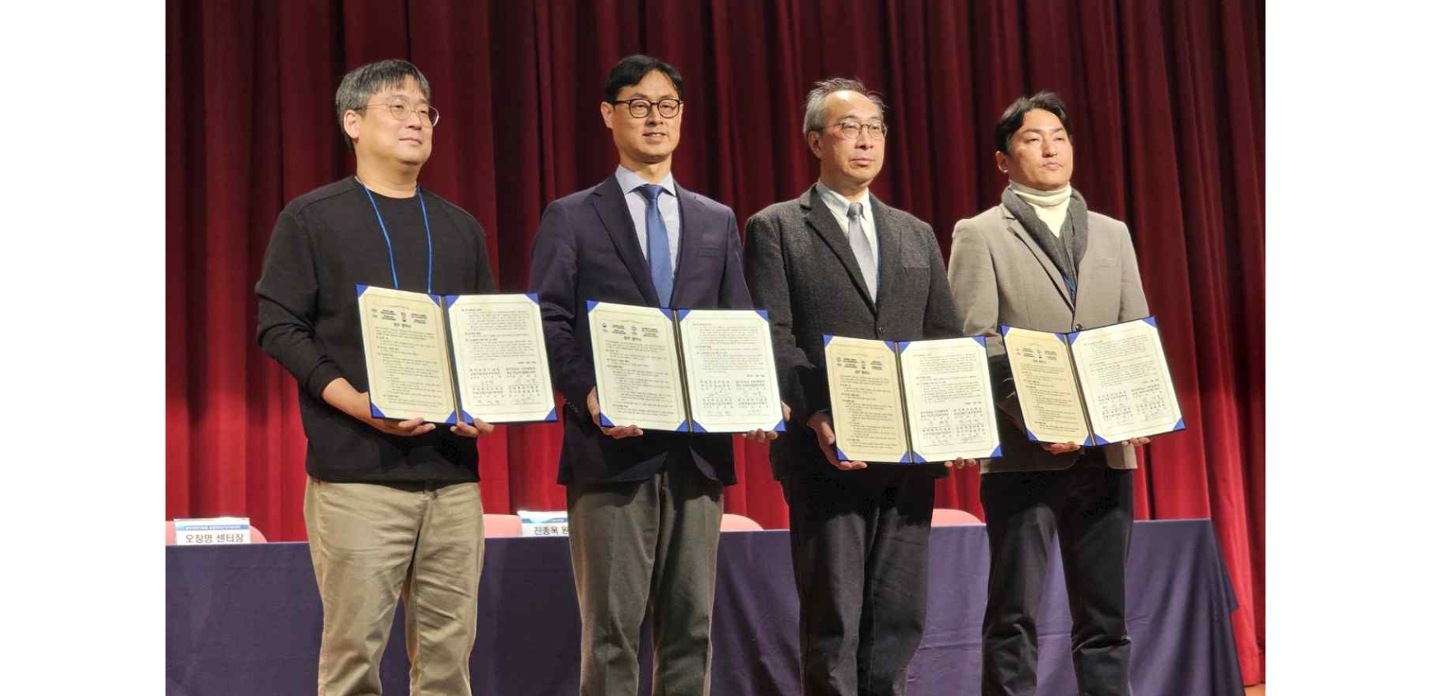▲ Senior industry support organizations in three regions, including the GIST Senior-Friendly Industry Support Center, and the Korean Agency for Technology and Standards are taking commemorative photos at the ‘Memorandum of Agreement on Expansion of Utilization of Human Body Data of Elderly People for the Development of the Senior Industry’ on the 28th. (From left) GIST Senior-Friendly Industry Support Center Director Chang-Myung Oh, Korean Agency for Technology and Standards Director Jong-wook Jin, Seongnam Senior Industry Innovation Center Director Jae-ho Shin, Busan Techno Park Medical Technology Support Center Director Seong-cheol Jeon

The Gwangju Institute of Science and Technology (GIST, President Kichul Lim), the Senior-Friendly Industry Support Center (Director Chang-Myung Oh) and the Ministry of Trade, Industry and Energy's Korean Agency for Technology and Standards (Director Jong-wook Jin, hereinafter referred to as the National Institute of Standards and Technology) are conducting a 'work on the expansion of the use of elderly people's human body data for the development of the senior industry' and announced that an agreement had been signed.

In addition, a joint business agreement with the same content was carried out with senior industry support organizations in two regions (Seongnam and Busan).

The agreement ceremony was held at the Seongnam Senior Industry Innovation Center on the 28th (Thursday) with GIST Senior-Friendly Industry Support Center Director Chang-Myung Oh, Korean Agency for Technology and Standards Director Jong-wook Jin, and Seongnam Senior Industry Innovation Center Director Jae-ho Shin. About 50 people, including Busan Techno Park Medical Technology Support Center Director Seong-cheol Jeon and senior industry officials, attended.

Through the 'Korean Human Body Measurement Survey Project (Size Korea),' the National Institute of Standards and Technology conducts human body size surveys every five years. As a result, it holds a vast amount of Korean human body standard information, including direct human body measurements and 3D measurement measurements, and as of last April, The ‘Human Body Dimension Survey for the Elderly’ was announced.

This agreement was promoted to actively respond to the government's efforts to strengthen the competitiveness of the elderly-friendly industry and support and foster it as a national growth engine industry by establishing a public-private cooperation and support system to utilize it.

Senior industry support organizations in three regions (Gwangju, Seongnam, and Busan) and the National Institute of Standards and Technology will serve as regional bases for industry, academia, and research information exchange cooperation, such as ▴data measurement, dissemination, and utilization consulting to improve senior industry products and services based on human body data ▴discovery of demand for human body data industry and return of results to strengthen the competitiveness of the senior industry.

Director Chang-Myung Oh said, "Although numerous products have been developed for the elderly, commercialization has been difficult due to the focus on R&D and creation that excludes the characteristics of the elderly. Through this cooperation, we will lead a new paradigm in the senior-friendly industry in the region by converging the center's data on seniors' lives and supporting the development of consumer-centered products."

