GIST hosts information session for UC Berkeley Student Placement Program
<SAP · Summer Session>

- UC Berkeley representative visits GIST... GIST has continued exchanges with UC Berkeley for 15 years since dispatching 100 first-generation undergraduate students in the summer semester of 2010

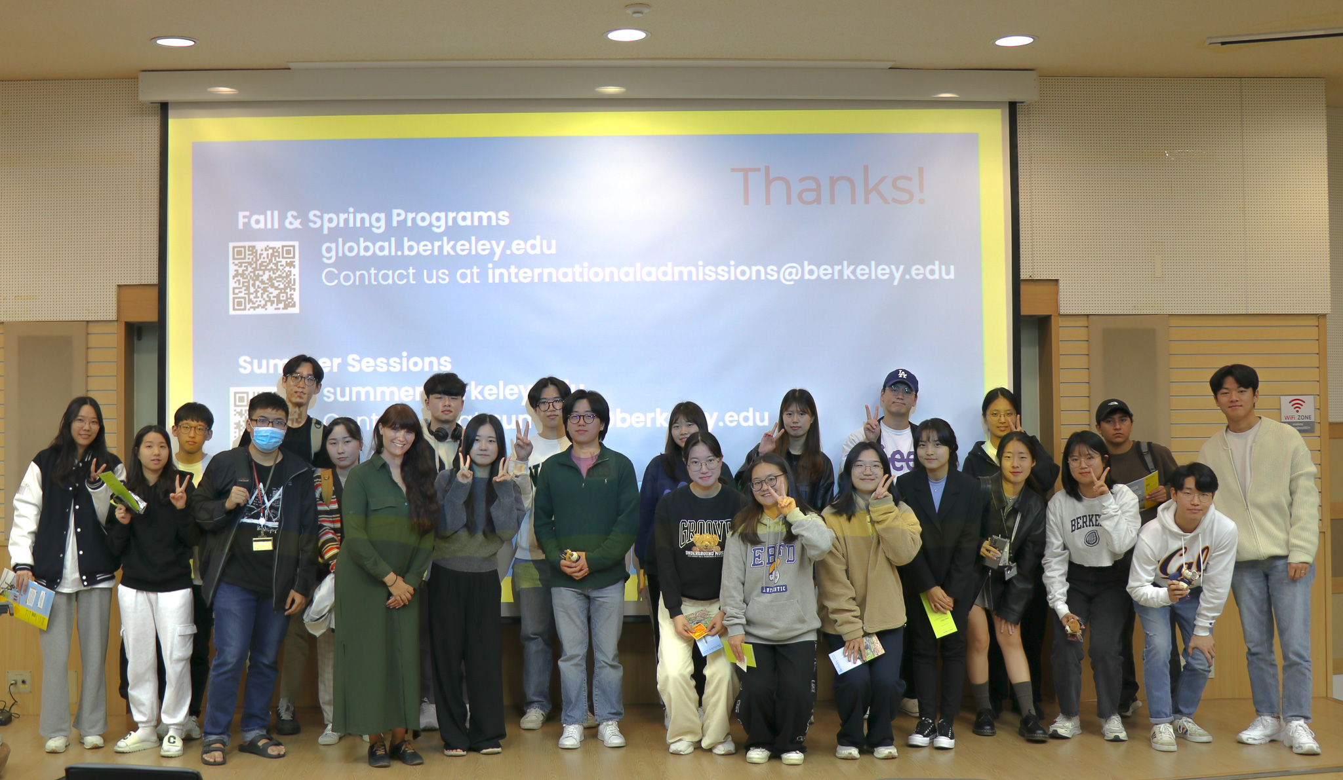▲ UC Berkeley representative Hannah Burney and GIST undergraduate students (including students participating in the 2023 SAP, summer semester program) who attended the briefing session are taking a commemorative photo.

Gwangju Institute of Science and Technology (GIST) announced that it held a briefing session for undergraduate students on UC Berkeley's Study Abroad Program (SAP) and Summer Program during a visit by officials from the University of California, Berkeley (UC Berkeley) in the United States.

GIST sent 100 first-year undergraduate students to UC Berkeley in the summer semester (June-August 8 weeks) in 2010, and has been sending students to UC Berkeley in the spring semester (January-May 16 weeks) for the SAP (Study Aborad Program) since 10 years ago.

In particular, at this briefing session, Hannah Burney, UC Berkeley's credit exchange manager, visited GIST and explained it in person, receiving a great response from students.

GIST’s ‘UC Berkeley SAP’ is a program that sends GIST undergraduate students in their third year or higher who have certain qualifications to complete UC Berkeley’s regular curriculum during the regular spring semester. Selected students will receive scholarship benefits worth up to 25 million won per person.

GIST has been stably operating UC Berkeley SAP for about 10 years since 2013, and a total of 86 students have been participated to date.

The Summer Session Program provides the opportunity for about 100 qualified second and third year GIST undergraduate students to complete summer sessions at prestigious overseas universities such as UC Berkeley, Boston University, and the University of Cambridge in the United Kingdom.

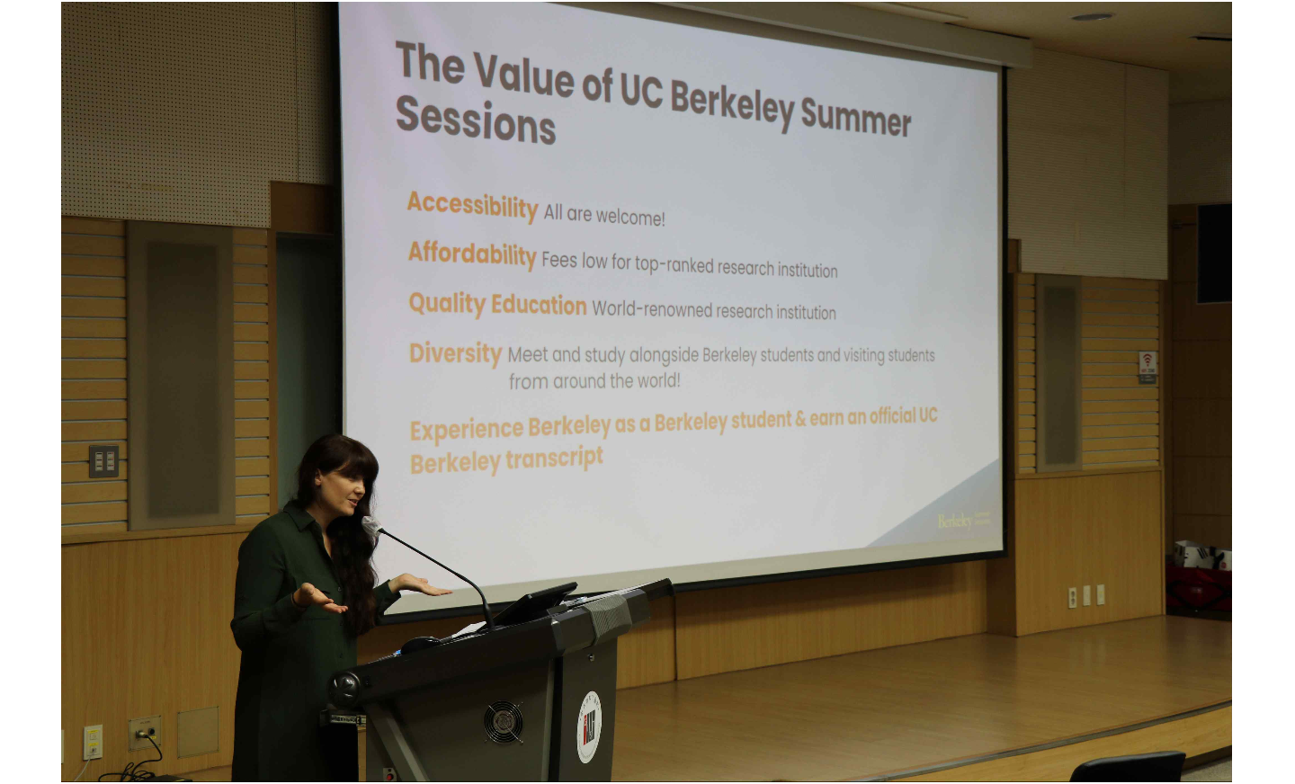▲ Hannah Burney, who attended as a UC Berkeley representative, is explaining the UC Berkeley student placement program.

The briefing session held on this day included ▵ a description of courses available at UC Berkeley, course period, accommodations, costs, etc. ▵ a presentation of reviews from seniors who participated in this year’s UC Berkeley SAP and summer semester programs ▵ a Q&A and networking session with students who plan to apply in the future or are interested.

UC Berkeley representative Hannah Burney said, "We would like to thank GIST for providing us with this opportunity to meet on campus with GIST students who are showing excellent academic achievements at UC Berkeley. We plan to continue our exchange with GIST by visiting GIST every year, meeting students in person and providing practical feedback."



