GIST Academy holds breakfast forum in October... "A Great Leap Forward for a Respected Country"

- GIST Professor Emeritus Untae Kang gave a special lecture on the 30th (Monday) on the theme of ‘The Path of the People - Dreams, Challenges, and Achievements’... Now is the stage for a great leap forward

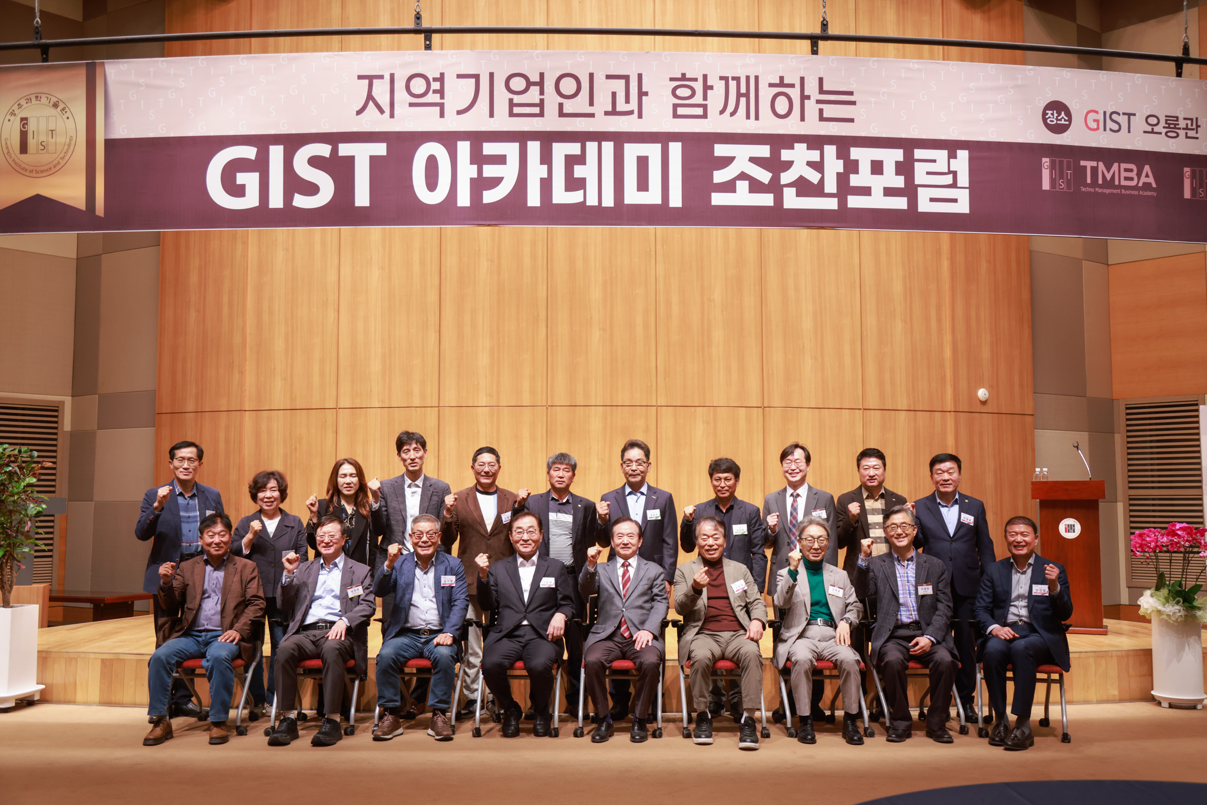▲ Commemorative photo of GIST Academy holding its October Breakfast Forum in October at Oryong Hall.

The Gwangju Institute of Science and Technology (GIST, President Kichul Lim) announced that it held the October Breakfast Forum at Oryong Hall on Monday, October 30, with about 50 representative businesspeople from the Gwangju and Jeonnam regions attending.

Professor Emeritus Untae Kang of the GIST Research Institute for Solar and Sustainable Energies, who was a speaker at the forum on this day, gave a lecture on the theme of ‘The Path of the People – Dreams, Challenges, and Achievements’.

Professor Untae Kang, who also served as the mayor of Gwangju Metropolitan City, explained the current status of Gwangju's local economy and industry prior to his lecture. Based on this, it attracted a lot of attention from attendees by presenting opportunities for leaping forward, such as an AI-specialized city and a Korean-style Silicon Valley.

Heo Gyun, a scholar of the Joseon Dynasty, wrote in his classic novel <Hominron (豪民論)> that 'Homin' is a people who challenge unfair treatment and social absurdity, unlike 'Hangmin' and 'Nonmin', who are people who can be easily manipulated. It was said that they were feared by the ruling class.

Professor Kang's key themes for Homin (豪民) are ▴ 'Direction and speed are important' ▴ 'Live a life with many question marks (?) and exclamation points (!)' ▴ 'The answer to the problem is in the field' ▴ ' Wisdom comes from earnestness' ▴ 'Do not be afraid of failure' ▴ 'In service, receiving is greater than giving' ▴ 'Train your body and mind'.

He also emphasized the importance of Korea's research achievements, citing 10 leading technologies of the future, including brain science, artificial intelligence, and humanoids, as key to becoming a "respected nation."

Professor Untae Kang said that the Republic of Korea has now reached the stage of great reform, and the seven necessary conditions for a great leap forward are: ▴ fulfillment of the great mission of unification ▴ normalization of population policy ▴ great reform of regressive politics ▴ strengthening job responsibility of large companies ▴ redesign and strengthening of the four major national insurance policies ▴ breaking down the unipolar system centered on the metropolitan area ▴ the importance of improving science and technology.

Lastly, Professor Kang said, "I emphasize the virtues of being a Homin, opportunities for new heights, challenges to achieve your dreams, and cheers for your success."

GIST Academy is a non-degree program at GIST that operates the Technology Management Academy (opened in 2010) and the Climate Change Academy (opened in 2016). On the last Monday of every month, the ‘GIST Academy Breakfast Forum’ is held for academy alumni and executives of local companies, inviting experts from various fields as speakers.

GIST Academy supports managers in each field to deeply understand changes in the corporate environment and global management strategies through lectures by Korea's best experts and to form a broad human network, contributing to the revitalization of the local economy and industry-academia cooperation.



