GIST master's student Sunghyun Kang wins the best student paper award at an international academic conference (IEEE SMC 2023)

- Professor Sung Chan Jun’s research team from the AI Graduate School participated in the ‘Brain-Machine Interface (BMI) System Category’ and won the IEEE Brain Best Student Paper Award
- Presentation of technology for identifying and removing abnormal noise in brain waves using real-time vision information

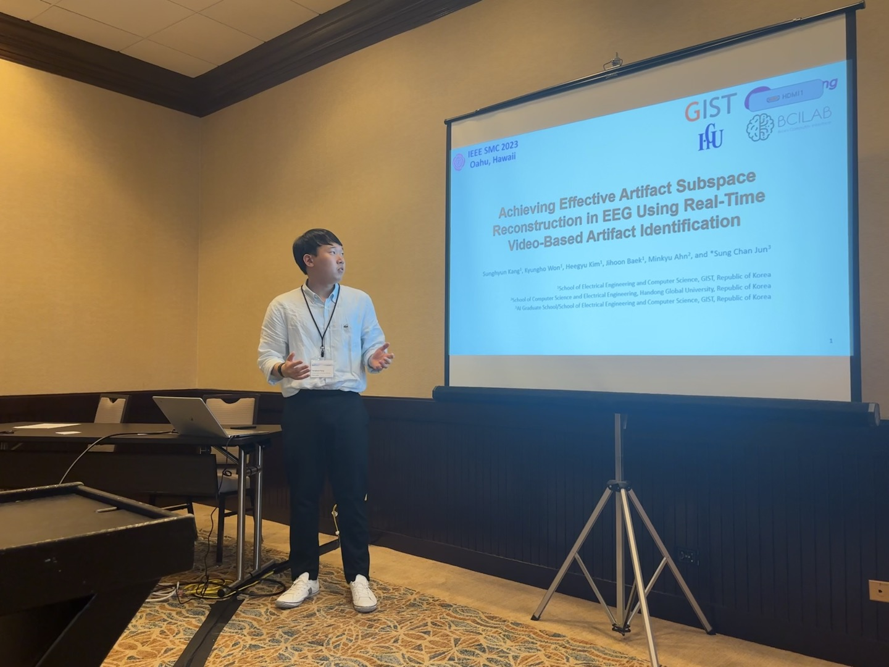▲ Master's student Sunghyun Kang is participating in the ‘Brain-Machine Interface (BMI) System Division’ of ‘IEEE SMC 2023’ and is presenting a paper presenting technology for identifying and removing abnormal noise in brain waves using real-time vision information.

The Gwangju Institute of Science and Technology (GIST, President Kichul Lim) announced that master's student Kang Seong-hyeon (School of Electrical Engineering and Computer Science) of the AI Graduate School's Biocomputing Lab (advisor Sung Chan Jun) won the IEEE Brain Best Student Paper Award at an international academic conference (IEEE SMC).

IEEE SMC (Systems, Man, and Cybernetics) is a renowned international conference in the fields of systems science and engineering, human-machine systems, and cybernetics.

Master's student Sunghyun Kang participated in the ‘System Division’ as the first author of the paper (paper title: Achieving Effective Artifact Subspace Reconstruction in EEG Using Real-Time Video-Based Artifact Identification) at the 'IEEE SMC' held in Honolulu, Hawaii, USA from October 1 to 4. 2023’s ‘Brain-Machine Interface (BMI)’ and presented technology for identifying and removing abnormal noise in brain waves using real-time vision information.

GIST AI Graduate School's BioComputing Laboratory conducted research to identify brainwave noise through real-time vision data when measuring brainwaves, designed a framework to remove it, and verified its effectiveness through various brainwave experiments.

Sunghyun Kang, the master’s student who gave the oral presentation, said, "It seems to have received good reviews for pointing out the limitations of existing brainwave noise processing methodologies and presenting an effective noise removal framework using real-time vision data to overcome them."

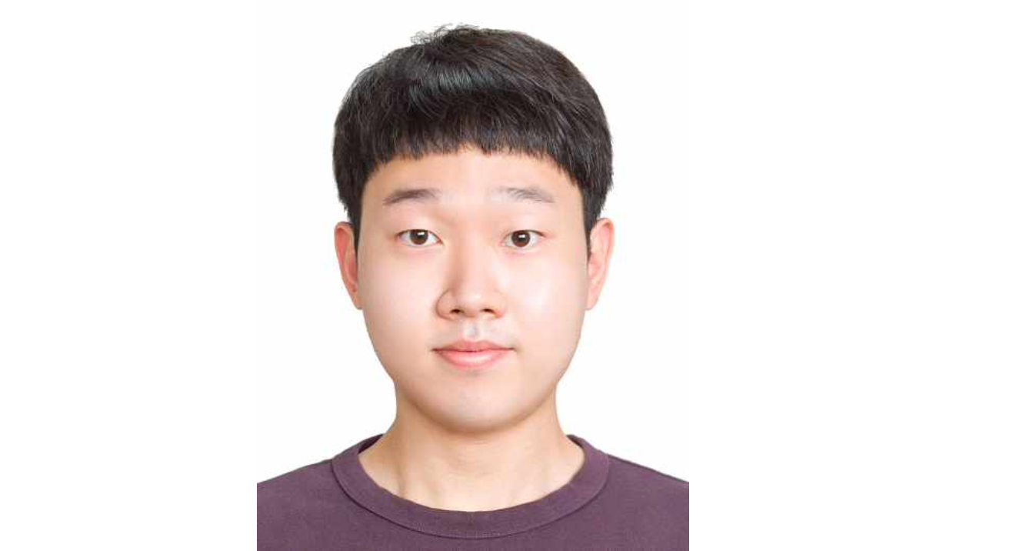▲ Master’s student Sunghyun Kang of the School of Electrical Engineering and Computer Science won the IEEE Brain Best Student Paper Award at the international academic conference ‘IEEE SMC 2023’.

The advising Professor Sung Chan Jun said, "EEG technology, which measures rapid changes in brain activity, is used in various applied research to identify people's cognitive/emotional information, especially in clinical settings such as sleep and depression. The importance of research is growing as it is used to diagnose diseases such as epilepsy."

Furthermore, "The biggest difficulty in using brain waves is the problem of noise that is larger than the signal, and this research result, which proposes a noise removal technology using visual information, is expected to have great impact and applicability."

Professor Sung Chan Jun's research team is conducting research to apply the technology to sleep control and brain-computer interface technology through advancement of the technology.



