'GIST Academy September Breakfast Forum' held... Professor Hojung Nam’s gives lecture on new drug design AI platform development

- Breakfast forum held on the 25th (Monday) under the theme of ‘AI-based new drug discovery and development’
- GIST Professor Hojung Nam developed an AI model that generates new drug structures and published it in a renowned academic journal

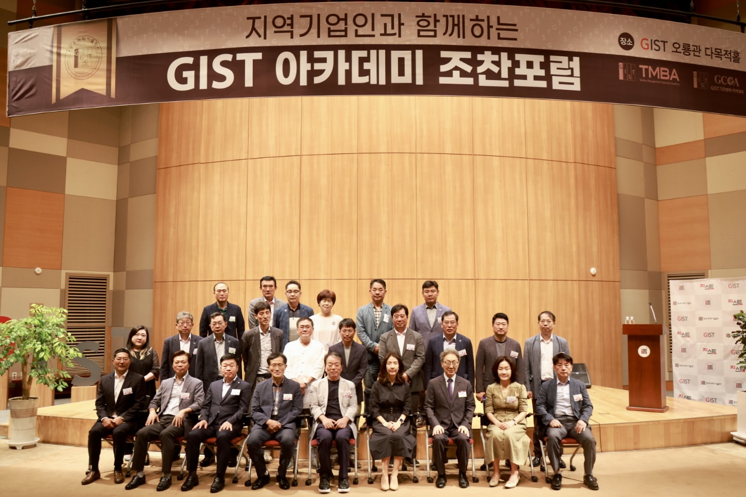▲ Commemorative photo of GIST Academy's breakfast forum in September at Oryong Hall

Gwangju Institute of Science and Technology (GIST, President Kichul Lim) announced that it held the ‘GIST Academy September Breakfast Forum’ at Oryong Hall on Monday, September 25, with about 60 company representatives from the Gwangju and Jeonnam regions attending.

GIST School of Electrical Engineering and Computer Science Professor Hojung Nam, who was a speaker at the forum on this day, gave a lecture on the topic of ‘AI-based new drug discovery and development.’

In the traditional new drug development process, the initial candidate discovery stage requires a long research process that can take several years at most, but with the introduction of artificial intelligence, development is possible as quickly as a few weeks, so the use of AI technology in the field of new drug development is attracting great attention.

Professor Hojung Nam recently developed an artificial intelligence model that generates new drug structures and published it in the ‘Journal of Cheminformatics’, a renowned academic journal in the field of chemical informatics.

Professor Nam's development of an AI platform for generating small molecule compounds is expected to contribute to dramatically shortening the development time for new drugs through generating small molecule compounds that optimize the effects of drugs.

In her lecture that day, Professor Hojung Nam introduced research on using artificial intelligence technology to quickly screen candidate substances in the development stage of new small molecule compounds, and she explained generative artificial intelligence technology that creates new structures in an easy-to-understand manner.

Professor Nam concluded the lecture by suggesting the possibility of application in various fields using the characteristics of AMPs (antimicrobial peptides: innate immune peptides that eliminate targets through various mechanisms).

GIST Academy operates the Techno Management Business Academy (opened in 2010) and the Climate Change Academy (opened in 2016) as non-degree programs. On the last Monday of every month, the ‘GIST Academy Breakfast Forum’ is held for academy alumni and executives of local companies, inviting experts from various fields as speakers.

GIST Academy supports managers in each field to deeply understand changes in the corporate environment and global management strategies through lectures by Korea's best experts and to form a broad human network, contributing to the revitalization of the local economy and industry-academia cooperation.

