Future developers gather together! GIST holds developer exchange and communication event

- ‘2023 GIST Dev Night’... Expectation of synergy by networking students dreaming of becoming developers
- NCSoft team leader Jeong-won Kim was invited to share his experiences and challenges as a developer

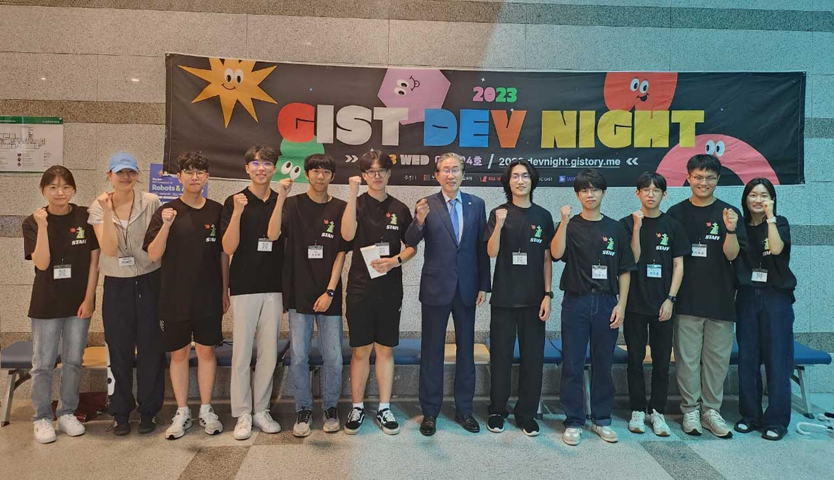▲ President Kichul Lim and students from the ‘2023 GIST Dev Night’ preparation committee are taking a commemorative photo in GIST College Building C.

Gwangju Institute of Science and Technology (GIST, President Kichul Lim) held ‘2023 GIST Dev Night (GIST Developer Night)’, a festival for young developers.

This event, which was held for the second time since last year, was held on the 13th (Wednesday) from 7 PM to 11 PM in Room 101, GIST College Building C, to share various ideas of GIST students dreaming of becoming developers and to expand their human network.

Undergraduate students Jeong-Hwan Lee, Sun-Kyu Kim, Jae-Hong Jeong, and Sang-Yoo Lee, majoring in electrical and electronic computer engineering, were selected as speakers for the 'presentation session' and shared their knowledge and experience in various fields ranging from app development to project management, data science, and artificial intelligence.

They gave lectures on the topics of ‘Short Form Era’, ‘Web Services’, ‘What I Learned While Creating an API Server Using 14 Different Methods’, and ‘Creating a Customized Email’.

In particular, NCsoft team leader Kim Jeong-won Kim, who attended as an external lecturer, received a great response by candidly communicating with participants about vivid experiences and challenges under the theme of ‘Living as a game developer.’

There are future developers actively working in their respective fields such as IT, bio, and energy within the hospital, but there has not been an opportunity to share knowledge and information about each field.

Accordingly, the Undergraduate Student Council Information Bureau organized the ‘GIST Dev Night’ preparatory committee and held the first event last year, opening up opportunities for free exchange for prospective developers.

GIST College Dean Kwang Hee Ko said, "This event was a very valuable developmental community event held with the voluntary support of students. We plan to identify development needs in the region and support expansion into various programs that seek cooperation with the developer community. We hope to establish a bridgehead for exchanges with other universities by utilizing the National Institute of Science and Technology association and network."

Yestay Yessenbay, a student from Kazakhstan who entered GIST this year, said, "I have always been interested in development, so I am glad that this opportunity was created. In the future, I hope that it will become a place of rich communication and exchange where foreign students of various nationalities can actively participate and share their experiences."

Jeong-woo Lee, an undergraduate student who served as the representative of the preparation committee, said, "t was a meaningful opportunity to gain practical know-how and knowledge from senior developers and experts in the field and share experiences about life as a developer."

